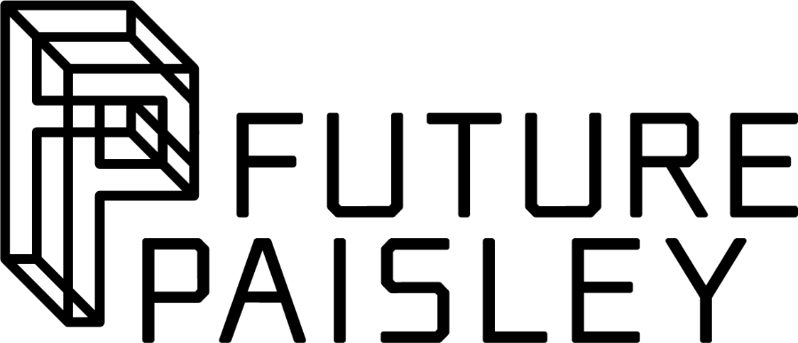
Cultural Organisations Development Fund
Round 4

Expression of Interest

Please complete this form if you are considering making an application to Round 4 of the Cultural Organisations Development Fund (CODF) and submit it by the deadline of 18th July 2023 to codf-enquiries@renfrewshire.gov.uk

Please read the CODF Round 4 guidance for applicants on https://www.renfrewshire.gov.uk/CODF before completing this form.

Organisation name
Contact name
Address

Email
Website
Phone
When are you available for a 1:1 advice surgery? Please tick all dates that apply

Date |  | Available: Yes / No
Morning of Thursday 27th July 2023
Afternoon of Thursday 27th July 2023
Morning of Thursday 10th August 2023
Afternoon of Thursday 10th August 2023
Not available on 27th July or 10th August 2023

What does your organisation do?

How many people does your organisation employ? |  | Do you have a business plan? | Yes / No
What is the legal status of your organisation?

What is your organisation’s ambition? (max 200 words)

Tell us about your interest in the Fund and any proposals or ideas you have that you think the Fund might be able to support.

In Round 4, we particularly welcome applications that include pathways for young people to develop their skills and careers in the creative industries. This might include work experience placements, internships and apprenticeships.  Is there potential to build in these kinds of opportunities into your proposal?  If so, please share your ideas below: | Yes/No

Do you have any specific questions you’d like to discuss? If so, please add them below.

