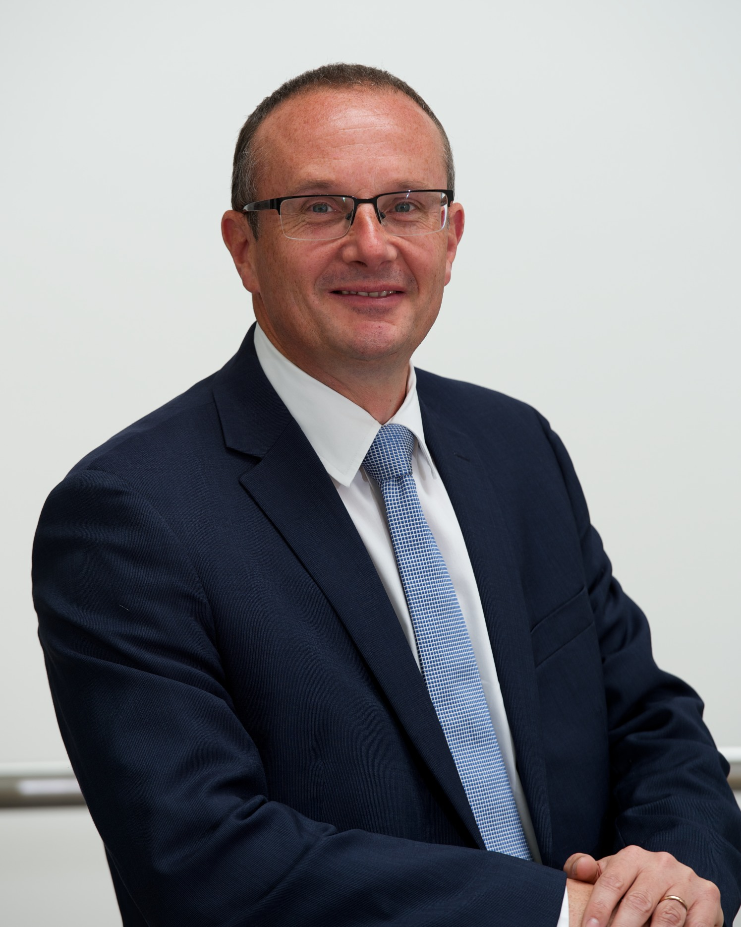
Director of Children’s Services
Chief Education Officer
Steven Quinn
0141 618 6839
steven.quinn@renfrewshire.gov.uk

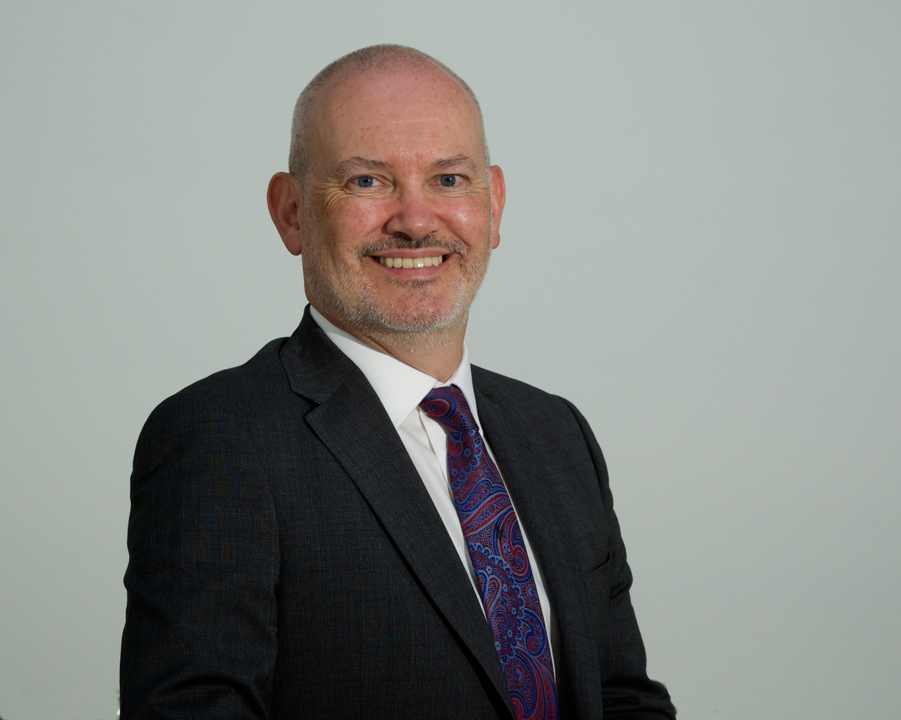
Head of Childcare and Criminal Justice
Chief Social Work Officer
John Trainer
0141 618 7194
john.trainer@renfrewshire.gov.uk
Head of Schools
Tracy McGillivray
0141 618 7194
tracy.mcgillivray@renfrewshire.gov.uk

Head of Education
Julie Calder
0141 618 7194
julie.calder@renfrewshire.gov.uk




