

Renfrewshire Council

Air Quality Action Plan

In fulfilment of Part IV of the

Environment Act 1995

Local Air Quality Management

March 2019

|  |  |
| --- | --- |
| Local Authority Officer | Chris Dalrymple,  Communities and Regulatory Manager |
| Department | Communities, Housing and Planning Services |
| Address | Renfrewshire Council, Renfrewshire House, Cotton Street, Paisley PA1 1BR |
| Telephone | 0300 300 0380 |
| E-mail | [e-prot.es@renfrewshire.gov.uk](mailto:e-prot.es@renfrewshire.gov.uk) |
| Report Reference number | RenAQAP2018v2 |
| Date | March 2019 |

## Executive Summary

This Renfrewshire Air Quality Action Plan (hereafter referred to as the Action Plan) has been produced to comply with statutory duties required by the Local Air Quality Management framework. It demonstrates the commitment to improving air quality in Renfrewshire and outlines the actions that will be undertaken up to 2022 to achieve this.

Air pollution is associated with a number of adverse health impacts. It is recognised as a contributing factor in the onset of heart disease and cancer and can affect the most vulnerable in society: children, the elderly and those with heart and lung conditions.

Renfrewshire currently has three Air Quality Management Areas (AQMAs); the Paisley Town Centre Air Quality Management Area declared August 2009 and the Johnstone High Street and Renfrew Town Centre Air Quality Management Areas both declared August 2016. The pollutants of concern are nitrogen dioxide (NO2) and particulate matter PM10 (particulate matter less than 10 microns in diameter).

An Air Quality Action Plan for the Paisley Town Centre Air Quality Management Area has been in place since 2014. The most significant measures delivered through this plan include improvements to Central Road which was previously the main bus stop location within Paisley; implementation of a Statutory Quality Bus Partnership Scheme across Paisley town centre; and council vehicle fleet improvements. A summary of the Paisley Town Centre Air Quality Action Plan measures and outcomes is included within the 2016 Annual Progress Report which can be found on the Council’s air quality webpage - http://www.renfrewshire.gov.uk/airquality

This Renfrewshire wide Action Plan incorporates all three Air Quality Management Areas and will supersede the Paisley Town Centre Air Quality Action Plan. The proposed action measures it contains address the following broad topic areas:

* Transport planning and infrastructure
* Traffic management
* Vehicle fleet efficiency
* Policy guidance and development control
* Promoting low emission transport
* Promoting travel alternatives
* Public information
* Freight and delivery management

A total of 16 measures have been identified. Some measures are specific to a particular Air Quality Management Area and some are generic measures which will offer Renfrewshire wide air quality improvements. Priorities include transport planning and infrastructure works, tackling emissions from congestion via various means, promoting low emissions transport and encouraging active travel alternatives.

By implementing this Action Plan the Council is striving to meet statutory air quality objectives and support the improvement of air quality within Renfrewshire as a whole. This is integral to the Council’s Local Outcome Improvement Plan, supporting the aim to make Renfrewshire a fairer, more inclusive place where all our people, communities and businesses thrive.

## Responsibilities and Commitment

This Action Plan was prepared by the Council’s Environmental Improvements Section within Communities, Housing and Planning Services with the support and agreement of the following Council Services:

**Environment & Infrastructure** -Transport and Roads;

**Communities, Housing & Planning Services** - Development Management, City Deals, Policy & Regeneration;

**Finance & Resources** -Energy Asset.

Consultation on a first draft of the Action Plan was undertaken during 2018 and the beginning of 2019. Consultation was undertaken with statutory consultees, businesses and the local community. The Action Plan has also been presented to the Council’s Infrastructure, Land & Environment Policy Board for consideration and approval by elected members. This final Action Plan has taken cognisance of comments received during the consultation process.

The Action Plan is a living document which will be updated with amendments and additions in response to future work including feasibility studies and further modelling work currently being undertaken to support some of the action measures. The Action Plan will be subject to an annual review and progress detailed within our Annual Progress Reports which are submitted to the Scottish Government at the end of June in compliance with statutory Local Air Quality Management duties.

If you have any comments in relation to this Action Plan please send them to:

Environmental Improvements

Communities, Housing and Planning Services

Renfrewshire Council

Renfrewshire House

Cotton Street

Paisley

PA1 1BR

Email: [e-prot.es@renfrewshire.gov.uk](mailto:e-prot.es@renfrewshire.gov.uk)

Tel: 0300 300 0380**Table of Contents**

Executive Summary i

Responsibilities and Commitment ii

1. Introduction 1

2. Summary of Current Air Quality in Renfrewshire 2

2.1 Paisley Town Centre Air Quality Management Area 2

2.2 Johnstone High Street Air Quality Management Area 3

2.3 Renfrew Town Centre Air Quality Management Area 5

2.4 2017 Annual Progress Report 6

2.5 2018 Annual Progress Report 6

3. Renfrewshire’s Air Quality Priorities 7

3.1 Policy and Planning Context 7

3.1.1 Cleaner Air for Scotland (CAFS) 7

3.1.2 Renfrewshire’s Local Transport Strategy 9

3.1.3 Town Centre Strategies 9

3.1.4 Paisley Town Centre Action Plan 10

3.1.5 Paisley Transport Strategy Feasibility Study 10

3.1.6 Johnstone Town Centre Transportation Plan 11

3.1.7 The Glasgow City Region City Deal 11

3.1.8 Renfrewshire Cycling Strategy 13

3.1.9 Renfrewshire Council Biomass Guidance Policy Document 14

3.2 Source Apportionment 14

3.2.1 Paisley Town Centre Air Quality Management Area 15

3.2.2 Johnstone High Street Air Quality Management Area 19

3.2.3 Renfrew Town Centre Air Quality Management Area 23

3.2.4 Summary 27

3.3 Required Reduction in Emissions 27

3.3.1 Required Reduction in Emissions 27

3.3.2 Emission Reduction Modelling Studies 27

3.6 Key Priorities 34

4. Development and Implementation of Renfrewshire’s Air Quality Action Plan……………………………………………. 36

4.1 Steering Group 36

4.2 Consultation and Stakeholder Engagement 36

5. Air Quality Action Plan Measures 39

6. Additional Information on Specific Action Measures 57

7. Glossary of Terms 59

8. References 60

9. Appendices 62

Appendix A: Monitoring Locations within the Air Quality Management Areas 63

Appendix B: Policy and Planning Context Additional Information 66

Appendix C: Response to Consultation 70

Appendix D: Action Plan Measures Not Pursued 72

Appendix E: Evaluation of Potential Action Measures 74

Appendix F: Action Measures & Links to CAFS Strategic Objectives 83

Appendix G: Air Quality Action Plan Support Study by AECOM 99

**List of Tables**

Table 1: NOx Emissions by source and vehicle type (µg.m-3)Paisley AQMA 15

Table 2: NOx Emissions by source and vehicle type (% of total NOx) Paisley AQMA 16

Table 3: PM10 Emissions by source and vehicle type (µg.m-3) Paisley AQMA 17

Table 4: PM10 Emissions by source and vehicle type (% of total PM10) Paisley AQMA 18

Table 5: NOx Emissions by source and vehicle type (µg.m-3) Johnstone AQMA 20

Table 6: NOx Emissions by source and vehicle type (% of total NOx) Johnstone AQMA 20

Table 7: PM10 Emissions by source and vehicle type (µg.m-3) Johnstone AQMA 21

Table 8: PM10 Emissions by source and vehicle type (% of total PM10) Johnstone AQMA 21

Table 9: NOx Emissions by source and vehicle type (µg.m-3) Renfrew AQMA 23

Table 10: NOx Emissions by source and vehicle type (% of total NOx) Renfrew AQMA 23

Table 11: PM10 Emissions by source and vehicle type (µg.m-3) Renfrew AQMA 25

Table 12: PM10 Emissions by source and vehicle type (% of total NOx) Renfrew AQMA 25

Table 13: Scenario 1 - Predicted 2014 annual mean NO2 concentrations at relevant receptors (µg.m-3) 29

Table 14: Scenario 2 - Predicted 2014 annual mean NO2 concentrations at relevant receptors (µg.m-3) 29

Table 15: Scenario 3 - Predicted 2014 annual mean NO2 concentrations at relevant receptors (µg.m-3) 30

Table 16: Predicted NO2 annual mean concentrations at each diffusion tube monitoring location for each modelling scenario (µg.m-3) 32

Table 17: Consultation Undertaken 37

Table 18: Air Quality Action Plan Measures 41

**List of Figures**

Figure 1: Paisley Town Centre AQMA 3

Figure 2: Johnstone High Street AQMA 4

Figure 3: Renfrew Town Centre AQMA 5

Figure 4: NOx Emissions by source and vehicle type (expressed in µg.m-3) Paisley AQMA 16

Figure 5: NOx Emissions by source and vehicle type (expressed as %) Paisley AQMA 17

Figure 6: PM10 Emissions by source and vehicle type (expressed in µg.m-3) Paisley AQMA 18

Figure 7: PM10 Emissions by source and vehicle type (expressed as %) Paisley AQMA 19

Figure 8: NOx Emissions by source and vehicle type (expressed in µg.m-3) Johnstone AQMA 20

Figure 9: NOx Emissions by source and vehicle type (expressed as %) Johnstone AQMA 21

Figure 10: PM10 Emissions by source and vehicle type (expressed in µg.m-3) Johnstone AQMA 22

Figure 11: PM10 Emissions by source and vehicle type (expressed as %) Johnstone AQMA 22

Figure 12: NOx Emissions by source and vehicle type (expressed in µg.m-3) Renfrew AQMA 24

Figure 13: NOx Emissions by source and vehicle type (expressed as %) Renfrew AQMA 24

Figure 14: PM10 Emissions by source and vehicle type (expressed in µg.m-3) Renfrew AQMA 26

Figure 15: PM10 Emissions by source and vehicle type (expressed as %) Renfrew AQMA 26

# Introduction

This Renfrewshire Air Quality Action Plan outlines the actions that Renfrewshire Council will deliver up to 2022 to reduce concentrations of air pollutants within Air Quality Management Areas to below statutory air quality objective levels; positively impacting on the health and quality of life of residents, workers and visitors to the area.

It has been developed in recognition of the legal requirement to work towards Air Quality Strategy objectives under Part IV of the Environment Act 1995 and to meet the requirements of the Local Air Quality Management (LAQM) statutory process.

The actions identified are considered to be the most effective, feasible and proportionate for Renfrewshire Council to take forward and have been drawn up following consultation with all relevant Council Services, statutory consultees, key stakeholders etc. Successful implementation and progress to deliver the measures within the Action Plan will require ongoing effective partnership working and communication between all relevant bodies. The Action Plan will be reviewed annually and progress on action measures reported within the Council’s Annual Progress Reports.

# 2. Summary of Current Air Quality in Renfrewshire

There are three Air Quality Management Areas declared in Renfrewshire within the towns of Paisley, Johnstone and Renfrew. The pollutants of concern are nitrogen dioxide (NO2) and particulate matter PM10 (particulate matter less than 10 microns in diameter). A variety of sources contribute to the levels of these pollutants within the Council area including background pollutant concentrations, transport, commercial and industrial sources. The main sources of pollution within each Air Quality Management Area are discussed in further detail in Section 3.3: Source Apportionment.

The Council monitors these pollutants via four continuous automatic analysers and a network of approximately seventy NO2 diffusion tube sites. One of these monitors (FIDAS) measures both PM10 & PM2.5 and was installed in Johnstone High St in July 2017. The Council also utilises an AQ Mesh monitor which is a mobile indicative monitor measuring NO2, PM10 & PM2.5. This is currently installed on Johnstone High St within a canyon location that is unsuitable for the permanent siting of a continuous automatic monitor. Maps detailing the monitoring locations within each Air Quality Management Area can be found in Appendix A.

Details of the Air Quality Management Areas are described below followed by a summary of the 2018 Annual Progress Report. This report, which is the most recent Local Air Quality Management report providing information on air quality levels within Renfrewshire, identified exceedances of the NO2 annual mean objective at two diffusion tube monitoring sites during 2017. The exceedances were recorded within the Renfrew Town Centre Air Quality Management Area and the Johnstone High Street Air Quality Management Area.



## Paisley Town Centre Air Quality Management Area

Paisley is Renfrewshire’s largest town with a population in excess of 70,000. The town centre is a mix of historic buildings, commercial and residential premises within a compact area. Around the town centre a ring road intercepts all the main routes converging on Paisley.

In 2005 the Council declared its first Air Quality Management Area at Central Road in Paisley due to exceedances of the 1-hour mean NO2 objective. Central Road was a main bus stop and HGV delivery area situated beneath a multi-storey car park resulting in poor air flow and high levels of pollution.

Following declaration of the Central Rd Air Quality Management Area, exceedances of the annual mean NO2 and PM10 objectives were identified at various other locations throughout the town centre; predominantly at busy roads and junctions on the town centre ring road. The Central Rd Air Quality Management Area was amended in August 2009 to cover the majority of Paisley town centre and to include the annual mean NO2 and PM10 objectives in addition to the existing 1-hr mean NO2 objective.This Air Quality Management Area, known as the Paisley Town Centre Air Quality Management Area, remains in place and is presented in Figure 1.

Figure 1: Paisley Town Centre AQMA

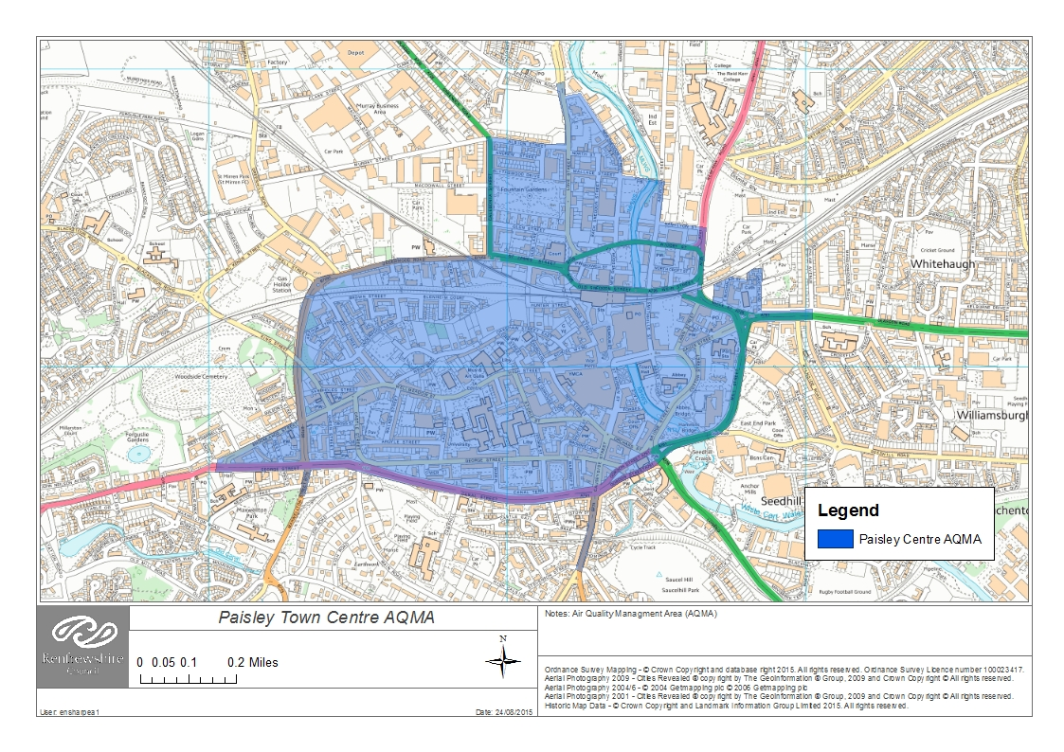

A Paisley Town Centre Air Quality Action Plan was developed by the Council and published at the beginning of 2014. Sixteen action plan measures were adopted with a focus on transport and vehicle emissions. The most significant of those included:

* Infrastructure and traffic flow improvements at Central Road which resulted in a marked improvement in air quality levels and less congestion in that area.
* Implementation of a Statutory Quality Bus Partnership Scheme within Paisley town centre requiring a phased introduction of buses meeting the minimum Euro emission standard of Euro III. This resulted in the replacement of significant numbers of pre EURO standard buses with mainly EURO III and EURO V buses.
* Council fleet improvements including the majority of vehicles being a minimum Euro V standard; the introduction of 24 electric vehicles; the provision of 20 electric charging points; and the fitting of rev limiters to HGVs.

By 2016 the majority of action measures had been implemented. A summary of these and their outcomes are included within the Council’s 2016 Annual Progress Report which can be found on the Council’s air quality webpage http://www.renfrewshire.gov.uk/airquality.

Significantly, a review of Central Road during 2014 confirmed that the location was no longer an area of relevant exposure in terms of the 1-hour NO2 objective. Previously members of the public may have waited in this area for up to an hour for public transport but the majority of bus services have now been relocated and there is no longer a likelihood that people will be in this area for at least an hour. The Scottish Government agreed with this conclusion and the Central Road automatic analyser was decommissioned in 2014.

## Johnstone High Street Air Quality Management Area

Johnstone is a town with a population in excess of 16,000. The town is set around a traditional grid pattern of streets and public spaces with the High Street, comprising mainly commercial properties on the ground floor and residential flats above, running through the centre. The town has strong transport links with the A737 lying immediately to the north linking to the M8 motorway. Johnstone rail station, including a park and ride facility, is less than half a mile from the town centre and there is an extensive bus service providing connections to surrounding settlements and Glasgow.

The Johnstone High Street Air Quality Management Area was declared in August 2016 for exceedances of the NO2 annual mean objective. Diffusion tube monitoring from previous years has identified several locations of exceedance of this objective along the High Street which were confirmed via modelling as part of the 2015 Detailed Assessment. This modelling also identified potential exceedances of the PM10 annual mean objective however, given no PM monitoring had been undertaken before in Johnstone, the Scottish Government advised that monitoring was necessary to confirm exceedances prior to also declaring this as a management area for PM10.

A continuous particulate monitor (FIDAS), measuring both PM10 & PM2.5, has been operational on the High St since the end of July 2017. Based on the initial 4 months of data, results indicate there are no exceedances of the short term objective for PM10 or the annual mean objectives for either PM10 or PM2.5. Concentrations are in the region of 9.1µg.m-3 and 5.4µg.m-3 respectively for annual means based on raw data.

The Johnstone Town Centre Air Quality Management Area boundary extends along the entire High Street and is presented in Figure 2.

Figure 2: Johnstone High Street AQMA

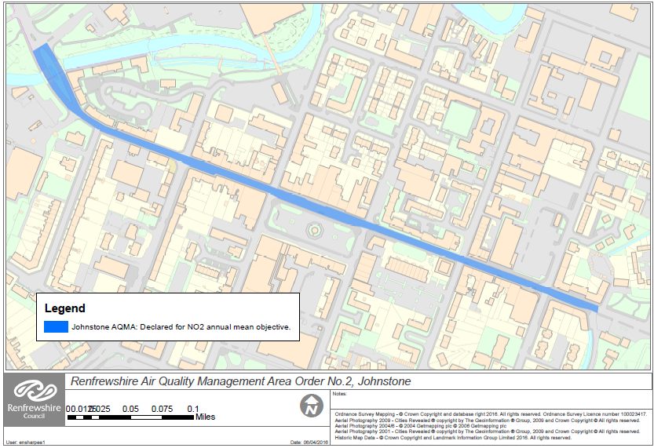

Congestion is a significant traffic issue on Johnstone High St caused mainly by traffic signal operations (with a higher than normal pedestrian demand) and a lack of road space which is exacerbated by illegal parking. This, combined with a high volume of bus operations and several locations of canyon type topography situated along the High St has resulted in several hot spot locations where exceedences of air quality objectives occur. Further details on this can be found within the 2015 Johnstone High Street Detailed Assessment on the Council’s air quality webpage <http://www.renfrewshire.gov.uk/airquality>

## Renfrew Town Centre Air Quality Management Area

Renfrew is the second largest settlement in Renfrewshire with a population in excess of 20,000 located on the River Clyde west of Braehead. The town centre is compact and comprises of commercial buildings and residential property, mainly in the form of tenement buildings. The town has strong transport links to Glasgow and the wider central belt. The M8 motorway lies less than a mile away and the town is supported by extensive bus services which provide connections to surrounding areas and Glasgow. The town also benefits from the close proximity of Glasgow Airport.

The Renfrew Town Centre Air Quality Management Area was declared in August 2016 for exceedances of both the NO2 annual and 1-hour mean objectives. Diffusion tube monitoring from previous years has identified several locations of exceedance of the NO2 annual mean objective within the town centre. An annual mean NO2 concentration in excess of 60 μg.m-3 (2014 data) was also measured at a ground floor residential property on Inchinnan Road which, in accordance with Local Air Quality Management technical guidance, presents a risk of the 1-hour NO2 objective being exceeded.

The Air Quality Management Area was declared for both the NO2 annual and 1-hour mean objectives. A continuous oxides of nitrogen (NOx) analyser was installed on Inchinnan Road within the town centre in January 2019 to confirm these exceedances based on reference monitoring. A review will be undertaken following a full year of monitoring. There is no monitoring of PM10 within Renfrew town centre, but modelling undertaken as part of the 2015 Detailed Assessment did not identify any risk of this objective being exceeded at locations of relevant exposure.

The Air Quality Management Area boundary extends across the main junctions within the town centre (Inchinnan Road, Hairst Street, Glebe Street, Paisley Road, Canal St and High St) and is presented in Figure 3.

Figure 3: Renfrew Town Centre AQMA

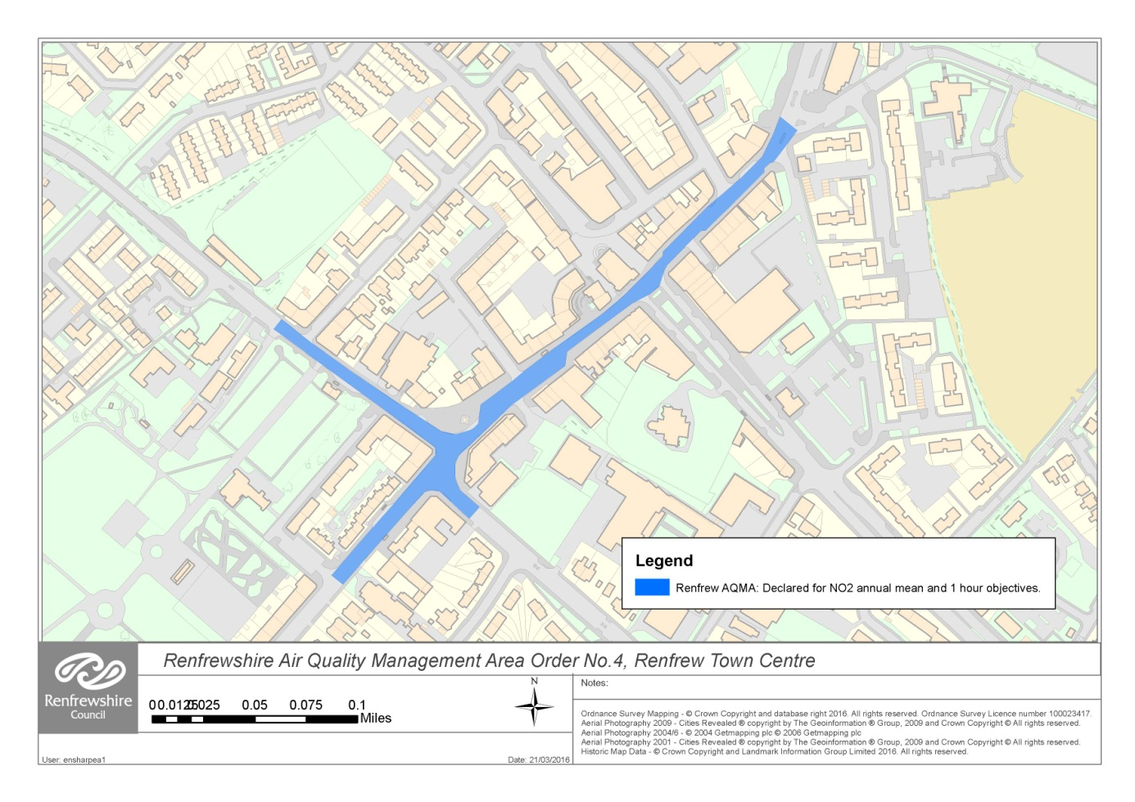

The main traffic issue within Renfrew is congestion at the main junction in the town centre at the merge of Inchinnan Road, Hairst Street, Glebe Street and Paisley Road. This is a complex junction as a result of its physical layout and presents traffic management challenges in terms of signal staging. The Council has optimised the operation of these traffic signals but there remain congestion issues particularly at peak times.

Further details on areas of exceedences can be found within the 2015 Renfrew Town Centre Detailed Assessment on the Council’s air quality webpage http://www.renfrewshire.gov.uk/airquality

## 2017 Annual Progress Report

The Council’s 2017 Annual Progress Report reviewed all monitoring data from 2016 and identified no exceedances of the NO2 and PM10 annual mean and short-term objectives anywhere within Renfrewshire.

In 2016 the Council operated three automatic monitoring sites (Gordon St Paisley, St James St Paisley and Cockels Loan Renfrew) which measured NO2 and/or PM10 concentrations. Concentrations recorded at all automatic monitoring sites were below the annual mean and short-term objective levels for both pollutants.

The Council also operates a network of approximately seventy NO2 diffusion tube monitoring sites. There were no exceedances of the NO2 annual mean objective at any diffusion tube locations across the Council area during 2016. This was an improvement on the 2 locations of exceedance measured in 2015 within the Renfrew Town Centre and Johnstone High Street Air Quality Management Areas and was the first time in over a decade where there were no exceedances identified anywhere throughout Renfrewshire.

## 2018 Annual Progress Report

The Council’s most recent Local Air Quality Management report, the 2018 Annual Progress Report, identified exceedances of the NO2 annual mean objective in 2017 at two diffusion tube monitoring locations, one within the Renfrew Town Centre Air Quality Management Area and one within the Johnstone High Street Air Quality Management Area. There were no exceedances at any of the automatic monitoring sites.

The two diffusion tube locations which exceeded the NO2 annual mean objective level of 40 µg/m3 (after bias adjustment and distance correction) were located at:

* Renfrew (DT No. 8) - Inchinnan Rd, Renfrew (42.5 µg/m3)
* Johnstone (DT No. 59) - High St, Johnstone (40.6 µg/m3)

Within the Paisley Town Centre Air Quality Management Area, there has been three years of consecutive monitoring data (2015, 2016 and 2017) with no exceedances. However, there remain some diffusion tube locations within Paisley where the annual mean NO2 concentration is close to the objective.

The Council is committed to continually improving the quality of air within Renfrewshire and will strive to achieve this with the implementation of the measures within this plan. The Council will maintain the current level of monitoring throughout Renfrewshire for the foreseeable future prior to considering whether to revoke or amend the Paisley Town Centre Air Quality Management Area.

# 3. Renfrewshire’s Air Quality Priorities

This chapter details the Council’s rationale and main drivers for selecting and prioritising the action measures within this Action Plan. It includes a description of strategies and policies that have the potential to impact on air quality within Renfrewshire followed by details of source apportionment studies undertaken within the three Air Quality Management Areas whereby the most significant pollutant contributors are identified and the conclusions used to identify and prioritise action measures. The chapter concludes by detailing the necessary reduction in emissions required to meet air quality objectives and a list of the Council’s key priorities for action.



## Policy and Planning Context

This Action Plan outlines the Council’s plan to effectively tackle air quality issues within its control; however, it is recognised there are numerous policies and strategies adopted at local, regional and national level that can exert significant effects, both positive and negative, on air quality within Renfrewshire. Whilst some of these may be outside the influence of the Council, there are a number of related policies and strategies at local and regional levels that can be tied directly with the aims of this Action Plan. Some of these are focused on transportation issues and therefore likely to help to contribute to overall improvements in air quality across the Council area. This section outlines the strategies and policies that have the most significant potential to impact on pollutant concentrations within Renfrewshire. Given their importance, the majority of measures listed below have been included as action measures within this Action Plan. Details of other national, regional and local strategies and policies which may impact on air quality within Renfrewshire but to a lesser degree are detailed in Appendix B.

### Cleaner Air for Scotland (CAFS)

The Scottish Government’s document ‘Cleaner Air for Scotland – The Road to a Healthier Future’ (CAFS) is a national cross-government strategy published at the end of 2015 that sets out how the Government and its partner organisations propose to deliver further improvements to air quality throughout Scotland. The strategy outlines a series of actions across a range of policy areas (Transport, Health, Legislation & Policy, Placemaking, Communication and Climate Change) and introduces a number of important new initiatives. Local authorities with air quality issues have a key role in helping achieve the objectives of CAFS with responsibility for implementing specific measures including the following:

**Transport**

* Avoiding Travel - All local authorities should ensure that they have a corporate travel plan (perhaps within a carbon management plan) which is consistent with any local Air Quality Action Plan.
* Active Travel - Transport Scotland/Local Authorities will work with partners to deliver the vision within the Cycling Action Plan for Scotland: by 2020 10% of everyday journeys will be made by bike.
* Freight - Encourage each local authority with an Air Quality Management Area to create a Freight Quality Partnership (or utilise an existing RTP Freight Quality Partnership).

**Climate Change**

* Any Scottish local authority which has or is currently developing a Sustainable Energy Action Plan to ensure that air quality considerations are covered.

The Cleaner Air for Scotland strategy was integral to the development of this Action Plan and was considered at an early stage of the process to ensure the aims and objectives of both documents were aligned. Progress by Renfrewshire Council against the relevant Local Authority actions within CAFS is demonstrated below.

**Transport – Avoiding Travel**

The Council’s previous Travel Plan was introduced in 2008 with an aim to reduce single-occupancy car journeys by employees and promote alternative modes of transport. Various initiatives were implemented to assist with this aim. Unfortunately the Travel Plan has not been kept up to date over recent years. The development of an up to date Corporate Travel Plan for the Council has therefore been added as an action measure within this Action Plan.

A detailed review is also being undertaken of the town centre Transportation Plans for Paisley and Johnstone. A review of Renfrew town centre was not considered appropriate at this time due to the proposed City Deal Projects which, when implemented, will have a significant impact on traffic within that area. A review of the Renfrewshire-wide Local Transport Strategy is also being undertaken. The concept of avoiding, alternative and/or active travel will be fundamental to these plans.

**Transport – Active Travel**

The Council recently published a Cycling Strategy for 2016 – 2025 which provides an up to date framework reflecting the increased focus on cycling across Scotland along with the aim to achieve the National targets that have been set for cycling. Further details on this strategy are provided in section 3.1.8.

**Transport – Freight**

ECO (Efficient and Cleaner Operations) Stars Fleet Recognition Scheme is a fuel management and operational efficiency support programme aimed at operators of goods vehicles, vans, buses, taxis and coaches. The scheme was first implemented in Renfrewshire during 2016 with further funding available from the Scottish Government to continue expansion into 2019. The scheme’s core objective is to encourage commercial fleet operators based within Renfrewshire to adopt operational and environmental best practice to continually improve efficiency, reduce fuel consumption and reduce fleet emissions - all helping to improve local air quality, maximise carbon savings and tackle climate change.

**Climate Change – Effective co-ordination of climate change and air quality policies to deliver co-benefits**

The Scottish Government expects any Scottish local authority which has or is currently developing a Sustainable Energy Action Plan to ensure that air quality considerations are covered. Renfrewshire Council’s most recent Carbon Management Plan was published in 2014 and includes replacement of inefficient appliances in buildings, continued investment in cleaner vehicles and the purchase of energy from renewable sources that should assist in achieving air quality improvements.

A consultant was commissioned during development of this Action Plan to undertake a study, an aim of which was to appraise the proposed action measures with respect to the CAFS air quality thematic objectives. The study entitled *Air Quality Action Plan Support* has been included in appendix G. The study contains a table linking the proposed action measures to the CAFS objectives which is detailed in appendix F of this Action Plan. Cells within the table have been colour-coded to indicate how well each action measure applies to the CAFS objective. Salmon represents only limited alignment, orange medium and green shading a greater degree of alignment. An indication is also provided as to the effectiveness of the measure to improve air quality. Whilst the table is relatively subjective, it provides a general indication of how the action measures assist in delivering and supporting sustainable development. Further information on Cleaner Air for Scotland is available at: <http://www.gov.scot/Publications/2015/11/5671/17>.

### Renfrewshire’s Local Transport Strategy

Renfrewshire’s Local Transport Strategy (LTS) was approved in 2007 setting out a vision for transport over a 10-20 year timeframe and which supports the wider economic, environmental and social objectives of the Council. A key objective of the strategy is to ensure a healthy and sustainable environment and there are several specific aims relevant to improving air quality. These include the following:

* The Council will continue to develop strategies for travel planning and parking which reduces the growth of trips by private car and achieves a shift to walking, cycling, public transport and car sharing thus having a positive impact upon air quality and climate change;
* The Council will strive to achieve the most efficient operation of the road network to minimise delays for road users, particularly for public transport;
* The Council will develop transport actions for Paisley, specifically which support and complement the wider economic regeneration strategy, improve accessibility, particularly for cycling, walking and public transport, minimise congestion around the Paisley Town Centre ring road and enhance the street environment; and
* The Council will prioritise development to sustainable locations in transport terms.

A review and refresh of the Local Transport Strategy was undertaken in February 2017 to provide an update on the Council’s achievements against the actions set out in the 2007 Strategy. A great deal of progress has been made with most actions now implemented and outcomes measured. The review also confirmed that much of the content of the 2007 strategy, including the vision and key objectives, are still relevant. The refreshed Local Transport Strategy including the update on measured outcomes can be found on the following webpage <http://www.renfrewshire.gov.uk/article/3556/Local-Transport-Strategy.>

The National Transport Strategy and the West of Scotland Regional Transport Strategy are also currently under review by the Scottish Government and Strathclyde Partnership for Transport respectively. The Council’s current refreshed Local Transport Strategy sets out a broad direction of travel for Renfrewshire while the content of the new National and Regional Transport Strategies are awaited following which a new Renfrewshire Local Transport Strategy will be produced. The new Renfrewshire Local Transport Strategy will build upon the 2007 strategy, providing a framework to deliver an affordable, sustainable and effective travel and transport network. It will continue to identify short, medium and long-term priorities that contribute towards relevant local, regional and national transport targets and goals.

Given that road transport is a significant contributor to local pollutant levels within Renfrewshire, this new Renfrewshire LTS and any key specific measures it may contain will play a significant role in improving air quality across Renfrewshire. This has therefore been included as an action measure within this Action Plan.

### Town Centre Strategies

In line with Scottish Planning Policy and the ‘Town Centre First’ approach, Renfrewshire Council has prepared Centre Strategies and associated Action Plans for numerous Centres in Renfrewshire, including Johnstone and Renfrew.

Centres are at the heart of Renfrewshire’s communities and are the hubs for a range of activities. Many people live and work in centres and it is important for the local economy that town centres thrive and meet the needs of residents, businesses and visitors. The strategies provide a framework for future growth and/or enhancement of Renfrewshire’s Centres, central to which is connectivity and ensuring town centres are more accessible by walking, cycling and public transport.

There are several key actions within the Johnstone and Renfrew Centre strategies aimed at delivering growth which is also relevant to improving air quality. The Johnstone Strategy, in particular, identifies better traffic management to improve traffic flow along the High Street corridor as a key action, as well as improvements to gateways and strengthening pedestrian links to the town centre. Proposals for a Johnstone Town Centre transportation plan have therefore been developed in relation to these aims, further details of which can be found in section 3.1.6.

The Renfrew Strategy highlights improvements to traffic management that will be implemented through the City Deal Projects, further information on which can be found in the City Deals summary below, section 3.1.7. Development of a Renfrew Town Centre transportation plan was not considered appropriate at this time due to the proposed City Deal Projects and the significant impact these will have on traffic within that area.

### Paisley Town Centre Action Plan

The Paisley Town Centre 2016-2026 Action Plan identifies key priorities to increase regeneration activities and investment in Paisley Town Centre. It details a clear vision for Paisley and sets out strategic activity areas to deliver these transformational changes. The vision goals relevant to air quality include making Paisley a liveable, green, connected and accessible place.

Five specific activity areas and associated objectives have been identified. Those with the greatest potential to impact on air quality include the following:

* Gilmour Street Gateway – develop a masterplan for Paisley Gilmour Street station and surrounding area to create a modern, integrated rail station with improved connectivity links to enable efficient transfer between different modes of transport e.g. rail, cycle, bus (by 2021-2026).
* Improving Connections – the development of a clear transport strategy to encourage use of the town centre by different forms of transport and the production of a feasibility study to redesign the Paisley Town Centre ring road to overcome the physical and perceived barriers presented by the ring road (by 2018). Improvements to car parking and key gateways including signage and traffic flow by 2021 and the long term vision of completion of the delivery of the ring road design by 2026.

### Paisley Transport Strategy Feasibility Study

A key objective identified within the Paisley Town Centre 2016-2026 Action Plan is the creation of a clear transport strategy for Paisley in order to improve connectivity, linkages and accessibility issues in the town centre. To assist with this, Renfrewshire Council’s Environment & Infrastructure Roads Service instructed an external consultancy to produce a feasibility study of potential transport interventions for Paisley titled ‘Paisley Transport Strategy’. This was undertaken in consultation with all relevant Renfrewshire Council Services e.g. Communities, Housing and Planning Services (Policy & Regeneration, Planning and City Deals) and other external stakeholders e.g. SPT, local bus operators, Scotrail, Glasgow Airport, Paisley First, Chamber of Commerce, Taxi Trade Association, Police Scotland and Scottish Fire & Rescue.

Paisley is unique in that it has the 4th busiest railway station in Scotland. The town centre is less than two miles from Glasgow International Airport and within close proximity to the strategic motorway network. Despite this, previous studies have indicated that there are several barriers to connecting Paisley town centre with surrounding assets and neighbourhoods, including the railway line, the White Cart River and in particular the existing large circulatory ring road around Paisley which can act as a barrier to pedestrian and cycle access to the town centre. This results in traffic dominating at the expense of pedestrian and cyclist movements and with the rail infrastructure, dislocates the town centre from surrounding residential areas.

The Paisley Transport Strategy feasibility study details a programme of phased interventions covering the short, medium and long term. The strategy presents 14 short-term interventions for consideration which could be in place by 2021 but also details further medium and long term aspirations which will allow Paisley to reach a vision for a more connected and accessible place with significant environmental and air quality benefits.

Interventions cover various modes of transport including road, bus, rail, walking and cycling and provides key recommendations with regards to the movement of traffic and pedestrians - such as re-instating two-way traffic flows on the existing one-way system, amending key junction nodes to improve connectivity for pedestrians and cyclists, improving options and facilities for public and active transport, improving bus journey time reliability, recommendations for rationalising and promoting car parking provision and increasing provision for cycling.

The options presented within the feasibility study are intentionally high level, providing ideas of potential key transport interventions which could be taken forward in Paisley. Some of these measures will now be developed from the current concept phase taking into account traffic modelling and allowing for appropriate assessment, design and eventual delivery where appropriate. It is recognised that the future implementation of recommended interventions may have a significant impact on traffic movement throughout Paisley town centre and therefore air quality. Effects on air quality from proposed interventions will be modelled as a requirement of the next phase of this study and updates provided in the Councils Annual Progress Reports.

### Johnstone Town Centre Transportation Plan

The Johnstone Town Centre Strategy identifies better traffic management to improve traffic flow along the High Street corridor as a key action, as well as improvements to gateways and strengthening pedestrian links to the town centre. A proposal for a Johnstone Town Centre transportation plan has therefore been produced by Environment & Infrastructure Roads Service specifically in relation to these aims.

The main traffic issue in Johnstone is congestion, exacerbated by traffic signal operations and illegal parking. It is therefore proposed that the yellow line restrictions in the town centre be reviewed and, where necessary, amendments to existing restrictions proposed. It is also proposed to erect new parking signage which will encourage better use of off-street car parks, to remove some pavement build outs at Houston Square on the High Street and relocate bus stops to free up more road space. A review of the operation of the traffic signals at the Barrochan Interchange will also be undertaken. An update of the traffic signals urban traffic control system (SCOOT) has been undertaken at the main junctions on the High Street in order to ensure they are operating at optimum efficiency.

Proposals will be discussed with the Community Council, Local Development Trust and Elected Members and will be implemented in a phased basis following approval.

### The Glasgow City Region City Deal

Renfrewshire, together with seven neighbouring local authorities across Glasgow and the Clyde Valley have secured the second largest City Deal in the UK.

The Glasgow City Region City Deal will fund major infrastructure projects; help create thousands of new jobs; improve public transport and connectivity; and deliver significant economic growth through investment within Renfrewshire.

The three major projects within Renfrewshire are summarised below and will result in the construction of new bridges across the Clyde and Cart rivers, new road and cycle routes and the creation of a direct link between Glasgow Airport, Paisley and Glasgow City Centre.

Planning applications for two of the City Deal projects (Clyde Waterfront & Renfrew Riverside (CWRR) and Glasgow Airport Investment Area (GAIA)) were submitted in July 2017. Planning consent for the construction of the core GAIA infrastructure works (including re-aligned Abbotsinch Road and a new two-lane link bridge over the White Cart) was granted at Renfrewshire’s Communities, Housing and Planning Board on 08 November 2017. A separate planning application for the GAIA project comprising a new cycling and pedestrian bridge over the Black Cart was also approved in August 2018. The CWRR application was referred to Scottish Government ministers for determination with planning consent granted on 16 November 2018.

For further information please refer to Renfrewshire’s City Deal webpage <http://www.renfrewshire.gov.uk/citydeal>.

**Clyde Waterfront & Renfrew Riverside (CWRR)**

The CWRR project will see the construction of a new opening bridge across the River Clyde connecting the communities of Renfrew, Yoker and Clydebank. Proposals also include the construction of new roads and cycle routes aimed at opening up access to development sites and providing an alternative route around Renfrew Town Centre.

The new bridge will accommodate vehicles, pedestrians and cyclists with work expected to commence January 2020 and be complete by Summer 2022.

Construction of the Renfrew North Development Road will provide an alternative route avoiding Renfrew Town Centre. This will optimise the operation of the local road network resulting in improved traffic flows in and around Renfrew Town centre and improved journey time reliability. A cycleway will also be provided on both sides of the new Development Road.

An Environmental Impact Assessment was submitted as part of the planning application which included air quality and traffic impact assessments. While the findings predict an increase in traffic at certain locations within Renfrew as development takes place, in terms of the Renfrew Town Centre Air Quality Management Area, construction of the Renfrew North Development Road is predicted to result in a decrease in traffic and therefore positive impact on air quality levels on Inchinnan Road where the highest levels of NO2 within the Air Quality Management Area are currently measured. The air quality assessment predicts that local air quality pollutant concentrations at sensitive receptors as a result of traffic flow changes will be below statutory air quality objectives. In addition, no new receptors will be introduced into an area of existing poor air quality. The assessment therefore concludes there will be no negative effects in relation to air quality as a result of the proposals. This is also the case when considering the CWRR project cumulatively with the Glasgow Airport Investment Area project.

**Glasgow Airport Investment Area (GAIA)**

The Glasgow Airport Investment Area project will help facilitate the creation of a world class business and commercial location focussed around the Airport. The project will deliver infrastructure and environmental improvements, all aimed at improving connections between the Westway, Inchinnan and Airport Business Parks, including the realignment of Abbotsinch Road, a new crossing over the White Cart Water, improved links for cyclists and pedestrians, including a new pedestrian and cycle bridge across the Black Cart. As well as enabling the continued growth and expansion of the Airport and surrounding businesses, this investment in infrastructure will help to make Renfrewshire a more attractive, vibrant and sustainable place to live and work by better connecting communities and businesses.

An Environmental Impact Assessment was submitted as part of the planning application including air quality and traffic impact assessments. The air quality assessment confirms there will be changes in traffic flows on the local road network following construction of the new infrastructure outlined above and as development takes place, however local air quality pollutant concentrations at sensitive receptors will be below statutory air quality objectives. In addition, no new receptors will be introduced into an area of existing poor air quality. The assessment therefore concludes there will be no negative effects in relation to air quality as a result of the proposed development.

Site works are expected to commence June 2019 and be complete by December 2020.

**Glasgow Airport Access Project (AAP)**

The Glasgow Airport Access project will provide a direct link between Glasgow Central Station, Paisley Gilmour Street Station and Glasgow Airport. A new state-of-the-art system is proposed to carry passengers on specially designed tram-trains using both the existing railway network and a new light spur from Paisley to the airport. The tram-train model was chosen as the preferred option after an appraisal established it offered the greatest opportunity of encouraging people to travel to and from the airport via public transport.

The AAP will support the continued expansion of Glasgow Airport and consolidate and extend the benefits of the other two City Deals infrastructure projects in Renfrewshire. It will help to open up the City Region, enabling growth and unlocking Renfrewshire's economic potential.

The AAP will be delivered jointly by Renfrewshire Council and Glasgow City Council and involve key stakeholders including Glasgow Airport, Transport Scotland and Network Rail.

However due to technical complexities and constraints involved, the AAP has a significantly longer development process, with construction expected to start in 2022 and operation of services by 2025. This City Deal project has therefore been excluded from the final list of action plan measures until further detailed information becomes available.

### Renfrewshire Cycling Strategy

The Renfrewshire Cycling Strategy 2016 – 2025 provides an up to date framework reflecting the increased focus on cycling across Scotland along with aiming to achieve the National targets that have been set for cycling.

The aim of the Cycling Strategy is simple: to get more people in Renfrewshire cycling more often. The strategy considers infrastructure and attitudes to cycling as existing and makes recommendations to achieve a step change. The key features to deliver step change are associated with improving and expanding the existing cycling infrastructure, providing better signage and network information, promoting and marketing cycle usage and running events to raise cycling profile.

A significant amount of cycling infrastructure has been constructed throughout Renfrewshire over the past few years. The Paisley South link is now complete and was delivered in 6 phases linking Barrhead to Linwood. The cost of this route was funded from Strathclyde Partnership for Transport (SPT) capital allocations, Sustrans and the Scottish Government. The route from Castle Semple in Lochwinnoch to the railway station was completed in 2015 and was funded in a similar way to the Paisley South Link. This project involved the construction of three bridges and significant raised embankments within a flood plain. The Cycle Strategy also identifies local improvements to cycle infrastructure such as toucan crossings to assist cyclists cross roads and traffic calming to ensure lower traffic speeds to assist cyclists. Cycle parking has also been installed at a number of locations throughout Renfrewshire. These measures will be funded from the Cycling Walking and Safer Streets grant.

The strategy contains a Cycling Action Plan which sets out a programme of activities and network interventions for the coming ten years including upgrades and expansion of cycle networks, upgrading the Council’s facilities for cyclists and updating the Council’s Travel Plan. The Council also has a ‘Try Bikes’ scheme which provides a pool of bikes for business travel by employees.

In recognition of its work towards encouraging its staff to travel actively, the Council was awarded the accolade of Cycle Friendly Employer in 2016 by the Neilston Development Trust which manages the Cycle Friendly Employer scheme in Renfrewshire.

An increase in cycling will ultimately help achieve the Council’s vision for a greener Renfrewshire by reducing congestion on the roads, cutting vehicle emissions and improving air quality.

### Renfrewshire Council Biomass Guidance Policy Document

A biomass guidance document was published by the Environmental Improvments Section of Communities, Housing and Planning Services in December 2015 titled ‘Biomass Guidance Document for the Assessment of Planning Applications for Biomass Installations within Renfrewshire - A resource for Renfrewshire Council Community Resources & Development Standards Officers’.

The development of a biomass policy document was an action measure within the 2014 Paisley Town Centre Air Quality Action Plan to address the increasing uptake of biomass as a source of energy both domestically and commercially and to ensure that the benefits obtained from the use of biomass as a fuel source in reducing CO2 emissions were not to the detriment of local air quality through increased emissions of particulate matter.

The document is for use by Council staff when assessing planning applications for developments which include biomass energy installations that are not regulated by the Scottish Environment Protection Agency (SEPA). It includes background and legislative information on Biomass; the impacts on local air quality of biomass installations and tools for the assessment of such impacts; consideration of cumulative impacts of biomass schemes and guidance on when to request more detailed assessments from prospective developers.

## Source Apportionment

Source apportionment is the process whereby the contribution of different pollutant sources to ambient concentrations is quantified. As previously detailed, the pollutants of concern within Renfrewshire are NO2 and PM10. A variety of sources contribute to the levels of these pollutants within the Air Quality Management Areas including background pollutant concentrations, transport, commercial and industrial sources. In the case of particulate matter, a significant proportion of this comes from sources outside of the Council area and even out with the UK.

Source apportionment studies were undertaken across all three Air Quality Management Areas in 2015 in order to:

* Quantify what proportion of each pollutant was due to background emissions or local emissions from busy roads in the local area.
* Establish whether local traffic management measures would have a significant impact on reducing emissions in the area or, whether national measures may be more effective.
* Determine the extent to which different vehicle types contributed to pollutant concentrations.

For each study, the contribution from the following sources was quantified: Background; Cars; Light Goods Vehicles; Heavy Goods Vehicles and Buses (motorcycles were excluded due to small numbers). The respective contribution from each source was modelled at a selection of receptor locations across the study areas. The findings of these studies are summarised below with the information used during selection of the action measures presented within this Action Plan to ensure measures are targeted towards the predominant sources of emissions within each Air Quality Management Area.

The studies refer to both nitrogen oxide (NOx) and nitrogen dioxide (NO2) emissions. It is therefore useful to define the relationship between NOx and NO2. Nitrogen oxide (NOx) is a combination of nitrogen monoxide (NO) and nitrogen dioxide (NO2), and is generally what is measured and modelled in terms of direct emissions from combustion processes, such as those found in diesel vehicles and industrial processes. The concentration of NO2 is what is measured at roadsides and at other locations when investigating air pollution. The NOx emitted from vehicles will undergo chemical reaction and dispersion to form the NO2 concentrations measured at roadsides. Emission limits for vehicles are then set in terms of NOx emissions, and the health-based air quality limits are set in terms of NO2 concentrations.

### Paisley Town Centre Air Quality Management Area

Following declaration of the Paisley Town Centre Air Quality Management Area in 2009 a *Further Assessment* was carried out in 2011 which included an emissions inventory, source apportionment and modelling study of the area. This allowed the Council to identify the main sources of nitrogen oxides (NOx) and PM10 within the Air Quality Management Area. An update of this study (including modelling at various heights representative of relevant receptor locations) was undertaken in 2015 within the report ‘Paisley Town Centre Air Quality Modelling Study 2015’.

The 2015 study was concerned with road traffic emissions from the town centre road network and receptors located within this area. The source apportionment results are summarised below however for a comprehensive understanding of the study please refer to the original report, a copy of which can be requested from Communities, Housing and Planning Services.

**Oxides of Nitrogen (NOx)**

The findings from the study indicated that the main source of NOx at the selected receptor locations were local road traffic sources. The percentage contribution of road traffic sources varied between 61.1% and 80.3% dependant on location with background NOx concentrations accounting for the remaining proportion. Of the local traffic sources, cars were identified as contributing the most significant proportion of NOx at seven of the eight specified receptor locations, with buses identified as the main source at Receptor 5 (Receptor 5 is Smithhills Street which is a bus and taxi only street in the town centre and a main bus stand location).

Table 1: NOx Emissions by source and vehicle type (µg.m-3)Paisley AQMA

| **Receptor location** | **Total NOx** | **Background** | **Road NOx** | **Cars** | **HGV** | **Buses** | **LGV** |
| --- | --- | --- | --- | --- | --- | --- | --- |
| R1 | 46.3 | 14.7 | 31.5 | 16.0 | 4.0 | 5.8 | 5.7 |
| R2 | 83.6 | 16.5 | 67.1 | 34.4 | 24.4 | 4.4 | 3.9 |
| R3 | 73.7 | 19.6 | 54.1 | 23.1 | 11.8 | 12.0 | 7.3 |
| R4 | 67.0 | 19.6 | 47.5 | 17.1 | 8.7 | 15.6 | 6.0 |
| R5 | 93.3 | 19.6 | 73.8 | 8.8 | 5.7 | 57.3 | 1.9 |
| R6 | 61.4 | 19.6 | 41.9 | 16.8 | 10.7 | 8.8 | 5.5 |
| R7 | 59.7 | 16.9 | 42.8 | 23.9 | 9.7 | 4.3 | 4.8 |
| R8 | 42.4 | 16.5 | 25.9 | 13.4 | 8.1 | 1.7 | 2.6 |

***Note: Receptor Locations R1 – Maxwellton St, R2 – Causeyside St, R3 – Renfrew Rd, R4 – Brick Lane, R5 – Smithhills St, R6 – Gauze St, R7 – Caledonia St, R8 – Gordon St***

Table 2: NOx Emissions by source and vehicle type (% of total NOx) Paisley AQMA

| **Receptor location** | **Total NOx** | **Background** | **Road NOx** | **Cars** | **HGV** | **Buses** | **LGV** |
| --- | --- | --- | --- | --- | --- | --- | --- |
| R1 | 100% | 31.8% | 68.2% | 34.6% | 8.7% | 12.5% | 12.4% |
| R2 | 100% | 19.7% | 80.3% | 41.1% | 29.2% | 5.3% | 4.7% |
| R3 | 100% | 26.5% | 73.5% | 31.4% | 16.0% | 16.3% | 9.9% |
| R4 | 100% | 29.2% | 70.8% | 25.5% | 13.0% | 23.3% | 9.0% |
| R5 | 100% | 20.9% | 79.1% | 9.4% | 6.1% | 61.4% | 2.1% |
| R6 | 100% | 31.8% | 68.2% | 27.4% | 17.4% | 14.3% | 9.0% |
| R7 | 100% | 28.3% | 71.7% | 40.1% | 16.3% | 7.2% | 8.1% |
| R8 | 100% | 38.9% | 61.1% | 31.6% | 19.2% | 4.1% | 6.2% |

Figure 4: NOx Emissions by source and vehicle type (expressed in µg.m-3) Paisley AQMA

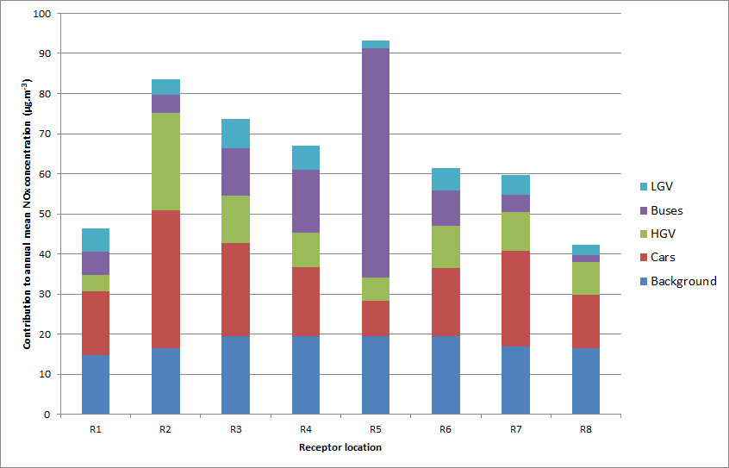

Figure 5: NOx Emissions by source and vehicle type (expressed as %) Paisley AQMA

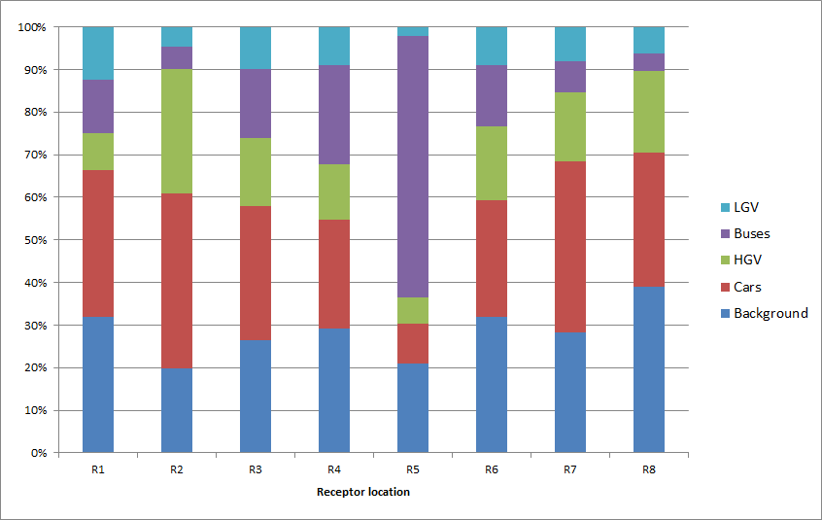

**PM10**

With respect to concentrations of PM10, background sources were the most significant contributors to local concentrations. The percentage contribution of background sources varied between 70.1% and 83% dependant on receptor location with PM10 from local road sources making up the remaining percentage. Of the local road sources, cars were the dominate source, contributing between 13.3% and 21.1% at seven of the eight receptor locations with buses identified as the main source at Receptor 5 (Smithhills Street).

Table 3: PM10 Emissions by source and vehicle type (µg.m-3) Paisley AQMA

| **Receptor location** | **Total PM10** | **Background** | **Road PM10** | **Cars** | **HGV** | **Buses** | **LGV** |
| --- | --- | --- | --- | --- | --- | --- | --- |
| R1 | 14.7 | 11.8 | 2.9 | 2.0 | 0.2 | 0.2 | 0.5 |
| R2 | 17.5 | 12.3 | 5.2 | 3.7 | 1.0 | 0.2 | 0.3 |
| R3 | 17.6 | 13.0 | 4.6 | 2.8 | 0.6 | 0.5 | 0.6 |
| R4 | 16.5 | 13.0 | 3.4 | 1.9 | 0.4 | 0.6 | 0.5 |
| R5 | 15.7 | 13.0 | 2.7 | 0.7 | 0.2 | 1.7 | 0.1 |
| R6 | 16.2 | 13.0 | 3.2 | 1.9 | 0.5 | 0.3 | 0.5 |
| R7 | 16.1 | 12.4 | 3.8 | 2.7 | 0.5 | 0.2 | 0.4 |
| R8 | 14.8 | 12.3 | 2.5 | 1.7 | 0.4 | 0.1 | 0.2 |

Table 4: PM10 Emissions by source and vehicle type (% of total PM10) Paisley AQMA

| **Receptor location** | **Total PM10** | **Background** | **Road PM10** | **Cars** | **HGV** | **Buses** | **LGV** |
| --- | --- | --- | --- | --- | --- | --- | --- |
| R1 | 100.0% | 80.3% | 19.7% | 13.3% | 1.4% | 1.6% | 3.4% |
| R2 | 100.0% | 70.1% | 29.9% | 21.1% | 5.7% | 1.2% | 1.9% |
| R3 | 100.0% | 74.0% | 26.0% | 16.0% | 3.5% | 3.1% | 3.6% |
| R4 | 100.0% | 79.2% | 20.8% | 11.8% | 2.4% | 3.6% | 3.1% |
| R5 | 100.0% | 82.8% | 17.2% | 4.7% | 1.2% | 10.6% | 0.7% |
| R6 | 100.0% | 80.4% | 19.6% | 11.9% | 2.9% | 1.9% | 2.9% |
| R7 | 100.0% | 76.6% | 23.4% | 16.5% | 2.9% | 1.4% | 2.6% |
| R8 | 100.0% | 83.3% | 16.7% | 11.7% | 2.9% | 0.6% | 1.6% |

Figure 6: PM10 Emissions by source and vehicle type (expressed in µg.m-3) Paisley AQMA

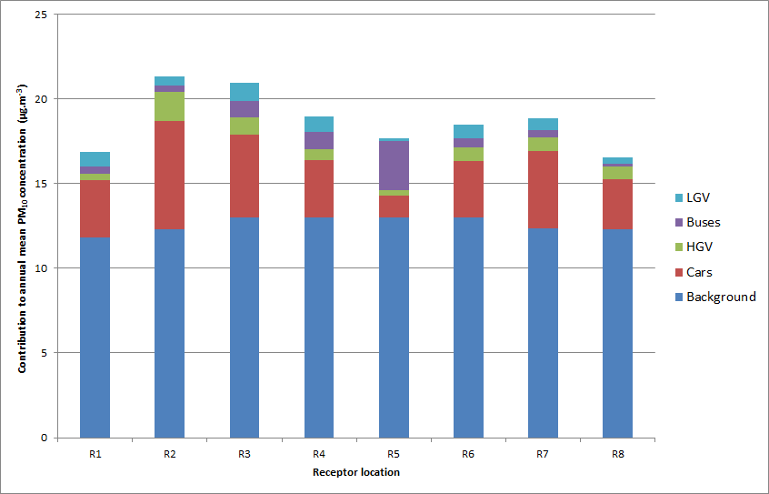

Figure 7: PM10 Emissions by source and vehicle type (expressed as %) Paisley AQMA

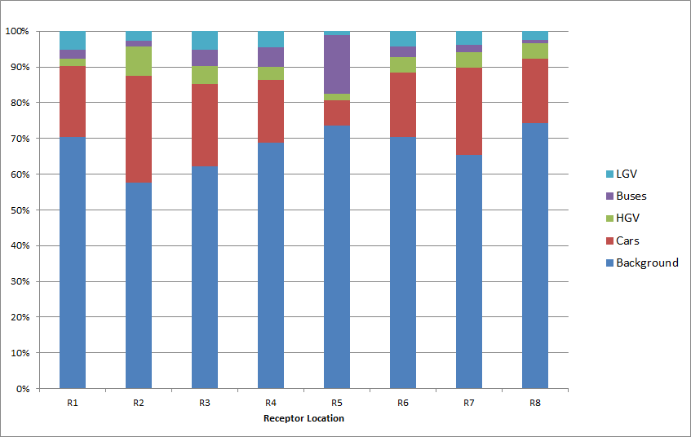

### Johnstone High Street Air Quality Management Area

A Detailed Assessment of Johnstone High Street was undertaken in 2015 including a source apportionment analysis of road traffic emissions. The source apportionment results are summarised below however, for a comprehensive understanding of the study, please refer to the original report *Detailed Assessment of Air Quality – High Street, Johnstone* which can be found on the council’s air quality web page http://www.renfrewshire.gov.uk/airquality

**NOx**

The findings from the study indicated that the main source of NOx at the selected receptor locations were local road traffic sources. The percentage contribution of road traffic sources varied between 88.5% and 90.5% dependant on location with background NOx concentrations accounting for the remaining proportion. Of the local traffic sources, buses were identified as the dominant source at all of the receptor locations contributing between 50.4% and 51.8% of NOx.The proportion of NOx (and PM10) emissions from HGV and LGV movements is relatively low when compared to other vehicle types at all receptor locations.

Action plan measures targeted at reducing emissions from buses will therefore likely help reduce NO2 (and PM10) concentrations within the Air Quality Management Area. In addition the locations where the highest pollutant concentrations are measured and modelled are within high sided street canyon topography and at locations where traffic is known to be regularly slow moving and congested at traffic lights. Measures aimed at improving traffic flow at these locations will therefore help to reduce vehicle emissions and concentrations.

Table 5: NOx Emissions by source and vehicle type (µg.m-3) Johnstone AQMA

|  |  |  |  |  |  |  |  |
| --- | --- | --- | --- | --- | --- | --- | --- |
| **Receptor location** | **Total NOx** | **Background** | **Road NOx** | **Cars** | **HGV** | **Buses** | **LGV** |
| High St 3 | 174.6 | 18.6 | 156.0 | 46.0 | 16.1 | 89.2 | 4.7 |
| High St 4 | 196.7 | 18.6 | 178.0 | 53.8 | 17.5 | 101.2 | 5.6 |
| High St 5 | 192.0 | 18.6 | 173.3 | 51.0 | 17.8 | 99.4 | 5.2 |
| High St 11 | 161.6 | 18.6 | 143.0 | 43.2 | 14.0 | 81.4 | 4.5 |
| High St 12 | 163.4 | 18.6 | 144.8 | 43.8 | 14.2 | 82.4 | 4.5 |

Table 6: NOx Emissions by source and vehicle type (% of total NOx) Johnstone AQMA

|  |  |  |  |  |  |  |  |
| --- | --- | --- | --- | --- | --- | --- | --- |
| **Receptor location** | **Total NOx** | **Background** | **Road NOx** | **Cars** | **HGV** | **Buses** | **LGV** |
| High St 3 | 100% | 10.7% | 89.3% | 26.3% | 9.2% | 51.1% | 2.7% |
| High St 4 | 100% | 9.5% | 90.5% | 27.3% | 8.9% | 51.5% | 2.8% |
| High St 5 | 100% | 9.7% | 90.3% | 26.6% | 9.3% | 51.8% | 2.7% |
| High St 11 | 100% | 11.5% | 88.5% | 26.7% | 8.6% | 50.4% | 2.8% |
| High St 12 | 100% | 11.4% | 88.6% | 26.8% | 8.7% | 50.4% | 2.8% |

Figure 8: NOx Emissions by source and vehicle type (expressed in µg.m-3) Johnstone AQMA

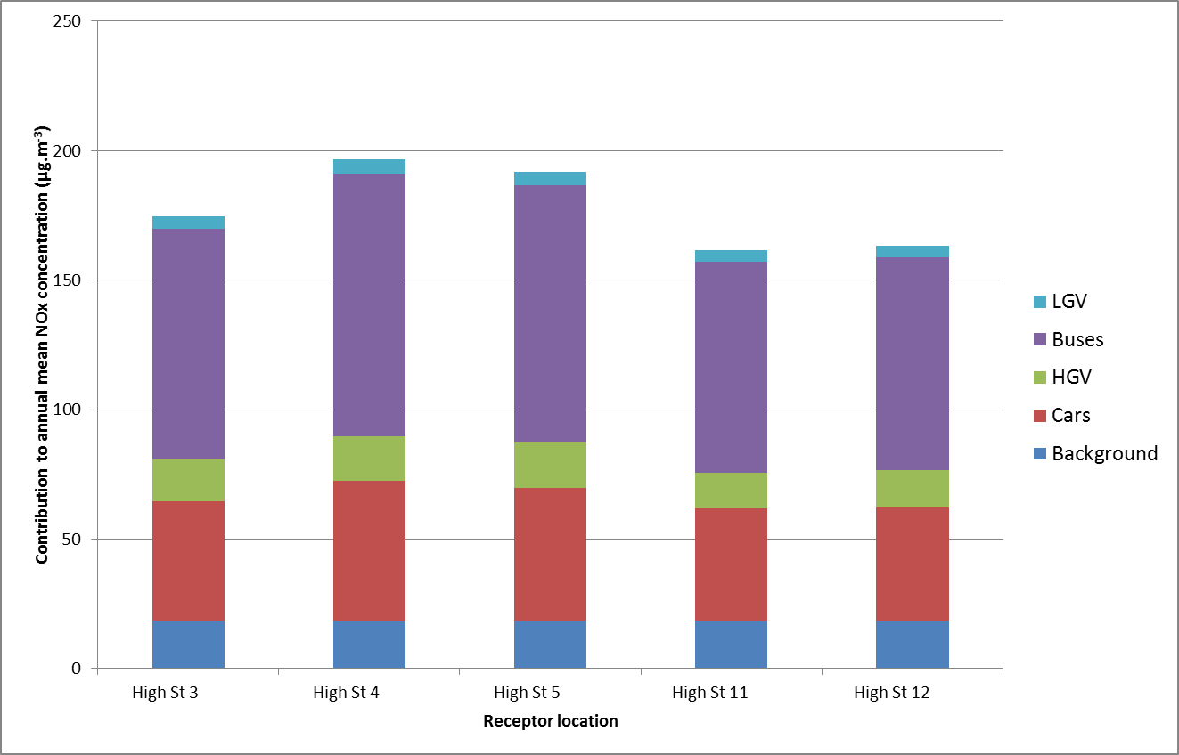

Figure 9: NOx Emissions by source and vehicle type (expressed as %) Johnstone AQMA

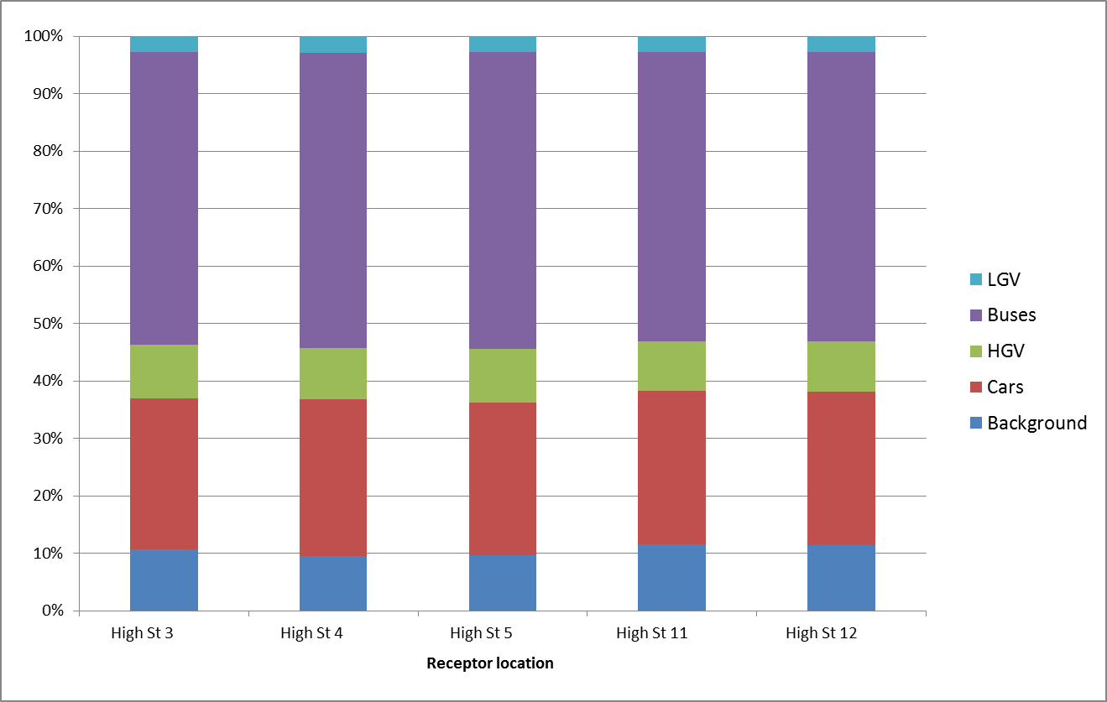

**PM10**

With respect to PM10, background sources were the most significant contributors to local concentrations. The percentage contribution of background sources varied between 62% and 66.8% dependant on receptor location with PM10 from local road sources accounting for the remaining proportion. Of the local road sources, buses contributed slightly more than cars as can be seen in the tables below.

Table 7: PM10 Emissions by source and vehicle type (µg.m-3) Johnstone AQMA

|  |  |  |  |  |  |  |  |
| --- | --- | --- | --- | --- | --- | --- | --- |
| **Receptor location** | **Total PM10** | **Background** | **Road PM10** | **Cars** | **HGV** | **Buses** | **LGV** |
| High St 3 | 22.4 | 14.8 | 7.5 | 3.2 | 0.4 | 3.7 | 0.2 |
| High St 4 | 23.9 | 14.8 | 9.1 | 3.8 | 0.5 | 4.5 | 0.3 |
| High St 5 | 23.0 | 14.8 | 8.2 | 3.4 | 0.5 | 4.0 | 0.3 |
| High St 11 | 22.2 | 14.8 | 7.4 | 3.1 | 0.4 | 3.6 | 0.2 |
| High St 12 | 22.3 | 14.8 | 7.5 | 3.2 | 0.4 | 3.7 | 0.2 |

Table 8: PM10 Emissions by source and vehicle type (% of total PM10) Johnstone AQMA

|  |  |  |  |  |  |  |  |
| --- | --- | --- | --- | --- | --- | --- | --- |
| **Receptor location** | **Total PM10** | **Background** | **Road PM10** | **Cars** | **HGV** | **Buses** | **LGV** |
| High St 3 | 100% | 66.3% | 33.7% | 14.1% | 1.9% | 16.6% | 1.1% |
| High St 4 | 100% | 62.0% | 38.0% | 16.0% | 2.1% | 18.7% | 1.2% |
| High St 5 | 100% | 64.5% | 35.5% | 14.8% | 2.0% | 17.5% | 1.2% |
| High St 11 | 100% | 66.8% | 33.2% | 14.0% | 1.8% | 16.4% | 1.1% |
| High St 12 | 100% | 66.5% | 33.5% | 14.1% | 1.8% | 16.5% | 1.1% |

Figure 10: PM10 Emissions by source and vehicle type (expressed in µg.m-3) Johnstone AQMA

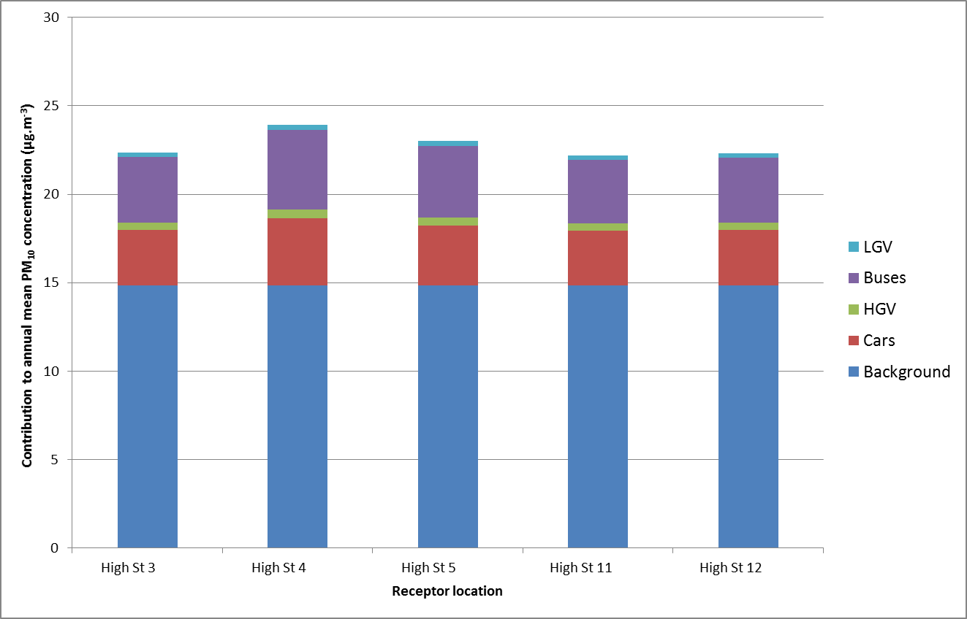

Figure 11: PM10 Emissions by source and vehicle type (expressed as %) Johnstone AQMA

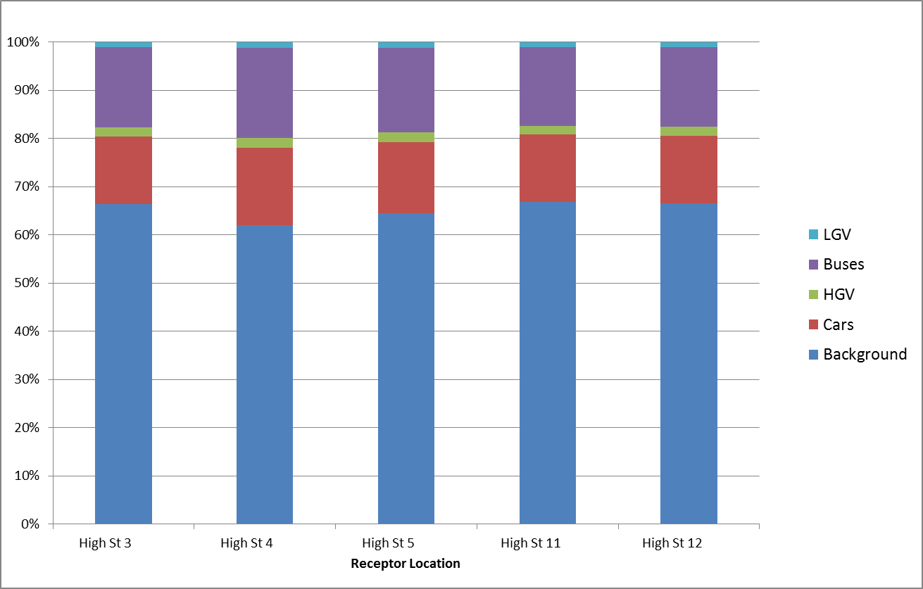

An additional study was commissioned by the Council to assist with the production of this Action Plan. This report, entitled *Air Quality Action Plan Support*, is described in more detail in section 3.4.2 but includes more up to date and detailed analysis of traffic composition and potential emission reduction scenarios specifically within High St Johnstone. The full report can be found in appendix G.

### Renfrew Town Centre Air Quality Management Area

A Detailed Assessment of Renfrew Town Centre was undertaken in 2015 including a source apportionment analysis of road traffic emissions. The source apportionment results are summarised below however, for a comprehensive understanding of the study, please refer to the original report *Detailed Assessment of Air Quality – Renfrew Town Centre* which can be found on the council’s air quality page http://www.renfrewshire.gov.uk/airquality

**NOx**

The findings from the study indicated that the main source of NOx at the selected receptor locations were local road traffic sources. The percentage contribution of road traffic sources varied between 72.1% and 86.5% dependant on receptor location with background NOx concentrations accounting for the remaining proportion.Of the local traffic sources, the dominant source was variable dependant on receptor location. For example the proportion of road NOx from buses was greater on Paisley Road and Hairst St but emissions from cars were the most dominant contributor on Inchinnan Rd.

The locations where the highest pollutant concentrations were measured and modelled are at the section of Inchinnan Road approaching the traffic lights at the main junction with Paisley Road and Hairst Street where traffic will regularly be slow moving and idling at the traffic lights. The high concentrations here also indicated that the one sided street canyon topography from the tenement properties at Nos. 1 to 19 Inchinnan Road, is possibly limiting dispersion of air pollutants. Measures aimed at improving traffic flow at these locations will therefore help to reduce vehicle emissions and concentrations.

Table 9: NOx Emissions by source and vehicle type (µg.m-3) Renfrew AQMA

|  |  |  |  |  |  |  |  |
| --- | --- | --- | --- | --- | --- | --- | --- |
| **Receptor location** | **Total NOx** | **Background** | **Road NOx** | **Cars** | **HGV** | **Buses** | **LGV** |
| R1 (5 Paisley Rd) | 71.9 | 20.1 | 51.8 | 15.4 | 7.5 | 23.1 | 5.8 |
| R2 (14d Paisley Rd) | 86.1 | 20.1 | 66.1 | 19.3 | 9.8 | 29.5 | 7.4 |
| R3 (1-5 Inchinnan Rd) | 97.1 | 20.1 | 77.1 | 26.3 | 15.7 | 28.7 | 6.3 |
| R4 (15 Inchinnan Rd) | 148.6 | 20.1 | 128.5 | 61.9 | 41.5 | 16.9 | 8.2 |
| R5 (2 Inchinnan Rd) | 122.1 | 20.1 | 102.0 | 48.9 | 32.5 | 14.3 | 6.4 |
| R6 (5-11 Hairst St) | 73.9 | 20.1 | 53.9 | 19.3 | 5.8 | 24.4 | 4.4 |
| R7 (4 Hairst St) | 75.0 | 20.1 | 54.9 | 20.0 | 6.1 | 24.4 | 4.5 |
| R8 (12 Inchinnan Rd) | 75.3 | 20.1 | 55.2 | 29.5 | 16.7 | 5.3 | 3.7 |

Table 10: NOx Emissions by source and vehicle type (% of total NOx) Renfrew AQMA

|  |  |  |  |  |  |  |  |
| --- | --- | --- | --- | --- | --- | --- | --- |
| **Receptor location** | **Total NOx** | **Background** | **Road NOx** | **Cars** | **HGV** | **Buses** | **LGV** |
| R1 (5 Paisley Rd) | 100% | 27.9% | 72.1% | 21.4% | 10.5% | 32.1% | 8.1% |
| R2 (14d Paisley Rd) | 100% | 23.3% | 76.7% | 22.4% | 11.4% | 34.3% | 8.6% |
| R3 (1-5 Inchinnan Rd) | 100% | 20.7% | 79.3% | 27.1% | 16.2% | 29.6% | 6.5% |
| R4 (15 Inchinnan Rd) | 100% | 13.5% | 86.5% | 41.7% | 27.9% | 11.4% | 5.5% |
| R5 (2 Inchinnan Rd) | 100% | 16.4% | 83.6% | 40.0% | 26.6% | 11.7% | 5.3% |
| R6 (5-11 Hairst St) | 100% | 27.1% | 72.9% | 26.1% | 7.9% | 33.0% | 5.9% |
| R7 (4 Hairst St) | 100% | 26.8% | 73.2% | 26.6% | 8.2% | 32.5% | 6.0% |
| R8 (12 Inchinnan Rd) | 100% | 26.7% | 73.3% | 39.1% | 22.2% | 7.1% | 5.0% |

Figure 12: NOx Emissions by source and vehicle type (expressed in µg.m-3) Renfrew AQMA

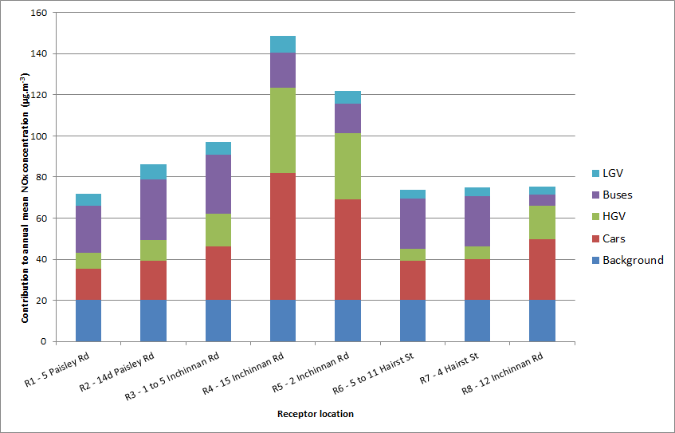

Figure 13: NOx Emissions by source and vehicle type (expressed as %) Renfrew AQMA

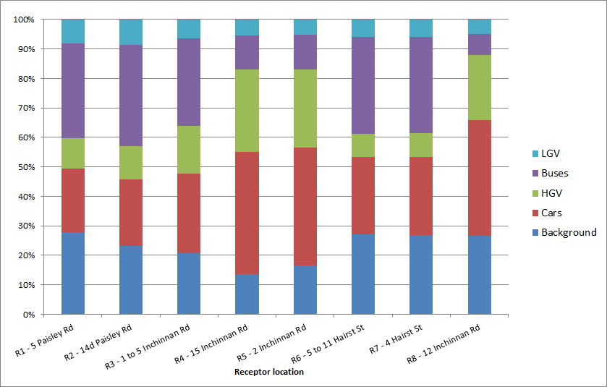

**PM10**

With respect to concentrations of PM10, background sources were the most significant contributors to local concentrations. The percentage contribution of background sources varied between 80.9% and 85.7% dependant on receptor location with PM10 from local road sources accounting for the remaining proportion. Of the local road sources, cars were the most significant contributor as can be seen in the tables below.

Table 11: PM10 Emissions by source and vehicle type (µg.m-3) Renfrew AQMA

| **Receptor location** | **Total PM10** | **Background** | **Road PM10** | **Cars** | **HGV** | **Buses** | **LGV** |
| --- | --- | --- | --- | --- | --- | --- | --- |
| R1 (5 Paisley Rd) | 15.9 | 13.4 | 2.5 | 1.2 | 0.3 | 0.7 | 0.3 |
| R2 (14d Paisley Rd) | 16.5 | 13.4 | 3.2 | 1.5 | 0.3 | 0.9 | 0.4 |
| R3 (1-5 Inchinnan Rd) | 16.4 | 13.4 | 3.0 | 1.6 | 0.4 | 0.6 | 0.3 |
| R4 (15 Inchinnan Rd) | 16.3 | 13.4 | 2.9 | 1.4 | 1.0 | 0.3 | 0.2 |
| R5 (2 Inchinnan Rd) | 15.6 | 13.4 | 2.2 | 1.0 | 0.8 | 0.2 | 0.1 |
| R6 (5-11 Hairst St) | 16.3 | 13.4 | 2.9 | 1.7 | 0.2 | 0.8 | 0.3 |
| R7 (4 Hairst St) | 16.4 | 13.4 | 3.0 | 1.7 | 0.2 | 0.8 | 0.3 |
| R8 (12 Inchinnan Rd) | 16.5 | 13.4 | 3.1 | 2.2 | 0.5 | 0.1 | 0.2 |

Table 12: PM10 Emissions by source and vehicle type (% of total NOx) Renfrew AQMA

|  |  |  |  |  |  |  |  |
| --- | --- | --- | --- | --- | --- | --- | --- |
| **Receptor location** | **Total PM10** | **Background** | **Road PM10** | **Cars** | **HGV** | **Buses** | **LGV** |
| R1 (5 Paisley Rd) | 100% | 84.1% | 15.9% | 7.7% | 1.7% | 4.5% | 2.0% |
| R2 (14d Paisley Rd) | 100% | 80.9% | 19.1% | 9.2% | 2.0% | 5.4% | 2.5% |
| R3 (1-5 Inchinnan Rd) | 100% | 81.6% | 18.4% | 10.1% | 2.5% | 3.9% | 2.0% |
| R4 (15 Inchinnan Rd) | 100% | 82.1% | 17.9% | 8.6% | 6.4% | 1.7% | 1.2% |
| R5 (2 Inchinnan Rd) | 100% | 85.7% | 14.3% | 6.6% | 5.3% | 1.5% | 0.9% |
| R6 (5-11 Hairst St) | 100% | 81.9% | 18.1% | 10.2% | 1.4% | 5.0% | 1.5% |
| R7 (4 Hairst St) | 100% | 81.6% | 18.4% | 10.4% | 1.4% | 5.1% | 1.6% |
| R8 (12 Inchinnan Rd) | 100% | 81.2% | 18.8% | 13.5% | 3.2% | 0.8% | 1.2% |

Figure 14: PM10 Emissions by source and vehicle type (expressed in µg.m-3) Renfrew AQMA

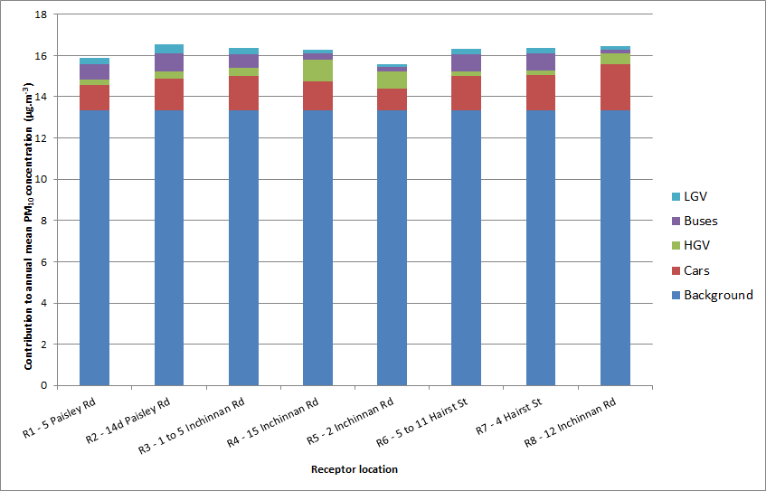

Figure 15: PM10 Emissions by source and vehicle type (expressed as %) Renfrew AQMA

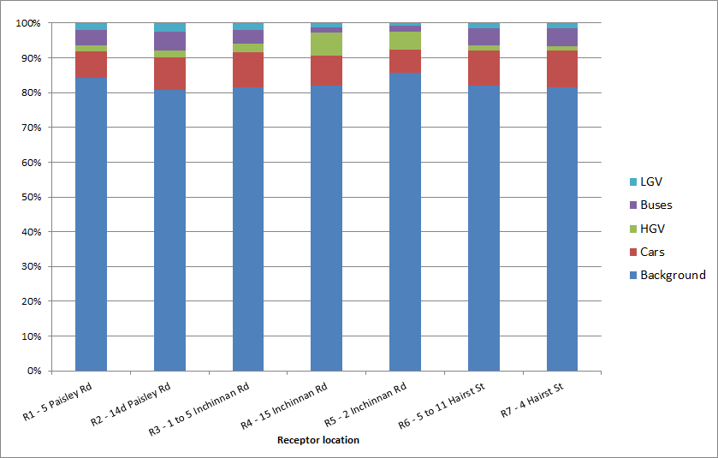

### Summary

The source apportionment studies across the three Air Quality Management Areas confirmed that, with regards to NOx emissions, the dominant source at all receptor locations are local road transport sources with different vehicle types contributing to variable extents dependant on location. Conversely, with regards to PM10 emissions, background sources are the most dominant contributor.

On the basis of these findings, effective local traffic management measures may assist in reducing NOx emissions in the local Air Quality Management Areas. This Action Plan therefore considers measures that will target reductions in emissions from road traffic in general. However with regards to PM10, national measures aimed at reducing background concentrations of particulate matter would be more effective.

## Required Reduction in Emissions

### Required Reduction in Emissions

As part of the action planning process local authorities require to identify the reduction in pollutant emissions required to attain the objectives within their Air Quality Management Areas to determine the scale of effort required within the Action Plan.

As previously detailed, the Council’s most recent Local Air Quality Management report, the 2018 Annual Progress Report, identified exceedances of the NO2 annual mean objective at two diffusion tube monitoring sites during 2017, one within the Renfrew Town Centre Air Quality Management Area and one within the Johnstone High Street Air Quality Management Area. There were no exceedances at any of the automatic monitoring sites.

The two diffusion tube locations which exceeded the NO2 annual mean objective level of 40 µg/m3 (after bias adjustment and distance correction) were located at:

* Renfrew (DT No. 8) - Inchinnan Rd, Renfrew (42.5 µg/m3)
* Johnstone (DT No. 59) - High St, Johnstone (40.6 µg/m3)

The emission reduction required at each of these locations to achieve the NO2 annual mean objective level of 40 µg/m3 is therefore:

* Renfrew (DT No. 8), Inchinnan Rd, Renfrew - 2.5 µg/m3 reduction required
* Johnstone (DT No. 59), High St, Johnstone - 0.6 µg/m3 reduction required.

Within the Paisley Town Centre Air Quality Management Area, there are now three years of consecutive monitoring data (2015, 2016 and 2017) with no exceedances. However, there remain some diffusion tube locations within Paisley where the annual mean NO2 concentration is close to the objective.

### Emission Reduction Modelling Studies

The Council is committed to continually improving the quality of air within Renfrewshire and will strive to achieve this with the implementation of the measures within this plan. Fundamental to this is ensuring action measures contained within this Action Plan are appropriate, effective and will achieve the required emissions reduction. Quantification of the air quality impact of proposed measures during the action planning process is therefore critical. Where possible, this was assessed through detailed modelling studies i.e. the City Deals Air Quality Assessments, the AECOM Air Quality Action Plan Support 2017 study and the Paisley Town Centre Air Quality Modelling Study 2015 but, where not feasible, a semi-quantitative assessment relying on a level of judgement from officers was undertaken.

With regards to the Paisley Town Centre Air Quality Management Area, an emissions reduction modelling study was undertaken in 2015 titled ‘*2015 Paisley Town Centre Air Quality Modelling Study’*. For the Johnstone High St Air Quality Management Area, a consultant was commissioned during 2017 to undertake a quantitative appraisal study, an aim of which was to use emission modelling to indicate the effects of proposed action measures on local air quality in Johnstone. The report titled ‘*Air Quality Action Plan Support’* is included within appendixG. With regards to the Renfrew Town Centre Air Quality Management Area, it was considered that the Clyde Waterfront & Renfrew Riverside (CWRR) City Deals project and construction of the Renfrew North Development Road will be the most significant measure for this Air Quality Management Area and therefore analysis of emission reductions from other measures was not appropriate at this time. Instead, a summary of the CWRR Air Quality Assessment detailing the proposed reduction in air quality levels as a result of the development is detailed below.

Conclusions from the emissions reductions studies were used to support the selection and implementation of the action measures contained within this Action Plan. A summary of these studies is provided below however reference should be made to the original reports for a comprehensive understanding of the conclusions. Copies of the reports can be requested from the Council’s Communities, Housing and Planning Service.

**Paisley Town Centre Air Quality Modelling Study 2015**

By 2015 the majority of action measures within the Paisley Town Centre Air Quality Action Plan had been completed yet there remained exceedances of statutory air quality objectives based on 2014 data. An update and review of the Paisley Town Centre Air Quality Action Plan was required to identify new focussed and effective action plan measures. The 2015 Paisley Town Centre Air Quality Modelling Studywas commissioned by the Council to provide an updated modelling assessment and source apportionment of the town centre and to evaluate the potential emission reductions that would result from a range of traffic management scenarios.

The source apportionment results of the study are detailed within section 3.3. The modelling identified no exceedances of PM10 but identified potential exceedances of the annual mean NO2 objective at locations consistent with previous years’ monitoring data (Smithhills St and Causeyside St). A number of possible emission reduction scenarios were modelled to assess the effect on local air quality.

* Scenario 1 – reduction in bus emissions by restricting the Euro standard of buses operating within the Air Quality Management Area to a minimum Euro V standard (a Statutory Quality Bus Partnership Scheme was previously in place that required buses to be a minimum Euro III standard).
* Scenario 2 – reduction in congestion at busy junctions (modelled by increasing average speed at junctions by 10%); and
* Scenario 3 – a 10% and 20% reduction in the volume of traffic passing through the Air Quality Management Area.

The modelling results for the three scenarios indicated that each option would provide a reduction in annual mean NO2 (and PM10) concentrations.

For scenario 1 a reduction in annual mean concentrations of NO2 from the 2014 baseline ranged from 0.1ug.m-3 to 1.6ug.m-3. As expected, Smithhills St was predicted to have the greatest air quality benefit with this measure (this location is a main bus route within the town centre).

Table 13: Scenario 1 - Predicted 2014 annual mean NO2 concentrations at relevant receptors (µg.m-3)

|  |  |  |  |  |  |
| --- | --- | --- | --- | --- | --- |
| **Receptor** | **Location** | **2014 baseline NO2 annual mean** | **Scenario 1 NO2 annual mean** | **Change in µg.m-3 compared to the baseline** | **Percentage reduction in NO2 concentrations compared to the baseline** |
| R1 | 22 Maxwellton Street | 22.6 | 22.3 | 0.3 | 1.1 % |
| R2 | 63 Causeyside Street | 18.5 | 18.3 | 0.2 | 1.0 % |
| R3 | 11 Renfrew Road | 33.2 | 32.7 | 0.5 | 1.4 % |
| R4 | 6 Brick Lane | 34.6 | 34.0 | 0.6 | 1.6 % |
| R5 | 14 Smithhills Street | **44.5** | **42.9** | 1.6 | 3.6 % |
| R6 | 43 Gauze Street | 28.6 | 28.4 | 0.2 | 1.0 % |
| R7 | 1 Caledonia Street | 31.6 | 31.2 | 0.4 | 1.1 % |
| R8 | 36 Gordon Street | 21.7 | 21.5 | 0.2 | 0.5 % |
| R9 | 25 Lawn Street | 39.0 | 38.8 | 0.2 | 0.6 % |
| R10 | 72 Causeyside Street | 28.8 | 28.5 | 0.3 | 1.0 % |
| R11 | 80 Causeyside Street | **41.8** | **41.7** | 0.1 | 0.3 % |
| R12 | 67 Causeyside Street | **41.0** | **40.9** | 0.1 | 0.4 % |
| R13 | 20 Smithhills Street | 32.1 | 31.2 | 0.9 | 2.7 % |
| R14 | 3 Lawn Street | 36.4 | 36.2 | 0.2 | 0.7 % |

**Exceedances of statutory AQOs are highlighted in bold and pink.**

For scenario 2 a reduction in annual mean concentrations of NO2 concentrations again ranged from 0.1ug.m-3 to 1.6ug.m-3.

Table 14: Scenario 2 - Predicted 2014 annual mean NO2 concentrations at relevant receptors (µg.m-3)

| **Receptor** | **Location** | **2014 baseline NO2 annual mean** | **Scenario 2**  **NO2 annual mean** | **Change in µg.m-3 compared to the baseline** | **Percentage reduction in NO2 concentrations compared to the baseline** |
| --- | --- | --- | --- | --- | --- |
| R1 | 22 Maxwellton Street | 22.6 | 21.9 | 0.7 | 3.0 % |
| R2 | 63 Causeyside Street | 18.5 | 18.1 | 0.4 | 2.4 % |
| R3 | 11 Renfrew Road | 33.2 | 31.9 | 1.3 | 3.9 % |
| R4 | 6 Brick Lane | 34.6 | 33.4 | 1.2 | 3.4 % |
| R5 | 14 Smithhills Street | **44.5** | **42.9** | 1.6 | 3.7 % |
| R6 | 43 Gauze Street | 28.6 | 28.1 | 0.5 | 1.8 % |
| R7 | 1 Caledonia Street | 31.6 | 31.2 | 0.4 | 1.1 % |
| R8 | 36 Gordon Street | 21.7 | 21.5 | 0.2 | 0.6 % |
| R9 | 25 Lawn Street | 39.0 | 38.3 | 0.7 | 1.7 % |
| R10 | 72 Causeyside Street | 28.8 | 28.2 | 0.6 | 2.2 % |
| R11 | 80 Causeyside Street | **41.8** | **41.7** | 0.1 | 0.3 % |
| R12 | 67 Causeyside Street | **41.0** | **40.8** | 0.2 | 0.5 % |
| R13 | 20 Smithhills Street | 32.1 | 31.1 | 1.0 | 3.0 % |
| R14 | 3 Lawn Street | 36.4 | 36.1 | 0.3 | 0.9 % |

**Exceedances of statutory AQOs are highlighted in bold and pink.**

For scenario 3, a 10% reduction in traffic volume resulted in a reduction in annual mean concentrations of NO2 concentrations ranging from 0.8ug.m-3 to 2.6ug.m-3. All receptor locations, with the exception of Smithhills St, were predicted to be below the objective level. By increasing the reduction in traffic volume to 20%, concentrations at Smithhills St are also below the objective level.

Table 15: Scenario 3 - Predicted 2014 annual mean NO2 concentrations at relevant receptors (µg.m-3)

| **Receptor** | **Location** | **2014 baseline** | **10% total flow reduction** | | **20% total flow reduction** | |
| --- | --- | --- | --- | --- | --- | --- |
| **Predicted NO2 annual mean -** | **Change in µg.m-3 compared to the baseline** | **Predicted NO2 annual mean -** | **Change in µg.m-3 compared to the baseline** |
| R1 | 22 Maxwellton Street | 22.6 | 21.4 | 1.2 | 20.2 | 2.4 |
| R2 | 63 Causeyside Street | 18.5 | 17.7 | 0.8 | 16.9 | 1.6 |
| R3 | 11 Renfrew Road | 33.2 | 31.3 | 1.9 | 29.4 | 3.8 |
| R4 | 6 Brick Lane | 34.6 | 32.7 | 2.0 | 30.7 | 3.9 |
| R5 | 14 Smithhills Street | **44.5** | **41.9** | 2.6 | 39.1 | 5.4 |
| R6 | 43 Gauze Street | 28.6 | 27.2 | 1.4 | 25.7 | 2.9 |
| R7 | 1 Caledonia Street | 31.6 | 29.8 | 1.8 | 27.9 | 3.7 |
| R8 | 36 Gordon Street | 21.7 | 20.6 | 1.1 | 19.6 | 2.1 |
| R9 | 25 Lawn Street | 39.0 | 36.8 | 2.2 | 34.5 | 4.5 |
| R10 | 72 Causeyside Street | 28.8 | 27.2 | 1.6 | 25.5 | 3.3 |
| R11 | 80 Causeyside Street | **41.8** | 39.3 | 2.5 | 36.6 | 5.2 |
| R12 | 67 Causeyside Street | **41.0** | 38.5 | 2.5 | 35.9 | 5.1 |
| R13 | 20 Smithhills Street | 32.1 | 30.3 | 1.8 | 28.5 | 3.6 |
| R14 | 3 Lawn Street | 36.4 | 34.4 | 2.0 | 32.3 | 4.1 |

**Exceedances of statutory AQOs are highlighted in bold and pink.**

Compliance with the NO2 annual mean objective based on 2014 data was only achievable at all locations by implementing the 20% reduction in traffic volume scenario. Whilst traffic restrictions could be considered within the Air Quality Management Area at certain locations, delivering a 20% reduction in traffic volume across the Air Quality Management Area is considered unlikely. Alternatively a combination of mitigation scenarios could be considered.

Whilst currently there have been no exceedances of statutory air quality levels within the Paisley Town Centre Air Quality Management Area for three consecutive years (2015, 2016 and 2017), this study provides useful information on the degree of intervention that is required to achieve improvements to air quality should there be future exceedances. The study has highlighted that, dependant on location and local traffic conditions, implementation of quite significant measures may result in only a small reduction in pollutant concentrations. This demonstrates the importance of accurate emissions reductions modelling to ensure that proposed measures are the most appropriate, feasible and cost effective.

**Air Quality Action Plan Support 2017 Study by AECOM**

A consultant was commissioned during development of this Action Plan to undertake an emissions modelling study to indicate the effects of proposed action measures on local air quality specifically within the Johnstone High Street Air Quality Management Area. Additional aims of the study were to understand the current air quality situation in Renfrewshire; provide a high level review of the expected impact of all proposed action measures contained within this Action Plan; appraise the proposed action measures with respect to the Scottish Government’s Cleaner Air for Scotland (CAFS) 2015 air quality strategy thematic objectives; and provide a robust evidence base against which the effects of proposed action measures can be tracked by proposing key performance indicators.

With regards to the emissions modelling study that was undertaken within the Johnstone High Street Air Quality Management Area, an Automatic Number Plate Recognition (ANPR) camera survey was conducted over a 24-hour period during August 2017 to determine the coarse composition of the vehicle fleet on Johnstone High St. Further analysis was performed to determine the detailed composition in terms of Euro emission standards. Emission rates and total emissions for each vehicle were derived using the Emission Factor Toolkit Version 7 (DEFRA, 2016). The objective for this study was to estimate, where possible, emissions for every vehicle passing each camera location. This approach was applied because it provided a higher level of emissions detail. The emissions data were then used as the basis to conduct dispersion modelling to determine air quality concentrations at selected receptors along Johnstone High Street. The ADMS-Roads dispersion modelling software (CERC, 2015) was used to consider and predict the impact of different modelling scenarios.

The pollutant of concern within the Johnstone Air Quality Management Area is NO2 and hence NOx emissions were the focus of the analysis. The three emission reduction scenarios modelled were:

* Scenario B - all buses were assumed to have achieved a minimum emission standard of Euro VI.
* Scenario C - all HGVs were assumed to have achieved a minimum emission standard of Euro V.
* Scenario D - all cars (diesel and petrol) were assumed to have achieved a minimum emission standard of Euro 5.

Modelled total adjusted annual mean (i.e. including background) NO2 concentrations at each diffusion tube monitoring location on Johnstone High St for each modelling scenario are given in Table 16 below.

Table 16: Predicted NO2 annual mean concentrations at each diffusion tube monitoring location for each modelling scenario (µg.m-3)

|  |  |  |  |  |  |  |  |
| --- | --- | --- | --- | --- | --- | --- | --- |
|  | Adjusted Annual Mean NO2 ­Concentration (µg/m3) for each scenario | | | | | | |
| Site ID | **A**  **Base** | **B**  **All buses minimum Euro VI** | **% Reduction** | **C**  **All HGVs minimum Euro V** | **% Reduction** | **D**  **All cars minimum Euro V** | **% Reduction** | |
| 20 | 31.6 | 29.7 | 6.0 | 31.4 | 0.6 | 31.2 | 1.3 | |
| 59 | 30.3 | 28.7 | 5.3 | 30.1 | 0.7 | 30.0 | 1.0 | |
| 72 | 27.6 | 26.1 | 5.4 | 27.4 | 0.7 | 27.2 | 1.4 | |
| 85 | 37.4 | 34.9 | 6.7 | 37.1 | 0.8 | 36.9 | 1.3 | |
| 86 | 29.5 | 27.2 | 7.8 | 29.2 | 1.0 | 29.1 | 1.4 | |
| 87 | 16.8 | 16.3 | 3.0 | 16.8 | 0.0 | 16.7 | 0.6 | |

***Note: Site ID refers to the NO2 diffusion tube locations modelled.***

The results indicate that each option would provide a reduction in total NO2 emissions to varying degrees but with the greatest reduction resulting from scenario B, the upgrading of all buses to Euro VI emission standard. This resulted in a reduction of total daily NOX emissions by up to 12.4% and a reduction in modelled adjusted annual mean NO2 contributions at diffusion tube receptor locations by between 3%-7.8% as compared to the baseline scenario. This relatively large change, in comparison to the other scenarios, is due to the fact that the current bus fleet is old compared to the national average (according to the National Atmospheric Emissions Inventory) and that the Euro VI NOx emissions standard is approximately 8.5 times lower than Euro IV.

Scenario C, converting HGVs to Euro V, was the least effective scenario whereby modelled adjusted annual mean NO2 concentrations reduced by only up to 1% as compared to the baseline scenario. This relatively minor change is due to the fact that the majority of HGVs are already of Euro V and Euro VI standard combined with the fact that any upgrade of pre Euro V to Euro V standard would not lead to particularly large gains as there is not a significant difference in the NOx emissions standards.

The air quality benefits of converting all cars to a minimum Euro 5 emission standard, scenario D, is also relatively marginal with reductions in modelled adjusted annual mean concentrations of NO2 between 0.6-1.4% as compared to the baseline scenario. The main reason for this is because the majority of light vehicles observed on the High St are already a minimum Euro 5 standard. A restriction of diesel cars to a minimum Euro 6 standard would be required in order to achieve any considerable improvement in emissions.

The limited gains for the HGV and car scenarios are a result of the underlying emissions standards of the current representative fleets. The ANPR study which provides a very robust account of vehicle characteristics shows that the majority of HGVs are already Euro V or above and any measures to restrict older more polluting vehicle types entering onto the High Street would be impractical, in terms of improving air quality, especially given the numbers observed. The study therefore confirms that little would be gained by Renfrewshire pursuing policies which restrict light and heavy goods vehicles entering the area based on emissions standards alone via, for example, implementation of a Low Emission Zone.

Interventions around bus operations are therefore considered the most effective way of reducing emissions in the short term and improving air quality to levels below air quality objectives in the future. This is consistent with the findings of the 2015 Detailed Assessment of Johnstone High Street described in Section 3.2.2 which included a source apportionment analysis of road traffic emissions. The findings from this 2015 study indicated that the main source of NOx at the selected receptor locations were local road traffic sources; buses being identified as the dominant source at all of the receptor locations.

In terms of the required emission reduction, the location of exceedance within the Johnstone High Street Air Quality Management Area is the Johnstone diffusion tube No. 59. This is described as Site ID 59 in Table 16 above. An exceedance of 40.6 µg/m3 was measured at this site during 2017. The emissions reductions at this diffusion tube location as a result of implementing each of the scenarios is as follows; Scenario B - 1.6ug/m3, Scenario C – 0.2ug/m3, Scenario D - 0.3ug/m3. Scenario B, the upgrading of all buses to Euro VI emission standard therefore provides the most significant reduction in pollutant levels and is the only measure sufficient to bring levels to below the statutory objective level of 40 µg/m3.

For a comprehensive understanding of the conclusions of this study please refer to the original report, *Air Quality Action Plan Support,* which is included within appendix G.

**Clyde Waterfront & Renfrew Riverside (CWRR) City Deals**

The Clyde Waterfront & Renfrew Riverside (CWRR) City Deals project and construction of the Renfrew North Development Road will be the most significant measure in terms of emissions reduction for this Air Quality Management Area.

Construction of the Renfrew North Development Road will provide an alternative route for traffic which avoids Renfrew town centre. This will reduce the volume of traffic going through the Air Quality Management Area and will optimise the operation of the local road network resulting in improved traffic flows in and around the town centre and improved journey time reliability.

An Environmental Impact Assessment was submitted as part of the planning application for the proposed CWRR development which included air quality and traffic impact assessments. While the findings predict an increase in traffic at certain locations within Renfrew as development takes place, in terms of the Renfrew Town Centre Air Quality Management Area, construction of the Renfrew North Development Road will result in a reduction in traffic and therefore a positive impact on air quality levels on certain roads once the development is in operation. This is particularly evident on Inchinnan Road, the location of the current exceedance of the NO2 annual mean objective within Renfrew. The air quality assessment predicts that there will be a reduction of 3ug.m-3 at this diffusion tube location based on a comparison between the 2020 baseline without development scenario versus the 2020 baseline with development scenario. The air quality assessment concludes that local air quality pollutant concentrations at sensitive receptors due to changes in traffic flows associated with operation of the proposed development will be below statutory air quality objectives at all locations. This is also the case when considering the CWRR project cumulatively with the Glasgow Airport Investment Area project. Site works for the CWRR development are expected to commence January 2020 and be complete by Summer 2022. It would therefore be anticipated that an improvement to air quality levels would be expected following this completion date.

**Summary**

The Council’s 2018 Annual Progress Report identified two diffusion tube locations within Renfrewshire which exceeded the NO2 annual mean objective level of 40 µg/m3 during 2017(after bias adjustment and distance correction). There were located at:

* Renfrew (DT No. 8) - Inchinnan Rd, Renfrew (42.5 µg/m3)
* Johnstone (DT No. 59) - High St, Johnstone (40.6 µg/m3)

The emissions reduction required at each of these locations to achieve the NO2 annual mean objective level of 40 µg/m3 is therefore:

* Renfrew (DT No. 8), Inchinnan Rd, Renfrew - 2.5 µg/m3 reduction required
* Johnstone (DT No. 59), High St, Johnstone - 0.6 µg/m3 reduction required.

With regards to the Renfrew exceedance, the air quality assessment submitted with the CWRR City Deals planning application predicted that the development will result in a reduction of 3ug.m-3 at the diffusion tube location (DT No. 8) where the exceedance of 42.5 µg/m3 was identified, based on a comparison between the 2020 baseline without development scenario versus the 2020 baseline with development scenario.

With regards to the Johnstone exceedance, the Air Quality Action Plan Support 2017 Study by AECOM identified interventions around bus operations as the most effective way of reducing emissions in the short term and improving air quality to levels below air quality objectives. The study looked at various emissions reductions scenarios with each option providing a reduction in total NO2 emissions to varying degrees but with the greatest reduction resulting from upgrading all buses to Euro VI emission standard. Implementing this measure would result in a reduction of 1.6ug/m3 at the diffusion tube location (DT No. 59) where the exceedance of 40.6 µg/m3 was identified.

Implementation of both measures would therefore achieve a reduction in NO2 emissions to below the statutory annual mean objective level of 40 µg/m3 at both of these locations.

## Key Priorities

Based on the information contained within this chapter and the conclusions that can be drawn from this, we have prioritised several areas for action as detailed below.

* Priority 1 - promotion of low emission transport within Renfrewshire by for example encouraging bus operators to use cleaner vehicles within certain Air Quality Management Area routes, in particular, Johnstone High St.
* Priority 2 - infrastructure improvements via progression with the City Deals project and in particular the Clyde Waterfront & Renfrew Riverside project. The construction of the Renfrew North Development Road as part of this project will provide an alternative route for traffic avoiding Renfrew Town Centre thus optimising the operation of the local road network and reducing congestion.
* Priority 3 - tackling emissions from congestion via various means e.g. improvements to our Urban Traffic Control system and development of town centre transport strategies. This is particularly relevant for the Paisley and Johnstone Air Quality Management Areas.

# 4. Development and Implementation of Renfrewshire’s Air Quality Action Plan



## Steering Group

A steering group was established at the start of the action planning process to take forward the development of the Action Plan. The remit of the group was to identify effective, feasible and proportionate action measures for inclusion within the Action Plan and to ensure implementation and delivery of these.

The group was composed mainly of Renfrewshire Council officers from those Services with an interest or potential impact on air quality and who may have an influence on the action measures being considered. Members included officers from Communities, Housing and Planning Services (Environmental Improvements, Development Management, City Deals and Policy & Regeneration), Environment & Infrastructure (Transport and Roads) and Finance and Resources (Energy Asset). Officers provided guidance in their respective areas of expertise to ensure evaluation and selection of the most appropriate measures. Communities, Housing and Planning Services Environmental Improvements section have taken lead responsibility for production of the plan.

The first steering group meeting was held in October 2016 with subsequent meetings carried forward through 2017. The meetings included presentations and agendas covering an overview of the action planning process, the air quality issues within Renfrewshire, consideration of potential action measures and those deemed insufficient, identification of priorities, action measure performance indicators and potential pollution reduction targets. Separate individual meetings between Environmental Improvements and officers from each Service were also conducted in order to discuss measures in more depth.

With regards to action measures such as improvements to the bus fleet and provision of real time bus information, engagement with external organisations is necessary e.g. local bus companies, SPT. The input and agreement from these organisations will be fundamental in successfully implementing the relevant measures.

Government guidance emphasises the importance of ensuring that transport planners are engaged in the action planning process to ensure the Action Plan is integrated with Local Transport Plans in a successful manner. This was particularly important in Renfrewshire given that road emissions were attributable to the majority of previous exceedances. As such, officers from our Roads Service worked in close partnership with Environmental Improvements during the development of the plan including managers and officers specialising in Urban Traffic Control Systems, transport planning, policy, active travel, infrastructure and regeneration.

The overall steering group process consisted of a gradual refinement of possible action measures to those contained within this Action Plan which are considered the most effective, feasible and cost-effective measures for us to pursue.

## Consultation and Stakeholder Engagement

Local Authorities must consult on the preparation of their Air Quality Action Plans. The statutory consultees that must be consulted are detailed in Table 17.

Table 17: Consultation Undertaken

|  |  |
| --- | --- |
| **Yes/No** | **Consultee** |
| Yes | Scottish Government |
| Yes | Scottish Environment Protection Agency |
| Yes | all neighbouring local authorities – Glasgow City Council, West Dunbartonshire Council, East Renfrewshire Council, North Ayrshire Council & Inverclyde Council |
| N/A | any National Park authority within or adjacent to the local authority area |
| Yes | other public authorities as appropriate – SPT, Transport Scotland, NHS Greater Glasgow and Clyde |
| Yes | bodies representing local business interests and other organisations as appropriate – Renfrewshire Chamber of Commerce, Freight Transport Association, Community Councils |

Development of an initial draft Renfrewshire Air Quality Action Plan was led by the Environmental Improvements section within Communities, Housing and Planning Services and involved internal steering group meetings with contributions from several Council Services. A range of measures aimed at improving air quality within Renfrewshire were identified and were included within the draft Action Plan which was presented to, and approved by, the Infrastructure, Land and Environment Policy Board on 24 January 2018.

The Council subsequently undertook a statutory consultation process in accordance with the Environment Act 1995. The draft Action Plan was submitted to statutory consultees for their consideration and comment including the Scottish Government, SEPA and neighbouring Local Authorities. A wider consultation incorporated other relevant public authorities e.g. SPT, NHS Greater Glasgow and Clyde and Transport Scotland; bodies representing local business interests e.g. Renfrewshire Chamber of Commerce and the Freight Transport Association; and the local community via community councils and directly with members of the public. Consultation with statutory consultees was undertaken throughout 2018 and a further 6-week public consultation was undertaken at the end of 2018 and beginning of 2019. The public consultation included publication of details of the draft Action Plan on our website and distribution of leaflets to public places within each of the Air Quality Management Areas e.g. Council offices, libraries, GP surgeries, sports venues, town halls.

Comments were received from statutory consultees including the Scottish Government, SEPA, neighbouring local authorities and SPT, in addition to comments from members of the public. Comments are positive with the Scottish Government and SEPA both agreeing with the objectives set out within the Action Plan. The Action Plan is described as well presented with significant levels of detail which provides for an effective Air Quality Action Plan. In particular, the Scottish Government have advised that they consider the Council has produced an Air Quality Action Plan with a strong basis for measures that can expect to deliver and meet air quality objectives in the near future.

SPT’s response welcomed the proposed action measures and stated that attractive, effective and efficient active and public transport connections are key to addressing the impacts of road traffic on air pollution levels. It was acknowledged that SPT and the Council will work together on some of the proposed measures e.g. the Local Transport Strategy, Renfrewshire Council’s Cycle Strategy & Action Plan and this joint working is welcomed and encouraged.

Neighbouring local authorities welcomed a combined approach in terms of physical infrastructure works and behavioural change e.g. promoting active travel. Glasgow City Council also provided comment in relation to the city’s newly implemented Low Emission Zone. They advised that the Low Emission Zone will introduce annually increasing targets on bus operators operating within Glasgow city centre culminating in 100% EURO VI compliance by 31 Dec 2022. At this point all vehicles entering the Low Emission Zone will be subject to its constraints and it is acknowledged that there will be likely benefits accruing to neighbouring authorities as the increased requirements of the Glasgow Low Emission Zone lead to bus operators improving their fleets. Conversely however, they have advised that vigilance may be required to ensure that the quality of the bus fleet is not diluted elsewhere due to Glasgow’s requirements.

Comments were received from members of the public following the 6-week public consultation exercise. Comments were generally positive and highlighted some topics of interest to members of the public in relation to air quality including the following:

* + - The possibility of optimising traffic flow through town centres via the removal of traffic lights and, where suitable, replacement with roundabouts,
    - Enforcement of parking restrictions,
    - Not introducing bus and cycle lanes as this will reduce road space resulting in further congestion,
    - Education within schools, in particular with regards to promoting cycling,
    - The promotion of public transport and a general shift away from the use of the car,
    - Idling enforcement aimed at HGVs and buses rather than cars given many vehicles are now fitted with stop-start technology,
    - A dedicated small village bus to be used in outlying areas of Renfrewshire to encourage residents away from use of the car.

The consultation exercise was successful and a useful experience to gain insight and comments on the Council’s proposals. The draft Renfrewshire Air Quality Action Plan was reviewed taking account of relevant consultation comments and brought back to the Infrastructure, Land and Environment Policy Board in final form for consideration and approval prior to being published. This final Renfrewshire Air Quality Action Plan was approved by Board on 20 March 2019.

This Renfrewshire Air Quality Action Plan 2019 is considered a living document which will be updated with amendments and additions in response to future work including feasibility studies and further modelling work currently being undertaken to support some of the action measures. The Action Plan will be subject to an annual review and progress on action measures will be detailed within our statutory Annual Progress Reports which are submitted to the Scottish Government at the end of June each year in compliance with statutory Local Air Quality Management duties.

A summary of the responses to the consultation and stakeholder engagement is given in Appendix C.

# 5. Air Quality Action Plan Measures

During development of this Renfrewshire Air Quality Action Plan the Council have considered a wide range of measures aimed at improving air quality within the three Air Quality Management Areas. Air Quality Policy Guidance LAQM.PG(S)16 states that Action Plans must focus on ‘effective, feasible, proportionate and quantifiable measures as the top priority’ and ‘provide evidence that all available options have been considered on the grounds of cost effectiveness and feasibility’.

A provisional evaluation of all possible measures was initially undertaken by the steering group with a gradual refinement of measures, taking into consideration the circumstances within each individual Air Quality Management Area, local knowledge, the source apportionment results and existing local council policies. Those measures that were short-listed for inclusion within the Action Plan were then assessed against a range of criteria in order to evaluate their suitability for inclusion within the plan. Further information in relation to this is provided within appendix E.

Measures that were considered during the action planning process but not included within the Action Plan are detailed in appendix D together with the reasons for these being not pursued.

Having undertaken this evaluation process, the resultant action measures contained within this Action Plan are considered the most effective, feasible and cost-effective to pursue in terms of potential air quality improvements within the Air Quality Management Areas. Given that road traffic is the principal source of NOx pollution within all three Air Quality Management Areas the action measures focus on traffic management scenarios and the promotion of low emission transport.

Table 18 details Renfrewshire’s Action Plan measures. For each measure the table details:

* the measure Category - this is consistent with the EU Categories and EU Classifications for reporting to the UK Government;
* the Lead Authority - the responsible individual, Council Service and/or external organisation who will deliver this action;
* timescales and dates for the planning, implementation, progress and completion of measures;
* Key Performance Indicators - details of how progress of measures will be monitored;
* whether the measure is specific to a certain Air Quality Management Area or generic across the council area and the expected benefit in terms of pollutant emission and/or concentration reduction; and
* estimated cost of implementing each action where this can be quantified (overall cost and cost to the Council).

Additional detail for some of the measures is also provided following Table 18.

The proposed action measures can be considered under the following broad topic areas:

* Freight and delivery management
* Policy guidance and development control
* Promoting low emission transport
* Promoting travel alternatives
* Public information
* Transport planning and infrastructure
* Traffic management
* Vehicle fleet efficiency

Measures include those that are specific to a certain Air Quality Management Area and generic measures which will offer council wide air quality improvements.

For the Paisley Town Centre Air Quality Management Area the proposed Transport Strategy for Paisley (measure 9) is considered to potentially have the most significant impact on future air quality levels dependant on the final measures within the Strategy. These final measures will be assessed taking into account traffic modelling and their air quality impact and so a quantitative analysis of the proposed reductions will be available and reported on in the Council’s future Annual Air Quality Progress Reports. The upgrades and improvements to the Council’s Urban Traffic Control (UTC) system SCOOT (measure 2) within Paisley town centre may also help improve congestion. A review of traffic data pre and post SCOOT updates will be compared to identify the level of improvement achieved. As previously stated, there are now three consecutive years (2015, 2016 and 2017) with no exceedances of statutory air quality levels within the Paisley Town Centre Air Quality Management Area.

With regards to the Renfrew Town Centre Air Quality Management Area, it is considered that the Renfrew City Deals project and construction of the Renfrew North Development Road will be the most significant measure for this Air Quality Management Area. This will result in reduced traffic volume through Renfrew Town Centre and in particular deliver a beneficial impact on air quality levels on Inchinnan Road where the highest levels of NO2 are measured. Measure 1 – Glasgow City Region City Deals Projects, has therefore been included as a measure specifically for the Renfrew Town Centre Air Quality Management Area. Site works for this development are expected to commence January 2020 and be complete by Summer 2022. We would therefore anticipate an improvement in pollutant levels following this completion date.

For the Johnstone High St Air Quality Management Area, the study undertaken by AECOM in 2017 specifically identified appropriate action measures for this Air Quality Management Area. The study titled *Air Quality Action Plan Support* is included within appendix G and concludes that interventions around bus operations would be the most effective way of reducing emissions in the short term. Measure 11 - Improvements in the Bus Fleet Standard, has therefore been included as a measure specifically for the Johnstone High Street Air Quality Management Area. Whilst there is no defined timescale detailed for this measure as this will be dependent on the outcome of consultation with local bus operators, we will now take forward this measure as a priority and commence engagement with local bus operators, with progress detailed in the next Annual Progress Report.

As detailed in Section 3.3 Required Reduction in Emissions, implementation of measures 1 and 11 alone should be sufficient to bring the exceedances measured at these locations to below the statutory air quality objective levels without taking account of any further improvements obtained by implementation of the other action measures.

The Action Plan and effectiveness of the measures will be subject to an annual review and progress detailed within our Annual Progress Reports which are submitted to the Scottish Government at the end of June each year for approval. Where specific Performance Indicators are detailed for a measure, progress against these will be reported. In order to ensure the ongoing effective implementation of the Action Plan, continuing effort and engagement by Council officers and relevant stakeholders is required. Therefore, in addition to reporting progress within our Annual Progress Reports, we will maintain regular communication and provide additional updates to steering group members.

Table 18: Air Quality Action Plan Measures

| **Measure No.** | **Measure** | **Category** | **Lead Authority** | **Planning Phase** | **Implementation Phase** | **Key Performance Indicator** | **Relevant AQMA & Target Pollution Reduction** | **Progress to Date** | **Estimated Completion Date & Costs** | **Comments** |
| --- | --- | --- | --- | --- | --- | --- | --- | --- | --- | --- |
| **1** | **Glasgow City Region City Deal Projects**  - Clyde Waterfront & Renfrew Riverside Project (CWRR)  - Glasgow Airport Investment Area Project (GAIA) | Transport Planning and Infrastructure  Traffic Management  Promoting Travel Alternatives | Scottish Government & Local Authorities (LAs) across the region.  The decision making body is the Glasgow City Region Cabinet.  The Renfrewshire projects are lead within the Council by Communities, Housing and Planning Services City Deals Section. | March 2017 – proposal of Application Notices submitted.  April to May 2017 –consultation with Elected Members/ Community Councils/ public.  June 2017 - submission of planning applications (GAIA ‘Core’ 17/0485/PP, GAIA ‘Cycleway’ 17/0487/PP & CWRR 17/0486/PP). | **GAIA**  Nov 2017 – planning consent granted  June 2019 – start of construction.  Dec 2020 – complete construction; roads & bridges open  **CWRR**  Nov 2018 – planning consent granted (by Scottish Ministers)  Jan 2020 – start of construction  Summer 2022 – complete construction; roads & bridges open | Various –reduced traffic volume through Renfrew Town Centre following construction of Renfrew North Development Road and reduced congestion and journey times.  KPIs may be measured via:  - % change in traffic flow: annual traffic counts on key commuter routes  - % improvement in journey times  - % reduction in queue lengths | **Renfrew AQMA**  The AQAs submitted within the EIAs for both developments state that pollutant concentrations at receptors due to traffic flow changes will be below AQO levels. The 2020 baseline concentrations vs 2020 with CWRR development will result in a minor to moderate beneficial impact on air quality levels (reduction of up to 3.9ugm3) measured at the 3 DTs on Inchinnan Road. A reduction of 3 ugm3 is expected at DT No.8 where there is current exceedance.  Reference should be made to the AQAs for full details. | Planning permission granted for both developments.  Fr the GAIA, tender contracts expected to be granted in April 2019 and works to commence on site end May/start of June 2019.  For the CWRR, the tender contract is expected to be published in May 2019 and contract awarded Jan 2020 with works to commence on site Jan 2020 also. | GAIA 2020  CWRR 2022  City Deal funding from the UK and Scottish Governments will be unlocked in 5-year funding blocks. The formal process for agreeing the release of funding will be a series of 5-yearly Gateway Reviews. If the City Deal meets agreed outputs and outcomes at each review, the full £1 billion of funding from the UK and Scottish Governments will be unlocked. | Refer to section 3.1.7 for further details on this measure. |
| **2** | **Upgrades & Improvements to the Council’s Urban Traffic Control (UTC) system**  - Identification of faults within the Council’s UTC SCOOT system, repair/ replacement of defective loops, validation of traffic signals & PROM updates to traffic controllers to ensure full optimisation of traffic signals in order to reduce congestion | **Traffic Management** (UTC, congestion management) | Environment & Infrastructure - Roads Section | Jan/Feb 2017 preparation and advertising of tender.  March 2017 award of tender. | May 2017 to Nov 2017 | An effective SCOOT system may reduce traffic delay by an average of 20%. Peak time congestion is a particular issue within the AQMAs. If this can be reduced then traffic would flow more freely resulting in a reduction in emissions.  Data in relation to traffic congestion pre and post SCOOT updates will be compared to identify the level of improvement achieved.  KPIs may be measured via:  - reduction in congestion monitored by an increase in overall speed through the junctions.  - % improvement in journey times  -improved traffic flow | **Paisley & Johnstone AQMA**  Paisley – 9 traffic signal sites repaired and validation on the Paisley Town Centre (PTC) ring road. The PTC source apportionment analysis confirmed that congestion contributes to pollutant levels to varying degrees dependant on location within the AQMA.  Johnstone – 2 sites on High St repaired and validation. | Defective loops repair/replaced in June 2017.  Validation of traffic signals & PROM updates completed in November 2017. | Physical works completed November 2017. Evaluation post works to be undertaken following a full year of operation for comparison against annual air quality levels.  A comparison of 2017 air pollutant data with 2018 pollutant data in the locality of the traffic signal sites will be undertaken in 2019 once 2018 data is available.  Cost - £31,500 provided through Scottish Government AQAP grant funding process. | Additional information on this measure is provided following this table. |
| **3** | **Council Fleet Improvements**  - Continue to improve the standard of fleet | **Promoting Low Emission Transport** (Company vehicle procurement -Prioritising uptake of low emission vehicles) | Environment & Infrastructure - Transport Section | Ongoing. There is an annual vehicle replacement programme whereby vehicles at the end of their service life are replaced with an improved EURO standard or an electric alternative.  The Council fleet consists of approx 440 vehicles of which >85% are of EURO V or VI standard.  There are approx 80 HGV vehicles, 32 of which are EURO VI standard with the remaining 48 being of EURO V standard. The EURO V HGVs are prioritised for replacement with EURO VI vehicles.  Small number of EURO 4 standard vans targeted for replacement thereafter. | Ongoing    In 2016/17 12 HGVs were replaced with EURO VI standard.  Further 12 EURO V HGVs replaced with EURO VI HGVs during 2017/18 (10 HGV lorries and 2 buses). | Reduces number of polluting vehicles, operational running costs of vehicles and CO2 emissions across entire Council area.  Existing Council KPIs:  - 2017/18 twelve EURO V HGVs will be replaced with EURO VI standard vehicles  - amount of CO2 emitted by vehicle fleet  KPIs may also be measured via:  -an annual review of Council vehicle fleet inventory in order to track year on year improvements which can then be reported in AQAP updates. | **All AQMAs, council wide air quality improvements.**  Improves overall environmental impact of vehicles.  Paisley – the Council’s transport depot is located within the Paisley AQMA therefore all vehicles travelling to and from the depot will go through the AQMA in addition to operating within it. The Council’s HQ is also located within the Paisley AQMA. Several thousand employees work from this location. | Approximately 32 HGVs are currently EURO VI standard. | Ongoing.  The Council will continue to improve the standard of fleet and introduce greener vehicles where opportunities and funding permits.  Full replacement of HGV fleet with minimum EURO VI vehicles by 2022 at latest.  Funded via the Council’s Vehicle Replacement Capital Programme. |  |
| **4** | **Council Fleet Improvements**  - Increase numbers of electric vehicles (EVs) & associated charging infrastructure  - EV Fleet Strategy Feasibility Study | **Promoting Low Emission Transport** (Company vehicle procurement prioritising uptake of low emission vehicles & Procuring alternative refuelling infrastructure to promote low emission vehicles, EV recharging) | Environment & Infrastructure - Transport Section | Ongoing. First Council EVs and charging points purchased and installed 2012.  An EV Fleet Strategy feasibility study is currently being undertaken to determine the maximum no. of EVs that could replace current diesel fleet vehicles. There is the potential for up to 200 EV vehicles to be purchased over the following 3 years. | Ongoing  Currently 38 EVs (cars/vans) in fleet.  With 10 of these introduced into the fleet in 2017/18 replacing existing diesel LGVs.  There are 25 council operated charging points, 8 of which members of the public can use. 5 new charging points were installed during 2017/18 – 2 within Johnstone Town Centre, 2 at the Council’s HQ in Paisley and 1 at Council’s Transport Depot. | Existing Council KPIs:  -% of the vehicle fleet which uses alternative fuels i.e. electricity (2016/17 target was 5% and achieved 6.7%)  - amount of CO2 emitted by vehicle fleet. | **All AQMAs, council wide air quality improvements.**  By acting to reduce its own emissions through the uptake of low emissions technology and vehicles, the Council will hopefully encourage other vehicle users to consider greener fuel options.  Target pollution reduction may potentially be measured via:  -An annual review of the mileage undertaken by each EV that has replaced a diesel alternative and the equivalent ‘savings’ in emissions. | Fleet currently contains 38 EVs.  There are 25 council operated charging points.  EV Fleet Strategy has been completed. The conclusions will be presented to a future Council Board meeting with implementation 2018/19/20 subject to funding and capital. | Ongoing.  The Council will continue to introduce EVs & charging points where opportunities and funding permits. As technology evolves the Council will extend the EV Fleet Strategy to include all vehicles including HGVs and buses.  Costs –  EV car costs variable. Funded via the Council’s Replacement Vehicle fund, Transport Scotland and the Scottish Govn AQAP grant.  Chargers cost approx £5k. Funding mainly from Transport Scotland & Scottish Govn AQAP Grant. |  |
| **5** | **Masternaut Connect Fleet Telemetrics System**  - Upgrade of fleet tracking telemetric system fitted to all Council vehicles to optimise utilisation of fleet. The tracking system allows close monitoring of movement and operating status of all fleet vehicles. | **Freight and Delivery Management** (Route management plans/ Strategic routing strategy for HGV's)  **Vehicle Fleet Efficiency** (other) | Environment & Infrastructure - Transport Section | Masternaut was originally installed in all council vehicles in 2009-10. This was upgraded to a newer Masternaut Connect version early 2017 which provides an easier reporting system and focuses in more detail on driver behaviour, vehicle utilisation etc.  Procurement process undertaken during 2016 and awarded at the end of 2016 following approval by Council Board. | System effective from 1st April 2017.  Dedicated member of staff will be employed from April 2018 to work solely with the Masternaut system to provide regular reports and identify problem areas e.g. low mileage users, excessive idling. Mileage of EV vehicles will also be monitored to ensure EV vehicles are being used to their optimum. | Improved scheduling and routing of journeys via optimising vehicle movements and increased utilisation of fleet thus reducing the no. of vehicles in operation.  Reduction of idling is also a key area to reduce fuel and maintenance costs & to lower emissions. Masternaut is able to monitor vehicle idling times and this is a specific area that will be monitored and addressed.  KPIs may be measured via:  -reduction in vehicle fleet numbers due to identification of under utilisation of vehicles.  -reduction of idling times  - improvements in driver behaviour e.g. harsh braking/ acceleration. | **All AQMAs, council wide air quality improvements.**  The new Masternaut provides an easier reporting system which may allow calculations to be undertaken on emissions reductions. This will be reviewed once the system has been fully operational for a period of time and the dedicated staff member is in post. | System operational from April 2017.  Dedicated member of staff employed from Autumn 2018. | Operational and ongoing. |  |
| **6** | **Introduction of Council Pool Car Scheme**  - Supply high mileage users with council cars and introduce a fleet of pool cars to replace business mileage for employees | **Alternatives to Private Vehicle Use** (Car clubs/sharing schemes)  **Promoting Low Emission Transport** | Environment & Infrastructure - Transport Section | Phase 1 of the Pool Car Scheme will be introduced across several teams within Communities, Housing and Planning Services during 2018/19. This will involve 33 vehicles being available for use to staff within this Service. Staff will require to use the fleet cars in replacement of their own cars.  Phase 2 will involve pool cars being available for all other relevant staff members within certain Services and council buildings. | Phase 1 – anticipated by end of 2017/18 financial year.  A trial pool car scheme was undertaken in 2016/17 with one EV pool car being available for use by the Environmental Improvements Section within Communities, Housing and Planning Services. The purchase of this vehicle was funded via the Scottish Govn AQAP grant fund. | In theory the introduction of pool cars generally sees a reduction of approx 20% in business mileage.  KPIs may be measured via:  -reduction in annual mileage undertaken per Service/Team since scheme implementation. | **All AQMAs, council wide air quality improvements.**  Renfrewshire House, the Council’s HQ is situated within the Paisley AQMA. Therefore business trips undertaken by staff based here will start and end within the Paisley AQMA.  Target pollution reduction may potentially be measured via:  -An annual review of the reduction in mileage and the equivalent ‘savings’ in emissions. | Ongoing.  Phase 1 of the Pool Car Scheme was introduced in October 2018. | Phase 2 introduction date to be confirmed | The introduction of the Pool Car Scheme will mean that officers no longer require to use their own car for work purposes. From experience this leads to officers travelling into work by alternative means e.g. train, cycling as observed from the trial of the EV pool car by the Environmental Improvements team. |
| **7** | **ECO Stars (Efficient and Cleaner Operations)**  **Fleet Recognition Scheme**  **-** A fuel management and operational efficiency support programme aimed at operators of goods vehicles, vans, buses, taxis and coaches. | **Vehicle Fleet Efficiency** (Fleet efficiency and recognition schemes) | Communities, Housing and Planning Services - Environmental Improvements Section | Scheme was initiated on a small scale during 2016/17.  Scottish Govn funding received to fully implement during 2017/18 & 2018/19.  Procurement process undertaken Winter 2017. | Full scheme implemented April 2018. | KPIs may be measured via:  -membership numbers & numbers of vehicles within scheme.  Total no. of members as of end of 2018 – 92  Total no. of vehicles operated by those members - 4564 | **All AQMAs, council wide air quality improvements.**  The ECO Stars emissions toolkit, which provides a quantitative estimate of the reduction in NOx and PM as a direct result of adopting ECO Stars and the recommended interventions, will be applied (subject to funding) to our own fleet. Funding will be applied for from the Scottish Govn air quality grant fund 2019/20. | Scheme first initiated at the end of 2016 on a small scale trial period. 10 members established during this time.  Continuation of scheme during 2017/18 and into 2019. | Will be ongoing.    Current scheme funded until March 2019.  Fully funded via the Scottish Government AQAP fund, no cost to council.  2016/17 £9,000  2017/18/19 £22,500 | Additional information on this measure is provided following this table. |
| **8** | **Renfrewshire’s Local Transport Strategy**  - A new LTS to replace the Council’s 2007 LTS will be undertaken. | **Policy Guidance and Development Control** (Other policy) | Communities, Housing and Planning Services - Policy & Regeneration  Environment & Infrastructure - Roads Section | The Council’s 2007 LTS set out key objectives and a vision for transport over 10-20 yrs. A refresh was undertaken in Feb 2017 providing an update on the Council’s achievements to date. A new Renfrewshire LTS will be prepared following publication of the new National and Regional Transport Strategies which are currently under review. The new LTS will identify short, medium and long term priorities that contribute towards relevant local, regional and national transport targets and goals. | New Renfrewshire LTS will be produced following publication of the new National and Regional Transport Strategies which are currently under review. | The 2007 LTS contains measures relevant to AQ e.g. development of a transport strategy for Paisley town centre (measure no.9 of this AQAP). Progress against these is detailed within the Feb 2017 refreshed LTS.  The new LTS will provide detailed aims and actions with specific KPIs associated with these.  In addition the following KPIs may be relevant: - % change in traffic flow: annual traffic counts on key commuter routes  - % improvement in journey times  - % reduction in queue lengths. | **All AQMAs, council wide air quality improvements.**  Any potential target pollution reduction will be dependent on the proposed new/updated action measures within the Renfrewshire Local Transport Strategy. | A refresh of the Renfrewshire LTS was undertaken Feb 2017 but awaiting publication of the new National and Regional Transport Strategies before a new Renfrewshire LTS will be prepared. | To be determined | Refer to section 3.1.2 for further details on this measure. |
| **9** | **Transport Strategy for Paisley**  -The strategy aims to allow Paisley to reach a vision for a more connected and accessible place with significant environmental and air quality benefits.  - Undertake a feasibility study of potential transport interventions for Paisley town centre e.g. reinstating two-way traffic flows, amending key junctions, review of lining & signage and trial removal of certain traffic lights on ring road.  - The study will also identify a possible location for an active travel hub and determine how it would be operated. | **Policy Guidance and Development Control** (Other policy)  **Traffic Management** (Congestion management) | Environment & Infrastructure - Roads Section | The development of a Transport Strategy for Paisley Town Centre (PTC) was identified as a key action within the Renfrewshire LTS and PTC 2016-2026 Action Plan.  A tender process for a consultancy to undertake this work was undertaken and awarded the beginning of 2017.  A first draft of the feasibility study has been produced which establishes initial proposals and reports on potential areas of improvement, their technical feasibility, benefits and deliverability. | Ongoing. The proposed options are intentionally high level, providing ideas of key potential transport interventions for Paisley. Some of these measures will now be developed from the current concept phase taking into account traffic modelling and allowing for appropriate assessment, design and eventual delivery.  The conclusions will then be subject to senior management review, Board approval and consultation with stakeholders before any decisions are made on potential action measures.    Implementation of final proposals will thereafter be subject to identification of funding streams. | The final Transport Strategy for Paisley will provide detailed aims and actions with specific KPIs associated with these.  In addition the following KPIs may be relevant::  - % change in traffic flow: annual traffic counts on key commuter routes  -improved flow in traffic  - % reduction in queue lengths  -overall reduction in congestion  -% improvement in journey times  -% improvement in bus journey times  -improved connectivity and accessibility within the town centre. | **Paisley AQMA**  In terms of target pollution reduction, it is recognised that the future implementation of recommended interventions may have a significant impact on traffic movement throughout Paisley town centre and therefore air quality. A requirement of the next phase of this study will be modelling the effect on air quality from proposed interventions.  The findings of this will be reported within the AQAP Progress Report. | The draft feasibility study details a programme of phased interventions covering the short, medium and long term. The strategy presents 14 short-term interventions for consideration which could be in place by 2021 but also details further medium and long term aspirations. Some of these measures will now be developed further taking into account traffic modelling and including an assessment of their air quality impact. | Further modelling has not as yet been undertaken.  A timeline for implementation of actual measures will be included within the final Strategy. It is intended to be a long term strategy in line with the PTC 10yr Action Plan, however the Council wish a series of shorter term interventions to be complete by 2021.  The feasibility study has been funded via SPT. Funding of any future proposed measures will be subject to availability of capital funding with the potential of funding from external partners also e.g. SPT. | Refer to section 3.1.5 for further details on this measure. |
| **10** | **Johnstone Town Centre Transportation Plan** | **Policy Guidance and Development Control** (Other policy)  **Traffic Management** (Parking enforcement on Highway) | Environment & Infrastructure - Roads Section  Communities, Housing and Planning Services -  Development Management, Policy & Regeneration and Community Safety Wardens | Ongoing.  An initial survey of Johnstone Town Centre has been undertaken with traffic management issues/problem areas identified.  Initial infrastructure improvements proposed e.g. review of TRO yellow line restrictions and effective enforcement of these, new parking signage and relocation of bus stops. | A final strategy and implementation plan requires to be developed which will then be subject to consultation with the Community Council, Local Development Trust, elected members etc.  This will then be implemented in a phased basis following approval. | The final Johnstone Town Centre Strategy & Action Plan will provide detailed aims and actions with perhaps some specific KPIs associated with these.  In addition the following KPIs may be relevant: - % change in traffic flow: annual traffic counts on key commuter routes  - % improvement in journey times  - % reduction in queue lengths | **Johnstone AQMA**  Any potential target pollution reduction will be dependent on the proposed action measures within the final Johnstone Town Centre Transportation Plan. | Ongoing. As per information within the Planning Phase. | Implementation of measures will be subject to approval and capital funding but expected to be complete by 2019/20. | Refer to section 3.1.6 for further details on this measure. |
| **11** | **Improvements in the Bus Fleet Standard** | **Vehicle Fleet Efficiency** (Promoting Low Emission Public Transport) | Renfrewshire Council Environment & Infrastructure and Communities, Housing and Planning Services in consultation with local bus operators and SPT | Consultation with local bus operators and SPT still to be undertaken | Subject to consultation outcomes | KPIs may be measured via:  -% of buses meeting set EURO standard | Johnstone AQMA  primarily but possibly Council wide benefits.  The Air Quality Action Plan Support 2017 Study by AECOM identified interventions around bus operations as the most effective way of reducing emissions in the short term within the Johnstone AQMA to levels below air quality objectives. From the scenarios considered, the greatest reduction was from upgrading all buses to Euro VI emission standard. Implementing this measure would result in a reduction of 1.6ug/m3 at the diffusion tube location (DT No. 59) where the exceedance of 40.6 µg/m3 was identified. | Engagement with local bus operators still to commence. | To be determined | Once consultation on this measure has taken place, the Council will require considering how this is implemented and taken forward. It is anticipated this will be a voluntary measure with the cooperation of local bus operators.  Refer to section 3.3 for further details on this measure. |
| **12** | **Vehicle Idling Awareness Raising**  - Regular targeted campaigns to raise awareness regarding idling vehicles & air pollution.  Campaigns aimed at specific categories of drivers or in areas where vehicles idle unnecessarily e.g. schools, bus terminals, taxi ranks or in response to complaints | **Traffic Management** (Anti-idling enforcement)  **Public Information** (via other mechanisms) | Renfrewshire Community Safety Partnership;  Community Safety Wardens |  | Ongoing since 2011 | Improves overall awareness of fuel efficiency & environmental impacts of vehicles particularly at areas of sensitive receptors e.g. primary schools.  KPI may be measured via:  -annual review of % change in vehicle idling complaints.  However an effective awareness raising campaign may actually increase the number of complaints received.  Also need to be aware that cold weather can affect personal preferences to idle engines. | All AQMAs  Measure is more an awareness raising tool however it is also a useful measure to prevent vehicles idling and stopping in inappropriate places that may cause congestion, which is a significant cause of emissions generated in the AQMA. The measure can be used where necessary to reduce congestion and keep traffic flowing. | The success of the School Idling Initiative and the provision of 2016/17 Scottish Government funding will enable the School Initiative to be rolled out at every primary school in Renfrewshire. | Ongoing measure subject to Scottish Government funding.  £15,000 of funding received to continue vehicle idling & emissions testing campaign in 2017/18. | The use of Fixed Penalty Notices was not adopted by the Council, drivers are instead requested to turn their engines off to which all drivers invariably comply. It provides the Wardens Service with a valuable opportunity to educate and engage with the public. |
| **13** | **Vehicle Emissions Testing**  - programme of roadside vehicle emissions testing of private vehicles in accordance with the Road Traffic (Vehicle Emissions) (Fixed Penalty) (Scotland) Regulations 2003. | **Vehicle Fleet Efficiency** (Testing vehicle emissions) | Renfrewshire’s Community Safety Partnership; Community Safety Wardens & Police Scotland with assistance from Glasgow City Council, East Renfrewshire Council & North Lanarkshire Council’s taxi enforcement and emissions testing officers. | An awareness raising and communication strategy is undertaken prior to testing. This includes:  -publication of a public notice and press release in local and national press  -information letters and idling leaflets sent to bus, taxi and large transport businesses operating within Renfrewshire  -information being made available on the Council’s website.  All drivers stopped & tested are given a Renfrewshire Council “Don`t Be An Idler” information leaflet & an explanatory letter. | From 2011 to current. | Improves overall awareness of fuel efficiency & environmental impacts of vehicles. Reduces numbers of polluting vehicles.  KPI may be measured via:  -% of vehicles failing the emissions test. | **All AQMAs**  The testing location is chosen to be within or as close to the AQMAs as possible.  Target pollution reduction would be minimal but measure is an effective awareness raising tool. | Testing undertaken over two days twice a year since 2011.  Where vehicles fail relevant emissions standards, drivers are issued with a fixed penalty notice. However, the notice is complied with if the driver presents an MOT test certificate within 14 days indicating that the fault has been repaired and vehicle exhaust emissions comply with current legislation.  A test undertaken in October 2017 resulted in  432 vehicles being tested with 3 FPNs served for failing the emissions test. | Ongoing measure subject to Scottish Government funding.  £15,000 of funding received in 2016/17. |  |
| **14** | **Renfrewshire Council Corporate Travel Plan** | **Promoting Travel Alternatives** (Workplace Travel Planning) | Communities, Housing and Planning Services – Environmental Improvements Section | The Scottish Government’s Cleaner Air for Scotland Strategy requires LAs with AQMAs to prepare a corporate travel plan that is consistent with its AQAP.  A procurement process was undertaken at the end of 2018 and a consultant instructed to commence the development of this measure. | Current.  A consultant was instructed at the end of 2018 and has since undertaken site visits of relevant council offices as part of the project. A staff survey is due to be undertaken to determine current transport modes etc. A staff commuter challenge will also be undertaken Spring 2019. Staff travel directories and a final travel plan will then be prepared and published. | KPIs will be an integral part of the Travel Plan and will be determined during development of the plan.  KPIs may be measured via:  -the overall distance travelled by Council staff per year on company business.  -the percentage of travel by staff using public transport per year. | **All AQMAs, council wide air quality improvements.** | As per the implementation phase. | July 2019  Funding was granted from the Scottish Government’s 2018/19 AQAP grant to cover the cost of this measure. |  |
| **15** | **Renfrewshire Council Cycle Strategy & Action Plan**  **-** The strategy contains a Cycling Action Plan which sets out a programme of activities and network interventions for the coming ten years including upgrades and expansion of cycle networks, upgrading the Council’s facilities for cyclists and updating the Council’s Travel Plan. | **Promoting Travel Alternatives**  (Promotion of cycling) | Environment & Infrastructure - Roads Section | 2014-2016 | The Cycle Strategy was approved by Board in Dec 2016.  Measures contained within the action plan will be implemented dependant on funding. | KPIs are detailed within the Cycle Strategy and Action Plan.  Currently there is a low level of everyday cycle use within Renfrewshire and so the KPI focus is on a small number of key targets to be achieved by 2025. For example  -3% of all journeys to work being made by bicycle  -% of children travelling to school by bicycle  -% of primary schools offered Bikeability Level 2 training. | **All AQMAs, council wide air quality improvements.**  The strategy identifies areas of improvement required on existing cycle routes, areas of potential expansion of the cycle network and methods to encourage increased cycle usage. Action measures associated with these have been identified, prioritised and timelines provided.  The target pollution reduction will be non-measureable. | Upgrade and development of the cycling network is ongoing as per the strategy priorities. | Ongoing  Funding is applied for each financial year from the Scottish Government under the Cycling, Walking and Safer Streets fund. At least 36% of this fund has to be allocated to cycling including for example infrastructure or design works. | Refer to section 3.1.8 for further details on this measure. |
| **16** | **Renfrewshire Council Staff Cycling Incentives**  **- Staff Cycle to Work Scheme**  Council employees can participate in this  Government approved salary sacrifice scheme which allows them to purchase a bike with tax free benefits.  **- Staff Bike Hire Scheme ‘Try Me’**  Bikes are available to staff for work purposes e.g. cycle to and from meetings | **Promoting Travel Alternatives** (Promotion of cycling) | Environment & Infrastructure -Roads Section |  | Ongoing | KPIs may be measured via:  -% of employees participating in scheme and who regularly travel to work by cycle  -usage of the hire bikes | **All AQMAs, council wide air quality improvements.** | Cycle to work scheme last open to employees Oct 2016.  Hire bikes are being used but aim is to increase awareness through further advertising to employees. | Ongoing |  |

# 6. Additional Information on Specific Action Measures

**Measure 2 - Upgrades & Improvements to the Council’s existing Urban Traffic Control system SCOOT**

The urban traffic control system SCOOT (Split Cycle Offset Optimisation Technique) is installed at numerous traffic signal locations throughout Renfrewshire including within Paisley town centre and Johnstone High Street.

SCOOT is a tool for managing and controlling traffic signals in urban areas. It is an adaptive system that responds automatically to fluctuations in traffic flow through the use of on-street detectors and can be used to try and address traffic management issues such as congestion.

Environment & Infrastructure Roads Section is responsible for the maintenance and effective operation of the SCOOT system within Renfrewshire. The system was originally installed in 2008. However, for various reasons, an overall review of the system including fault finding and revalidation with current traffic data has not been undertaken for several years. The system and traffic signals are therefore unlikely to be operating to their optimum performance. A review of SCOOT was identified as a potential improvement measure to improve localised congestion issues within Paisley town centre and Johnstone High Street.

A tender process was undertaken in February 2017 with the appointed contractor completing improvement works in November 2017. Works included identification of faults, repair/replacement of defective loops, validation of traffic signals and PROM updates to traffic controllers where required at specific junctions.

Traffic data pre and post SCOOT updates will be compared to identify the level of improvement achieved. Validation was completed in November therefore traffic flows will be allowed to settle before comparison of traffic and/or air quality data is undertaken the following year to compare differences.

**Measure 7 - ECO Stars Fleet Recognition Scheme**

ECO Stars (Efficient and Cleaner Operations) Fleet Recognition Scheme is a fuel management and operational efficiency support programme aimed at operators of goods vehicles, vans, buses, taxis and coaches. The scheme’s core objective is to encourage commercial fleet operators based (or with significant operations) within Renfrewshire to adopt operational and environmental best practice. The Scheme is designed to give operators recognition for their current practices and then ongoing support and free guidance to continually improve efficiency, reduce fuel consumption and reduce fleet emissions - all helping to improve local air quality, maximise carbon savings and tackle climate change. The scheme is completely free for operators to join with funding provided via the Scottish Government’s Air Quality Action Plan grant.

Within the three Air Quality Management Areas, HGVs & congestion contribute to pollutant levels to varying degrees dependant on location. HGVs, despite their lower number in comparison to LGVs, produce a significantly higher contribution to pollutant levels due to the increased emissions from these vehicles. The source apportionment for Johnstone High St identified that buses contributed over 50% to total NOx emissions. The source apportionment for Renfrew town centre identified HGVs as a significant contributor to NOx emissions on Inchinnan Road. Action plan measures targeted at HGVs and buses across all three Air Quality Management Areas was therefore considered beneficial and ECO Stars was identified as a suitable measure.

Implementation of the scheme within Renfrewshire commenced at the end of 2016 on a temporary trial basis and was delivered and managed by a specialist transport consultant, TRL, on behalf of the Council. The Council was the first member of the scheme with an inspection of the Council fleet and operational and environmental best practices undertaken in November 2016. The Council were awarded a 4 star rating (out of a maximum of 5 stars). This is an excellent rating to achieve, particularly due to the size and diversity of the fleet. The Council have been commended following the assessment for a number of positive environmental operational practices including our on-going corporate policy of fleet renewals, implementation of a ‘fuel champion’, regular meetings with all relevant service managers, willingness to trial new technologies (electric and ultra-low emission vehicles), consideration of whole life costs of vehicles, ongoing skills development for all drivers and the recent installation of the Masternaut telemetric support system (action measure 5). The report suggests a number of additional measures for the Council to build upon achievements to date which will hopefully enable progression to the 5 star rating.

By the end of 2018 the Renfrewshire scheme had successfully recruited 92 commercial fleet operators as members (including Renfrewshire Council). These members operate 4564 commercial vehicles. Members are drawn from a variety of industry sectors across a range of organisational sizes. Scottish Government funding has been secured to carry on the scheme into 2018/19.

TRL have also recently developed an Emissions Toolkit that provides a quantitative estimate of the reduction in NOx and PM as a direct result of adopting ECO Stars and the recommended interventions. This toolkit will be applied to our own fleet (subject to funding) to calculate the change in emissions through application of the ECO Stars recommendations and will be reported on within the Action Plan update.

Over time, the ECO Stars scheme could provide a valuable intervention and contribute to our Action Plan by helping to reduce emissions from HGVs across the entire Council area as well as providing a channel for the Council to discuss transport related air quality issues with the main freight operators in the area. The Scottish Government’s 2015 Cleaner Air for Scotland strategy also encourages local authorities with an Air Quality Management Area to consider creating a Freight Quality Partnership. The implementation of ECO Stars will assist in addressing this recommendation.

# 7. Glossary of Terms

|  |  |
| --- | --- |
| **Abbreviation** | **Description** |
| AQAP | Air Quality Action Plan - A detailed description of measures, outcomes, achievement dates and implementation methods, showing how the local authority intends to achieve air quality limit values’ |
| AQMA | Air Quality Management Area – An area where air pollutant concentrations exceed / are likely to exceed the relevant air quality objectives. AQMAs are declared for specific pollutants and objectives |
| AQO | Air Quality Objective |
| AQS | Air Quality Strategy |
| APR | Annual Progress Report |
| CAFS | Cleaner Air For Scotland – The Road to a Healthier Future, November 2015 Scottish Government Strategy |
| Defra | Department for Environment, Food and Rural Affairs |
| EU | European Union |
| LAQM | Local Air Quality Management |
| NO2 | Nitrogen Dioxide |
| NOx | Nitrogen Oxides |
| PM10 | Airborne particulate matter with an aerodynamic diameter of 10µm (micrometres or microns) or less |
| PM2.5 | Airborne particulate matter with an aerodynamic diameter of 2.5µm or less |

# 8. References

AECOM/Renfrewshire Council (2015) - Biomass Guidance Document for the Assessment of Planning Applications for Biomass Installations within Renfrewshire, A Resource for Renfrewshire Council Community Resources & Development Standards Officers, December 2015, Ref: 60343187

AECOM/Renfrewshire Council (2017) - Air Quality Action Plan Support, November 2017

BMT Cordah/Renfrewshire Council (2011) - Further Assessment of Paisley Town Centre AQMA, January 2011, Ref:GREN012FA01

Defra (2016) - Local Air Quality Management Technical Guidance (TG16), April 2016

Glasgow and the Clyde Valley Strategic Development Planning Authority Plan - Clydeplan - Strategic Development Plan July 2017

Peter Brett/Renfrewshire Council (2017) - Paisley Transport Strategy (Feasibility Study)

Renfrewshire Council (2007) - Renfrewshire Local Transport Strategy & Refresh February 2017

Renfrewshire Council (2014) - Carbon Management Plan 2014/15-2019/20

Renfrewshire Council (2014) - Paisley Town Centre Air Quality Action Plan

Renfrewshire Council (2014) - Renfrewshire Local Development Plan August 2014

Renfrewshire Council (2015) - Renfrewshire Centre Strategy, Johnstone

Renfrewshire Council (2015) - Renfrewshire Centre Strategy, Renfrew

Renfrewshire Council (2016) - Air Quality Annual Progress Report (APR) for Renfrewshire Council, June 2016, Ref: 10657-001

Renfrewshire Council (2016) - Paisley Town Centre Action Plan 2016-2026

Renfrewshire Council (2016) - Renfrewshire Cycling Strategy 2016-2025

Renfrewshire Council (2016) - Renfrewshire Outdoor Access Strategy ‘Outdoors For You’ 2016-2026

Renfrewshire Council (2016) - Renfrewshire Strategic Economic Framework 2016-2018

Renfrewshire Council (2017) - Air Quality Annual Progress Report (APR) for Renfrewshire Council, June 2017, Ref: 11025-001

Renfrewshire Council (2017) - Renfrewshire’s Community Plan 2017-2027

Renfrewshire Council (2017) - Renfrewshire’s Council Plan 2017-2022 Thriving People, Connected Communities

Ricardo-AEA (2015) - Detailed Assessment of Air Quality, Renfrew Town Centre, January 2016, Ref: ED59712, Issue Number 6

Ricardo-AEA (2015) - Updated Detailed Assessment of Air Quality, High Street, Johnstone, December 2015, Ref: ED59712001, Issue Number 2

Ricardo-AEA (2016) - Paisley Town Centre Air Quality Modelling Study 2015, June 2016, Ref: ED59712001, Issue Number 4

Scottish Government (2014) - Scotland’s National Planning Framework – NPF3

Scottish Government (2015) - Cleaner Air for Scotland (CAFS) - The Road to a Healthier Future, November 2015

Scottish Government (2016) - National Transport Strategy, January 2016

Scottish Government (2016) - Part IV of the Environment Act 1995 Local Air Quality Management, Policy Guidance, PG(S)(16), March 2016

Strathclyde Partnership for Transport (2008) - A Catalyst for Change, The Regional Transport Strategy for the West of Scotland 2008-21,

# 9. Appendices

Appendix A: Monitoring Locations within the Air Quality Management Areas

Appendix B: Policy and Planning Context Additional Information

Appendix C: Response to Consultation

Appendix D: Action Plan Measures Not Pursued

Appendix E: Evaluation of Potential Action Measures

Appendix F: Action Measures & Links to CAFS Strategic Objectives

Appendix G: Air Quality Action Plan Support Study by AECOM

# Appendix A: Monitoring Locations within the Air Quality Management Areas

# Paisley.jpg

# Johnstone.jpg

# Renfrew.jpg

# Appendix B: Policy and Planning Context Additional Information

Section 3.2 of the Action Plan outlines the most significant Council strategies, policies and planning applications in terms of potential impact on pollutant concentrations in Renfrewshire. These are also listed as action measures within the Action Plan. Details of other strategies and policies both national and local, that have the potential to impact on air quality but to a lesser extent, are detailed below.

**ROADS AND TRANSPORTATION POLICIES**

**National Transport Strategy (Jan 2016)**

The Scottish Government’s National Transport Strategy (NTS) sets the long term vision for transport policies and aims to address the key challenges facing the Scottish transport system which includes an increase in number of vehicles on the road coupled with a decrease in the use of public transport. The strategy identified the need to provide an efficient, integrated and reliable transport network that successfully promotes economic growth, protection of the environment, health and social inclusion. The NTS was first published in 2006 and is currently undergoing a full review. A refresh was undertaken in 2016 with continued emphasis on the three key strategic objectives:

* Improving journey times and connections to tackle congestion and lack of integration;
* Reducing emissions to tackle climate change, air quality and health improvement;
* Improving quality, accessibility and affordability of transport.

There is also a greater focus on the climate change agenda, in particular meeting emission reduction targets and the climate change adaptation programme, and integration of the land use plans with transportation objectives.

The NTS includes a wide range of commitments aimed at addressing the key strategic objectives and reducing emissions. Those commitments identified as being of particular significance to Renfrewshire Council and interconnected with other action measures within this Action Plan include:

* Improved connections between major centres of economic activity;
* Improved efficiency and reliability of public transport;
* Encouraging new vehicle technologies;
* Improved land use planning;
* Encouraging eco-driving;
* Promotion of walking and cycling; and
* Improving the efficiency of freight movements and the transfer of freight from roads to rail and water.

**The Regional Transport Strategy for the West of Scotland - Strathclyde Partnership for Transport – A Catalyst for Change**

The Regional Transport Strategy, derived by Strathclyde Partnership for Transport, was approved by the Scottish Ministers in 2008. The strategy has four main strategic aims – improved connectivity, access for all, reduced emissions and attractive, reliable travel. Similar to the National Transport Strategy, there have been significant changes, new plans, policies and strategies along with other wider economic, social and environmental considerations that the Regional Transport Strategy requires to take into account. Strathclyde Partnership for Transport is therefore reviewing the current Regional Transport Strategy and will prepare an updated refreshed Strategy in line with the refreshed National Transport Strategy.

The Regional Transport Strategy Review will provide the opportunity to form an initial co-ordinated view from the west of Scotland perspective. The Review is anticipated to be completed by summer with Renfrewshire Council assisting and contributing to the preparation of the Refreshed Regional Transport Strategy throughout the year.

**PLANNING AND DEVELOPMENT POLICIES AND PLANS**

**Scotland’s National Planning Framework – NPF3**

Scotland’s National Planning Framework 3 sets out the Scottish Government’s Economic Strategy and future investment plans. NPF3 sets out that Renfrewshire, as part of the Glasgow and the Clyde Valley City Region, requires to build upon the economic strategy, working in partnership to successfully deliver the City Deal projects. The City Deal projects within Renfrewshire have been discussed in detail within the main Action Plan. Implementation of these projects will see a boost to employment and economic development in Renfrewshire as well as across the City Region. The Council’s Local Transport Strategy, currently under review, will require to set out a framework and align its actions so that it can support the delivery of infrastructure and regeneration projects which will enhance Renfrewshire’s accessibility and connectivity

**Clydeplan – Glasgow and the Clyde Valley Strategic Development Plan**

Clydeplan is the second Glasgow and Clyde Valley Strategic Development Plan to be produced. Clydeplan retains the focus and emphasis on the growth of the City Region. Placemaking is a principle objective in Clydeplan, supporting a safe, pleasant and sustainable City Region where priority is given to people movement over vehicle movement. Clydeplan also supports high quality and convenient public transport which is integrated with land use and development. It highlights support for development which is concentrated along transport corridors in close proximity to existing transport connections, optimising the use of existing infrastructure. The main areas of interest with regards to local air quality therefore relate to transport planning. The Clydeplan aims to promote green transport including walking, cycling and public transport to the main employment centres as well as improving rail access, improving public transport, managing congestion and upgrading strategic road corridors. The aims of Clydeplan should therefore result in overall improvements to local air quality.

**Renfrewshire’s Community Plan**

The vision of the Community Plan is of ‘Working together to make Renfrewshire a fairer, more inclusive place where all people, communities and businesses thrive’. Some themes of the Community Plan will align with the aims of this Action Plan and also the Renfrewshire Local Transport Strategy. In particular the following:

* Assisting in meeting the Scottish Government’s carbon reduction targets;
* Promoting and delivering sustainable growth through sustainable travel and transport options being available across Renfrewshire;
* Coordinating transport activities across Renfrewshire to enable a reduction in fuel use, carbon impacts and improve air quality.

**Renfrewshire’s Council Plan – A Better Future, A better Council**

The vision of working more closely with communities, making the most of opportunities and delivering first class services will be a key consideration in the refreshed Renfrewshire Local Transport Strategy which will ultimately tie in with the aims of this Action Plan.

Similar to the Community Plan, the refreshed Renfrewshire Local Transport Strategy will play its part in assisting with tackling climate change, focusing on a reduction in carbon emissions. This Action Plan will also provide actions in relation to the Council’s Carbon Management Plan, in particular in relation to the Council’s own fleet vehicles and staff travel.

**Renfrewshire’s Strategic Economic Framework**

The Strategic Economic Framework is directly aligned to the Scottish Government’s Economic Strategy, aiming to increase competitiveness and tackle inequality. The Framework intends to deliver 10 strategic priorities. One with particular relevance is ‘Strengthening transport infrastructure’.

It is outlined that a full accessible and integrated network is a vitally important part of the Economic Framework and there requires to be a focus on behavioural shift to more sustainable forms of transport. Importantly, the ease by which people can get to Renfrewshire and move around is fundamental to achieving economic and social ambitions.

An action from the Framework is the preparation of a new Transport Strategy for Renfrewshire, which will focus on the following areas:

* Achieving a behavioural shift from the private car to other more sustainable modes of transport;
* Improved road network, reducing journey times;
* Walking and cycling provision;
* ‘Smart’ public transport and Quality Bus Corridors, Park and Ride and improved feeder services (including accessible and rural transport services)
* Developed and enhanced transport infrastructure, rail and station upgrades.

The refreshed Renfrewshire Local Transport Strategy will require to focus on these areas, although many of these actions are already central to the existing Renfrewshire Local Transport Strategy. The refreshed Strategy will provide an updated Action Plan which will focus on those points outlined in the Renfrewshire Strategic Economic Framework.

**Renfrewshire Local Development Plan**

The current Renfrewshire Local Development Plan was adopted in 2014. It sets out the Council’s priorities spatially to facilitate investment, directing development to existing built-up areas where existing active travel and transport links and networks exist.

The aim of the Renfrewshire Local Development Plan is to create sustainable mixed communities, high quality places, assisting in the delivery of sustainable economic growth across Renfrewshire. The current Renfrewshire Local Development Plan is being reviewed.

**Renfrewshire Access Strategy**

Renfrewshire’s Outdoor Access Strategy ‘Outdoors For You – Renfrewshire Outdoor Access Strategy 2016 – 2026’, provides a framework for an integrated network of routes for walking, cycling, horse riding and water based activities which can be reached by all. The strategy takes account of routes to schools, jobs, communities and recreational opportunities. It has been prepared in consultation with key stakeholder agencies, community representatives, user groups and land managers from across Renfrewshire. The strategy aims to improve health and well being, increase economic benefits and improve connectivity between people and places. To achieve these aims requires good active travel networks and infrastructure which correlates to several other Renfrewshire strategies e.g. the Local Transport Strategy, Paisley Town Centre Action Plan. The strategy was also developed in parallel with the Cycling Strategy, and the objectives and actions have been co-ordinated so that the two are complementary.

# Appendix C: Response to Consultation

Table A.1 ‒ Summary of Responses to Consultation and Stakeholder Engagement on the Air Quality Action Plan

|  |  |
| --- | --- |
| **Consultee** | **Response** |
| Scottish Government | *The Council have provided a strong basis for measures that can expect to deliver the air quality objectives in the near future.*  *There is significant detail within the study providing a strong basis for an effective AQAP.* |
| SEPA | *SEPA agrees with the Council’s objectives but if these measures do not succeed the Council should consider further actions such as deploying traffic regulation enforcement initiatives.*  *Whatever initiatives the Council adopts, it must be able to measure emission reduction to illustrate effectiveness.* |
| SPT | *SPT welcomes Renfrewshire Council’s AQAP proposed measures. Attractive, effective and efficient active and public transport connections are key to addressing the impacts of road traffic on air pollution levels.*  More detailed comment was also provided by SPT in relation to some specific action measures. |
| Neighbouring Local Authorities | Glasgow City Council - *From 31 Dec 2018 Glasgow will begin the implementation of the city’s Low Emission Zone. The LEZ will initially introduce annually increasing targets on bus operators operating within Glasgow city centre culminating in 100% EURO VI compliance by 31 Dec 2022 at which point all vehicles entering the LEZ will be subjects to the constraints of the LEZ. There is an expectance that there will be benefits accruing to neighbouring authorities as the increased requirements of the Glasgow LEZ lead to bus operators improving their fleets. Conversely however, vigilance may be required to ensure that the quality of the bus fleet is not diluted elsewhere due to Glasgow’s requirements.*  North Ayrshire Council - *Having considered the proposals within Renfrewshire's Air Quality Action Plan we welcome a combined approach of the physical infrastructure and behavioural change encouraging community engagement.* |
| Members of the Public | * + - *The possibility of optimising traffic flow through town centres via the removal of traffic lights and, where suitable, replacement with roundabouts.*     - *Enforcement of parking restrictions.*     - *Not introducing bus and cycle lanes as this will reduce road space resulting in further congestion.*     - *Education within schools, in particular with regards to promoting cycling.*     - *The promotion of public transport and a general shift away from the use of the car.*     - *Idling enforcement aimed at HGVs and buses rather than cars given many vehicles are now fitted with stop-start technology.*     - *A dedicated small village bus to be used in outlying areas of Renfrewshire to encourage residents away from use of the car.* |

# 

# Appendix D: Action Plan Measures Not Pursued

Those measures that were considered during the action planning process but not included within the Action Plan are detailed within this appendix together with the reasons for these not being pursued.

Air Quality Policy Guidance LAQM.PG(S)16 states that Action Plans must focus on ‘effective, feasible, proportionate and quantifiable measures as the top priority’ and ‘provide evidence that all available options have been considered on the grounds of cost effectiveness and feasibility’.

All reasonable potential action measures were therefore initially considered at the start of the action planning process with a gradual refinement of measures, taking into consideration the circumstances within each individual Air Quality Management Area, the source apportionment results and existing council policies.

Reference was made to LAQM Scottish Policy Guidance, the Scottish Air Quality website, the list of EU classifications of action measures and local planning policies for identification of an initial list of potential measures for evaluation.

Some examples of measures that were immediately excluded due to cost, feasibility and/or disproportionality were:

* *Alternatives to Private Vehicle Use* – Bus Based Park and Ride, Rail Based Park and Ride

* *Environmental Permit Restrictions*
* *Freight & Delivery Management* – Freight Consolidation Centre, Freight Partnership for City Centre Deliveries, Quiet and out of hour’s delivery
* *Promoting Low Emission Plant*
* *Moving Receptors Away from the AQMAs*
* *Moving Sources Away from the AQMA* – LEZs, Selective Vehicle Routing, Pedestrianisation, local ban on freight, car or bus traffic
* *Strategic Actions –* Road user charging and workplace levy

The table below discusses some further measures in more detail and the reasons for not pursing these. It also references some measures which were included within the Paisley Town Centre 2014 Air Quality Action Plan but which are no longer included within this Action Plan.

Action Plan Measures Not Pursued and the Reasons for that Decision

|  |  |  |
| --- | --- | --- |
| **Action category** | **Action description** | **Reason action is not being pursued (including Stakeholder views)** |
| **Council Fleet Improvements**  **- Vehicle Fleet Efficiency** (Vehicle retrofitting programmes) | Continuation of previous scheme of retrofitting Council fleet HGVs with rev limiting abatement technology to maximise fuel efficiency (this was an action measure within the 2014 Paisley Action Plan). | Currently 75 out of a total of 100 HGVs fitted with rev limiters. The remaining HGVs are prioritised to be replaced with EURO 6 vehicles and so it is not considered cost effective to fit rev limiters to these vehicles. This previous action measure from the 2014 Paisley Town Centre AQAP has therefore been removed. |
| **Greener Transport Subgroup**  **- Promoting Travel Alternatives** (Workplace Travel Planning etc) | A working group of various public and private sector organisations and major employers within Renfrewshire the aim of which was to co-ordinate greener, more sustainable transport across Renfrewshire, improving air quality and reducing fuel use and carbon emissions. | The Greener Transport sub group was a working group of the Greener Thematic Board, one of the thematic groups of the Renfrewshire Community Planning Partnership. A key aim of this Board was to meet the Government’s carbon reduction targets and cut emissions from transport, fuel and waste as far as possible. However a change to the thematic groups in 2017 has meant this subgroup has been temporarily disbanded. It is hoped that the work of the subgroup can be mainstreamed across the other groups and re-established following which this would be added as an action measure within the Action Plan. |
| **ERDF Low Carbon Travel & Transport Challenge Fund**  **-Transport Planning and Infrastructure**  **-Promoting Travel Alternatives**  **-Promoting Low Emission Transport** | Transport Scotland were inviting applications for funding in relation to delivering Low Carbon Travel and Transport projects within a local authority area. These may include Active Travel hubs which could provide a focal point for cycling and walking routes and/or Low Carbon Transport hubs which could provide refuelling facilities for a range of alternative fuels and transport modes. | Renfrewshire’s Community Planning Partnership undertook a workshop in August 2016 in order to discuss available options and finalise a project idea in order to apply for funding to employ a consultant to work up a challenge fund bid. Unfortunately, due to time constraints and issues with identifying appropriate funding streams, the group had to withdraw from the funding application process. However it was proposed that those still interested in the process continue with working up proposals should another application be forthcoming in the future or should partners wish to proceed with something similar on a smaller scale out with the ERDF Challenge Fund. This measure has therefore not been included within the Action Plan at present. |
| **20mph Speed Limits**  **-Traffic Management** (20mph zones) | Reduce speed limits from 30mph to 20mph within Town Centre AQMAs where appropriate. | A proposal for a bill to replace the current 30mph default speed limit on restricted roads with a 20mph limit was lodged with the Scottish Government in May 2017 by an MSP Member for Mid Scotland and Fife. The right to introduce the Member’s Bill was secured and the Member has the right to introduce this proposal until June 2020. We will await the publication of this Bill before considering this as an action measure. |
| **Low Emission Zone(LEZ) or Clean Air Zone (CAZ)** | The introduction of LEZs/CAZs at certain locations within the AQMAs | The Scottish Government’s CAFS Strategy requires local authorities with AQMAs related to transport emissions to undertake an appraisal of action measures aimed at reducing pollutant levels. This will include a screening/feasibility study on whether an LEZ or CAZ would be appropriate within each AQMA by June 2019. We will await the outcome of this process before considering this as an action measure. |

# Appendix E: Evaluation of Potential Action Measures

Appendix D details the action measures that were immediately eliminated from further consideration by the steering group during the action planning process. Remaining measures were then assessed against a range of criteria in order to evaluate their suitability for inclusion within the action plan and then enable these to be prioritised.

Measures were assessed against the following criteria:

* Potential air quality impact
* Implementation costs
* Cost effectiveness
* Potential co-environmental benefits, risk factors, social impacts and economic impacts
* Feasibility and Acceptability

The assessment method and the quantitative descriptions utilised followed those detailed on the Scottish Government’s Air Quality Action Planning Resource [website](http://www.scottishairquality.co.uk/laqm/action-planning-resource?view=7). A brief summary of these are provided below.

**Potential Air Quality Impact**

This was assessed through detailed modelling studies e.g. the City Deals Air Quality Assessment, the AECOM Air Quality Action Plan Support 2017 study or, where this was not possible, a semi-quantitative assessment relying on a level of judgement from officers. The assessment method followed that as described in the above Scottish Government website with final classification based on how significant the change in emissions would be in terms of making progress towards the air quality standards and expressed in accordance with the following:

* **Zero** local AQ benefit if realistic intervention is 0% or worse;
* **Small** local AQ benefit if the realistic intervention is 1%;
* **Medium** local AQ benefit if the realistic intervention is 2-5%;
* **Large** local AQ benefit if the realistic intervention is >5%.

**Implementation Costs & Cost-Effectiveness**

Implementation costs were assessed under the following:

* **Cost neutral** (measure already implemented through existing plans/programmes)
* **Low costs** (up to £20k annually)
* **Medium costs** (up to £60k annually)
* **High costs** (up to £200k annually)
* **Very high costs** (above £200k annually e.g. for new infrastructure)

The Potential Air Quality Impact and the Implementation Costs were then compared using the matrix found on the Scottish Government website to produce an estimated Cost-Effectiveness weighted score – low, medium or high.

**Consideration of Potential Co-Environmental Benefits, Risk Factors and Social /Economic Impacts**

Where detailed information on these factors was not available, a simple qualitative assessment based on judgement was undertaken in relation to these. For example, potential co-environmental benefits could include reduction in greenhouse gases and/or a reduction in noise. Risk factors could include relocation of emissions to elsewhere or limiting areas of development. Social and economic impacts may include increased road safety, improved accessibility or a reduction in overall travel time.

**Feasibility & Acceptability**

With regards to feasibility, factors such as legislative powers and availability of funding for measures were considered. In relation to acceptability, the opinions of stakeholders and potential impact on members of the public were taken into account.

The following table provides a summary of this assessment process.

| **Measure** | **Potential AQ Impact** | **Estimated Costs** | **Cost Effectiveness** | **Potential Co-Env Benefits** | **Risk Factors** | **Potential Social Impacts** | **Potential Economic Impacts** | **Lead Authority** | **Feasibility/ Acceptability** |
| --- | --- | --- | --- | --- | --- | --- | --- | --- | --- |
| **1. Glasgow City Region City Deal Projects** | **Large**  -for the Renfrew AQMA via the construction of the Renfrew North Development Road  -potentially up to 9.9% change in concentration levels relative to AQO  -reference should be made to the Air Quality Assessments submitted with the planning applications for full details. | **Cost Neutral**  The measure will be implemented via the City Deals Clyde Waterfront & Renfrew Riverside project. | **High** | Other AQ pollutants - positive  -reference should be made to the Environmental Impact Assessments submitted with the planning applications for full details. | Risk factors are addressed within the EIAs and reference should be made to these for full details.  There is the possibility that traffic will be introduced into new areas and emissions increased at these locations but pollution levels will still remain below AQO levels. | Improved accessibility with the construction of the North Development Road and the bridge over the Clyde connecting the communities north and south of the river.  -reference should be made to the EIAs submitted with the planning applications for full details. | In terms of employment -moderate/ substantial beneficial  Potentially improve congestion and reduce journey times.  -reference should be made to the EIAs submitted with the planning applications for full details. | Scottish Government & Local Authorities across the region.  The decision making body is the Glasgow City Region Cabinet.  The Renfrewshire projects are lead within the Council by Communities, Housing and Planning Services, City Deals Section. | Will be addressed through the official planning application process which is currently underway as will include consultations with relative stake holders, members of public etc. |
| **2. Upgrades & Improvements to the Council’s Urban Traffic Control (UTC) system** | **Medium**  -Data in relation to traffic congestion pre and post SCOOT updates will be compared to identify any AQ impact. | **Medium**  Cost - £31,500 provided through Scottish Government AQAP grant funding process. | **Medium** | Greenhouse gases (GHG) – positive  Other AQ pollutants – positive | Potentially relocate emissions | None identified | Potentially improve congestion and reduce journey times. | Environment & Infrastructure -Roads Section | Feasible & acceptable |
| **3. Council Fleet Improvements**  -Improving the standard of fleet | **Small** | **Cost Neutral**  Funded via the Council’s Vehicle Replacement Capital Programme. | **Medium** | Greenhouse gases (GHG) – positive  Other AQ pollutants – positive | None identified | None identified | None identified | Environment & Infrastructure -Transport Section | Feasible & acceptable |
| **4. Council Fleet Improvements**  - Increase numbers of electric vehicles (EVs) & associated charging infrastructure | **Small** | **Cost Neutral**  Funded via the Council’s Replacement Vehicle fund, Transport Scotland and the Scottish Govn AQAP grant.  For chargers, funding mainly from Transport Scotland & Scottish Govn AQAP Grant.  An EV Fleet Strategy feasibility study currently being undertaken to determine the max no. of EVs that could replace current diesel vehicles. Potential for up to 200 EV vehicles to be purchased over the following 3 years. | **Medium** | Greenhouse gases (GHG) – positive  Other AQ pollutants – positive | Will be identified via feasibility study | Will be identified via feasibility study | Will be identified via feasibility study | Environment & Infrastructure Transport -Section | Feasible & acceptable in principle and feasibility study will determine the max no. of vehicles able to be replaced with EVs. |
| **5. Masternaut Connect Fleet Telemetrics System** | **Small** | **Cost Neutral**  Funded via the Council’s Transport Service budget. | **Medium** | Greenhouse gases (GHG) – positive  Other AQ pollutants – positive  Reduction in idling of vehicles | None identified | None identified | Cost savings to the Council via optimisation of vehicle movements and increased utilisation of fleet thus reducing the no. of vehicles in operation. Also targets reducing idling which reduces fuel use further and maintenance costs. | Environment & Infrastructure -Transport Section | Feasible & acceptable. |
| **6. Introduction of Council Pool Car Scheme** | **Small** | To be determined. Feasibility study to be undertaken | Estimated to be **Low** | Greenhouse gases (GHG) – positive  Other AQ pollutants – positive | To be determined | May encourage staff to travel to work by alternative means e.g. cycle, train as they will no longer require their own car for work purposes. | Cost savings in the long term for Council as reduction in business mileage paid to employees. | Environment & Infrastructure - Transport Section | To be determined.  Will require to be assessed within a feasibility study as some issues may arise from implementation of scheme. |
| **7. ECO Stars (Efficient and Cleaner Operations)**  **Fleet Recognition Scheme** | **Small** | **Low**  Fully funded via the Scottish Government AQAP fund, no cost to council.  2016/17 £9,000  2017/18/19 £22,500 | **Low** | Greenhouse gases (GHG) – positive  Other AQ pollutants – positive | None identified | None identified | Cost savings from reduced fuel use and/or change in fuel type etc for members of the scheme. | Communities, Housing and Planning Services - Environmental Improvements Section | Feasible & acceptable. |
| **8. Renfrewshire’s Local Transport Strategy** | To be determined, dependant on measures within new strategy. Could potentially be **Medium** | To be determined. | To be determined. Could potentially be **Medium** | Greenhouse gases (GHG) – positive  Other AQ pollutants – positive | To be determined | May increase accessibility to town centres.  Encouragement of alternatives means of travel including green travel means. | May influence development | Communities, Housing and Planning Services -Policy & Regeneration  Section  Environment & Infrastructure -Roads Section | Feasible & acceptable. |
| **9. Transport Strategy for Paisley** | To be determined, dependant on final measures taken forward within the strategy. Could potentially be **Medium/**  **Large** | The feasibility study has been funded via SPT.  However funding of any future proposed measures will be subject to availability of capital funding with the potential of funding from external partners also e.g. SPT. Could potentially be **High** costs but may ultimately be **Cost Neutral** as measures would be taken forward as part of the Transport Strategy and funded out with any air quality budget. | To be determined, dependant on final measures taken forward within the strategy. Could potentially be **Medium/ High** | Greenhouse gases (GHG) – positive  Other AQ pollutants – positive | To be determined, dependant on final measures taken forward within the strategy. The initial draft feasibility study reports on potential measures, their technical feasibility, benefits and deliverability albeit the measures within this draft study are intentionally high level. These will be narrowed down and a further assessment of impacts, risk factors, acceptability etc undertaken on the final measures. | A socio economic analysis was undertaken as part of the feasibility study.  Examples of impacts include  -Increased accessibility to town centres  -Encouragement of alternatives means of travel including green travel means  -Health benefits  -Less congestion  - Increased road safety  -Improved town centre appearance.  Please refer to the full feasibility study for further details. | A socio economic analysis was undertaken as part of the feasibility study.  Examples of impacts include  -May influence development.  Please refer to the full feasibility study for further details. | Environment & Infrastructure -Roads Section | To be determined. The proposed measures within the feasibility study will now be considered in more detail with these criteria forming part of that process. |
| **10. Johnstone Town Centre Transportation Plan** | To be determined, dependant on final measures taken forward within the plan. Could potentially be **Low/ Medium** | **Medium**  Implementation of measures will be subject to approval and capital funding but expected to be complete by 2019/20. | Potentially **Low/ Medium** | Greenhouse gases (GHG) – positive  Other AQ pollutants – positive | None identified although dependant on final measures taken forward within the plan. | None identified | None identified | Environment & Infrastructure -Roads Section  Communities, Housing and Planning Services -Policy & Regeneration, Planning | Feasible & acceptable.  There may potentially be some resistance in relation to the review and implementation of any new TROs. |
| **11.**  **Improvements in the Bus Fleet Standard** | **Potentially Medium**  This is something which could potentially be modelled once a decision is made on implementation of the measure. A more definite AQ impact could therefore be determined. | To be determined | To be determined | Greenhouse gases (GHG) – positive  Other AQ pollutants – positive | None identified | None identified | To be determined | Renfrewshire Council Environment & Infrastructure and Communities, Housing and Planning Services in consultation with local bus operators and SPT | To be determined. Discussions with relevant bus operators require to be undertaken. |
| **12. Vehicle Idling Awareness Raising** | **Small** | **Low**  Funding provided via Scottish Government specific air quality grant approx £15,000 per annum. | **Low** | Greenhouse gases (GHG) – positive  Other AQ pollutants – positive | None identified | None identified | None identified | Renfrewshire Community Safety Partnership;  Community Safety Wardens Service | Feasible & acceptable. |
| **13. Vehicle Emissions Testing** | **Zero** | **Low**  Funding provided via Scottish Government specific air quality grant approx £15,000 per annum. | **Low** | Greenhouse gases (GHG) – positive  Other AQ pollutants – positive | None identified | None identified | None identified | Renfrewshire’s Community Safety Partnership; Community Safety Wardens & Police Scotland with assistance from Glasgow City Council, East Renfrewshire Council & North Lanarkshire Council’s taxi enforcement and emissions testing officers. | Feasible & acceptable. |
| **14. Renfrewshire Council Corporate Travel Plan** | **Small** | **Low** | **Low** | Greenhouse gases (GHG) – positive  Other AQ pollutants – positive | None identified | - Health benefits via encouragement of alternatives means of travel including green travel means e.g. walking cycling  -Less congestion | None identified | Communities, Housing and Planning Services – Environmental Improvements Section | Feasible & acceptable. |
| **15. Renfrewshire Council Cycle Strategy & Action Plan** | **Small** | **Cost Neutral**  Funding is applied for each financial year from the Scottish Government under the Cycling, Walking and Safer Streets fund. At least 36% of this fund has to be allocated to cycling including for example infrastructure or design works. | **Medium** | Greenhouse gases (GHG) – positive  Other AQ pollutants – positive | None identified | - Health benefits via encouragement of alternatives means of travel including green travel means e.g. walking/ cycling  -Less congestion | None identified | Environment & Infrastructure -Roads Section | Feasible & acceptable. |
| **16. Renfrewshire Council Staff Cycling Incentives** | **Zero** | **Cost Neutral** | **Low** | Greenhouse gases (GHG) – positive  Other AQ pollutants – positive | None identified | - Health benefits via encouragement of alternatives means of travel including green travel means e.g. walking/ cycling  -Less congestion | None identified | Environment & Infrastructure - Roads Section | Feasible & acceptable. |

# Appendix F: Action Measures & Links to CAFS Strategic Objectives

|  |  |  |  |  |  |  |  |  |  |  |  |  |  |  |  |  |  |  |  |  |  |  |  |  |  |  |  |  |  |  |
| --- | --- | --- | --- | --- | --- | --- | --- | --- | --- | --- | --- | --- | --- | --- | --- | --- | --- | --- | --- | --- | --- | --- | --- | --- | --- | --- | --- | --- | --- | --- |
|  | Measure ID | | Measure | | | AQ impact - Low Medium High | | | | Core measure | | | Wellbeing | | | | | Health | | | | | | Finance | | | Safety | | | |
| 1 | | Glasgow City Region City Deal (GCRCD)- Clyde Waterfront & Renfrew Riverside Project (CWRR) - Glasgow Airport Investment Area Project (GAIA) - Airport Access Project (AAP) | | | Low/ Medium | | | | Avoiding travel, such as homeworking when required | | | Increased wellbeing having more time with family | | | | | Avoid stress of commute to work | | | | | | Increased staff productivity and concentration | | | Reduced workplace hazards | | | |
|  | Active travel | | | Improves mental well-being | | | | | Improves mental concentration and physical fitness | | | | | | Saves money in comparison to driving | | | Safest form of travel | | | |
|  | Use public transport | | | Reduces stress during journey travel | | | | | Potentially reduces number of private vehicle registrations and associated health impacts | | | | | | Safest form of motorised transport | | | |
|  | Decarbonising transport plus use of low emission vehicles | | | Experience of new, alternative, low or zero carbon technologies for travel | | | | | Reduces production of pollutants that are harmful to health | | | | | | Means you will pay less for road tax | | | Quieter vehicles reduce noise annoyance | | | |
|  | Transport integration | | | Connected journeys provide travellers with confidence of movements | | | | | Encourages exploration of alternative means of travel | | | | | | Inclusion at design is more cost-effective than retrofitting | | | Paths connect active travel to integrated transport hubs | | | |
|  | Greening Urban Spaces | | | Provides more pleasant environment for people to live, work and relax | | | | | Encourages exploration of alternative means of travel | | | | | | Attracting employers to vibrant urban spaces | | | Create safer, pleasant environments for active travel | | | |
| Measure ID | | Measure | | | AQ impact - Low Medium High | | | | Core measure | | | Wellbeing | | | | | Health | | | | | | Finance | | | Safety | | | |
| 2 | | Upgrades & Improvements to the Council’s Urban Traffic Control (UTC) system  - Identification of faults within the Council’s UTC SCOOT system, repair/ replacement of defective loops, validation of traffic signals & PROM updates to traffic controllers to ensure full optimisation of traffic signals in order to reduce congestion | | | Low/ medium | | | | Avoiding travel, such as homeworking when required | | | Increased wellbeing having more time with family | | | | | Avoid stress of commute to work | | | | | | Increased staff productivity and concentration | | | Reduced workplace hazards | | | |
| Active travel | | | Improves mental well-being | | | | | Improves mental concentration and physical fitness | | | | | | Saves money in comparison to driving | | | Safest form of travel | | | |
| Use public transport | | | Reduces stress during journey travel | | | | | Potentially reduces number of private vehicle registrations and associated health impacts | | | | | | Safest form of motorised transport | | | |
| Decarbonising transport plus use of low emission vehicles | | | Experience of new, alternative, low or zero carbon technologies for travel | | | | | Reduces production of pollutants that are harmful to health | | | | | | Means you will pay less for road tax | | | Quieter vehicles reduce noise annoyance | | | |
| Transport integration | | | Connected journeys provide travellers with confidence of movements | | | | | Encourages exploration of alternative means of travel | | | | | | Inclusion at design is more cost-effective than retrofitting | | | Paths connect active travel to integrated transport hubs | | | |
| Greening Urban Spaces | | | Provides more pleasant environment for people to live, work and relax | | | | | Encourages exploration of alternative means of travel | | | | | | Attracting employers to vibrant urban spaces | | | Create safer, pleasant environments for active travel | | | |
| Measure ID | | Measure | | | | AQ impact -Low Medium High | | Core measure | | | Wellbeing | | | | | | Health | | | | | Finance | | | | | | | Safety |
| 3 | | Council Fleet Improvements - Continue to improve the standard of fleet | | | | Low | | Avoiding travel, such as homeworking when required | | | Increased wellbeing having more time with family | | | | | | Avoid stress of commute to work | | | | | Increased staff productivity and concentration | | | | | | | Reduced workplace hazards |
| Active travel | | | Improves mental well-being | | | | | | Improves mental concentration and physical fitness | | | | | Saves money in comparison to driving | | | | | | | Safest form of travel |
| Use public transport | | | Reduces stress during journey travel | | | | | | Potentially reduces number of private vehicle registrations and associated health impacts | | | | | Safest form of motorised transport |
| Decarbonising transport plus use of low emission vehicles | | | Experience of new, alternative, low or zero carbon technologies for travel | | | | | | Reduces production of pollutants that are harmful to health | | | | | Means you will pay less for road tax | | | | | | | Quieter vehicles reduce noise annoyance |
| Transport integration | | | Connected journeys provide travellers with confidence of movements | | | | | | Encourages exploration of alternative means of travel | | | | | Encourages exploration of alternative means of travel | | | | | | | Paths connect active travel to integrated transport hubs |
| Greening Urban Spaces | | | Provides more pleasant environment for people to live, work and relax | | | | | | Provides more pleasant environment for people to live, work and relax | | | | | Attracting employers to vibrant urban spaces | | | | | | | Create safer, pleasant environments for active travel |
| Measure ID | | Measure | | | | AQ impact -Low Medium High | | Core measure | | | Wellbeing | | | | | | Health | | | | | Finance | | | | | | | Safety |
| 4 | | Council Fleet Improvements  - Increase numbers of electric vehicles (EVs) & associated charging infrastructure  - Purchase EV Bus | | | | Low/ Medium | | Avoiding travel, such as homeworking when required | | | Increased wellbeing having more time with family | | | | | | Avoid stress of commute to work | | | | | Increased staff productivity and concentration | | | | | | | Reduced workplace hazards |
| Active travel | | | Improves mental well-being | | | | | | Improves mental concentration and physical fitness | | | | | Saves money in comparison to driving | | | | | | | Safest form of travel |
| Use public transport | | | Reduces stress during journey travel | | | | | | Potentially reduces number of private vehicle registrations and associated health impacts | | | | | Safest form of motorised transport |
| Decarbonising transport plus use of low emission vehicles | | | Experience of new, alternative, low or zero carbon technologies for travel | | | | | | Reduces production of pollutants that are harmful to health | | | | | Means you will pay less for road tax | | | | | | | Quieter vehicles reduce noise annoyance |
| Transport integration | | | Connected journeys provide travellers with confidence of movements | | | | | | Encourages exploration of alternative means of travel | | | | | Inclusion at design is more cost-effective than retrofitting | | | | | | | Paths connect active travel to integrated transport hubs |
| Greening Urban Spaces | | | Provides more pleasant environment for people to live, work and relax | | | | | | Encourages exploration of alternative means of travel | | | | | Attracting employers to vibrant urban spaces | | | | | | | Create safer, pleasant environments for active travel |
| Measure ID | | Measure | | | | AQ impact -Low Medium High | | Core measure | | | Wellbeing | | | | | | Health | | | | | Finance | | | | | | Safety | |
| 5 | | Masternaut Connect Fleet Telemetrics System  - upgrade of fleet tracking telemetric system fitted to all Council vehicles to optimise utilisation of fleet | | | | Low | | Avoiding travel, such as homeworking when required | | | Increased wellbeing having more time with family | | | | | | Avoid stress of commute to work | | | | | Increased staff productivity and concentration | | | | | | Reduced workplace hazards | |
| Active travel | | | Improves mental well-being | | | | | | Improves mental concentration and physical fitness | | | | | Saves money in comparison to driving | | | | | | Safest form of travel | |
| Use public transport | | | Reduces stress during journey travel | | | | | | Potentially reduces number of private vehicle registrations and associated health impacts | | | | | Safest form of motorised transport | |
| Decarbonising transport plus use of low emission vehicles | | | Experience of new, alternative, low or zero carbon technologies for travel | | | | | | Reduces production of pollutants that are harmful to health | | | | | Means you will pay less for road tax | | | | | | Quieter vehicles reduce noise annoyance | |
| Transport integration | | | Connected journeys provide travellers with confidence of movements | | | | | | Encourages exploration of alternative means of travel | | | | | Inclusion at design is more cost-effective than retrofitting | | | | | | Paths connect active travel to integrated transport hubs | |
| Greening Urban Spaces | | | Provides more pleasant environment for people to live, work and relax | | | | | | Encourages exploration of alternative means of travel | | | | | Attracting employers to vibrant urban spaces | | | | | | Create safer, pleasant environments for active travel | |
| Measure ID | Measure | | | AQ impact Low Medium High | | | Core measure | | | | Wellbeing | | | | | | Health | | | | | Finance | | | | | | Safety | |
| 6 | Introduction of Council Pool Car Scheme | | | Low | | | Avoiding travel, such as homeworking when required | | | | Increased wellbeing having more time with family | | | | | | Avoid stress of commute to work | | | | | Increased staff productivity and concentration | | | | | | Reduced workplace hazards | |
| Active travel | | | | Improves mental well-being | | | | | | Improves mental concentration and physical fitness | | | | | Saves money in comparison to driving | | | | | | Safest form of travel | |
| Use public transport | | | | Reduces stress during journey travel | | | | | | Potentially reduces number of private vehicle registrations and associated health impacts | | | | | Safest form of motorised transport | |
| Decarbonising transport plus use of low emission vehicles | | | | Experience of new, alternative, low or zero carbon technologies for travel | | | | | | Reduces production of pollutants that are harmful to health | | | | | Means you will pay less for road tax | | | | | | Quieter vehicles reduce noise annoyance | |
| Transport integration | | | | Connected journeys provide travellers with confidence of movements | | | | | | Encourages exploration of alternative means of travel | | | | | Inclusion at design is more cost-effective than retrofitting | | | | | | Paths connect active travel to integrated transport hubs | |
| Greening Urban Spaces | | | | Provides more pleasant environment for people to live, work and relax | | | | | | Encourages exploration of alternative means of travel | | | | | Attracting employers to vibrant urban spaces | | | | | | Create safer, pleasant environments for active travel | |
| Measure ID | Measure | | AQ impact Low Medium High | | | | Core measure | | | | Wellbeing | | | | | | Health | | | | | Finance | | | | | | Safety | |
| 7 | ECO Stars Fleet Recognition Scheme | | Low | | | | Avoiding travel, such as homeworking when required | | | | Increased wellbeing having more time with family | | | | | | Avoid stress of commute to work | | | | Increased staff productivity and concentration | | | | | | Reduced workplace hazards | | |
| Active travel | | | | Improves mental well-being | | | | | | Improves mental concentration and physical fitness | | | | Saves money in comparison to driving | | | | | | Safest form of travel | | |
| Use public transport | | | | Reduces stress during journey travel | | | | | | Potentially reduces number of private vehicle registrations and associated health impacts | | | | Safest form of motorised transport | | |
| Decarbonising transport plus use of low emission vehicles | | | | Experience of new, alternative, low or zero carbon technologies for travel | | | | | | Reduces production of pollutants that are harmful to health | | | | Means you will pay less for road tax | | | | | | Quieter vehicles reduce noise annoyance | | |
| Transport integration | | | | Connected journeys provide travellers with confidence of movements | | | | | | Encourages exploration of alternative means of travel | | | | Inclusion at design is more cost-effective than retrofitting | | | | | | Paths connect active travel to integrated transport hubs | | |
| Greening Urban Spaces | | | | Provides more pleasant environment for people to live, work and relax | | | | | | Encourages exploration of alternative means of travel | | | | Attracting employers to vibrant urban spaces | | | | | | Create safer, pleasant environments for active travel | | |
| Measure ID | Measure | | AQ impact Low Medium High | | | | Core measure | | | | Wellbeing | | | | | | Health | | | | Finance | | | | | | Safety | | |
| 8 | Renfrewshire’s Local Transport Strategy Update | | Medium | | | | Avoiding travel, such as homeworking when required | | | | Increased wellbeing having more time with family | | | | | | Avoid stress of commute to work | | | | Increased staff productivity and concentration | | | | | | Reduced workplace hazards | | |
| Active travel | | | | Improves mental well-being | | | | | | Improves mental concentration and physical fitness | | | | Saves money in comparison to driving | | | | | | Safest form of travel | | |
| Use public transport | | | | Reduces stress during journey travel | | | | | | Potentially reduces number of private vehicle registrations and associated health impacts | | | | Safest form of motorised transport | | |
| Decarbonising transport plus use of low emission vehicles | | | | Experience of new, alternative, low or zero carbon technologies for travel | | | | | | Reduces production of pollutants that are harmful to health | | | | Means you will pay less for road tax | | | | | | Quieter vehicles reduce noise annoyance | | |
| Transport integration | | | | Connected journeys provide travellers with confidence of movements | | | | | | Encourages exploration of alternative means of travel | | | | Inclusion at design is more cost-effective than retrofitting | | | | | | Paths connect active travel to integrated transport hubs | | |
| Greening Urban Spaces | | | | Provides more pleasant environment for people to live, work and relax | | | | | | Encourages exploration of alternative means of travel | | | | Attracting employers to vibrant urban spaces | | | | | | Create safer, pleasant environments for active travel | | |
| Measure ID | Measure | | AQ impact Low Medium High | | | | Core measure | | | | Wellbeing | | | | | Health | | | | Finance | | | | | | | Safety | | |
| 9 | Transport Strategy for Paisley | | Medium | | | | Avoiding travel, such as homeworking when required | | | | Increased wellbeing having more time with family | | | | | Avoid stress of commute to work | | | | Increased staff productivity and concentration | | | | | | | Reduced workplace hazards | | |
| Active travel | | | | Improves mental well-being | | | | | Improves mental concentration and physical fitness | | | | Saves money in comparison to driving | | | | | | | Safest form of travel | | |
| Use public transport | | | | Reduces stress during journey travel | | | | | otentially reduces number of private vehicle registrations and associated health impacts | | | | Safest form of motorised transport | | |
| Decarbonising transport plus use of low emission vehicles | | | | Experience of new, alternative, low or zero carbon technologies for travel | | | | | Reduces production of pollutants that are harmful to health | | | | Means you will pay less for road tax | | | | | | | Quieter vehicles reduce noise annoyance | | |
| Transport integration | | | | Connected journeys provide travellers with confidence of movements | | | | | Encourages exploration of alternative means of travel | | | | Inclusion at design is more cost-effective than retrofitting | | | | | | | Paths connect active travel to integrated transport hubs | | |
| Greening Urban Spaces | | | | Provides more pleasant environment for people to live, work and relax | | | | | Encourages exploration of alternative means of travel | | | | Attracting employers to vibrant urban spaces | | | | | | | Create safer, pleasant environments for active travel | | |
| Measure ID | Measure | | AQ impact Low Medium High | | | | Core measure | | | | Wellbeing | | | | | Health | | | | Finance | | | | | | | Safety | | |
| 10 | Johnstone Town Centre Strategy & Action Plan | | Low | | | | Avoiding travel, such as homeworking when required | | | | Increased wellbeing having more time with family | | | | | Avoid stress of commute to work | | | | Increased staff productivity and concentration | | | | | | | Reduced workplace hazards | | |
| Active travel | | | | Improves mental well-being | | | | | Improves mental concentration and physical fitness | | | | Saves money in comparison to driving | | | | | | | Safest form of travel | | |
| Use public transport | | | | Reduces stress during journey travel | | | | | Potentially reduces number of private vehicle registrations and associated health impacts | | | | Safest form of motorised transport | | |
| Decarbonising transport plus use of low emission vehicles | | | | Experience of new, alternative, low or zero carbon technologies for travel | | | | | Reduces production of pollutants that are harmful to health | | | | Means you will pay less for road tax | | | | | | | Quieter vehicles reduce noise annoyance | | |
| Transport integration | | | | Connected journeys provide travellers with confidence of movements | | | | | Encourages exploration of alternative means of travel | | | | Inclusion at design is more cost-effective than retrofitting | | | | | | | Paths connect active travel to integrated transport hubs | | |
| Greening Urban Spaces | | | | Provides more pleasant environment for people to live, work and relax | | | | | Encourages exploration of alternative means of travel | | | | Attracting employers to vibrant urban spaces | | | | | | | Create safer, pleasant environments for active travel | | |
| Measure ID | Measure | | AQ impact Low Medium High | | | | Core measure | | | | Wellbeing | | | | Health | | | | | Finance | | | | | | | Safety | | |
| 11 | Improvements in the Bus Fleet Standard | | Low | | | | Avoiding travel, such as homeworking when required | | | | Increased wellbeing having more time with family | | | | Avoid stress of commute to work | | | | | Increased staff productivity and concentration | | | | | | | Reduced workplace hazards | | |
| Active travel | | | | Improves mental well-being | | | | Improves mental concentration and physical fitness | | | | | Saves money in comparison to driving | | | | | | | Safest form of travel | | |
| Use public transport | | | | Reduces stress during journey travel | | | | Potentially reduces number of private vehicle registrations and associated health impacts | | | | | Safest form of motorised transport | | |
| Decarbonising transport plus use of low emission vehicles | | | | Experience of new, alternative, low or zero carbon technologies for travel | | | | Reduces production of pollutants that are harmful to health | | | | | Means you will pay less for road tax | | | | | | | Quieter vehicles reduce noise annoyance | | |
| Transport integration | | | | Connected journeys provide travellers with confidence of movements | | | | Encourages exploration of alternative means of travel | | | | | Inclusion at design is more cost-effective than retrofitting | | | | | | | Paths connect active travel to integrated transport hubs | | |
| Greening Urban Spaces | | | | Provides more pleasant environment for people to live, work and relax | | | | Encourages exploration of alternative means of travel | | | | | Attracting employers to vibrant urban spaces | | | | | | | Create safer, pleasant environments for active travel | | |
| Measure ID | Measure | | AQ impact Low Medium High | | | | Core measure | | | | Wellbeing | | | | Health | | | | | Finance | | | | | | | Safety | | |
| 12 | Vehicle Idling Awareness Raising | | Low | | | | Avoiding travel, such as homeworking when required | | | | Increased wellbeing having more time with family | | | | Avoid stress of commute to work | | | | | Increased staff productivity and concentration | | | | | | | Reduced workplace hazards | | |
| Active travel | | | | Improves mental well-being | | | | Improves mental concentration and physical fitness | | | | | Saves money in comparison to driving | | | | | | | Safest form of travel | | |
| Use public transport | | | | Reduces stress during journey travel | | | | Potentially reduces number of private vehicle registrations and associated health impacts | | | | | Safest form of motorised transport | | |
| Decarbonising transport plus use of low emission vehicles | | | | Experience of new, alternative, low or zero carbon technologies for travel | | | | Reduces production of pollutants that are harmful to health | | | | | Means you will pay less for road tax | | | | | | | Quieter vehicles reduce noise annoyance | | |
| Transport integration | | | | Connected journeys provide travellers with confidence of movements | | | | Encourages exploration of alternative means of travel | | | | | Inclusion at design is more cost-effective than retrofitting | | | | | | | Paths connect active travel to integrated transport hubs | | |
| Greening Urban Spaces | | | | Provides more pleasant environment for people to live, work and relax | | | | Encourages exploration of alternative means of travel | | | | | Attracting employers to vibrant urban spaces | | | | | | | Create safer, pleasant environments for active travel | | |
| Measure ID | Measure | | AQ impact Low Medium High | | | | Core measure | | | | Wellbeing | | | | Health | | | | | Finance | | | | | | | Safety | | |
| 13 | Vehicle Emissions Testing | | Low | | | | Avoiding travel, such as homeworking when required | | | | Increased wellbeing having more time with family | | | | Avoid stress of commute to work | | | | | Increased staff productivity and concentration | | | | | | | Reduced workplace hazards | | |
| Active travel | | | | Improves mental well-being | | | | Improves mental concentration and physical fitness | | | | | Saves money in comparison to driving | | | | | | | Safest form of travel | | |
| Use public transport | | | | Reduces stress during journey travel | | | | Potentially reduces number of private vehicle registrations and associated health impacts | | | | | Safest form of motorised transport | | |
| Decarbonising transport plus use of low emission vehicles | | | | Experience of new, alternative, low or zero carbon technologies for travel | | | | Reduces production of pollutants that are harmful to health | | | | | Means you will pay less for road tax | | | | | | | Quieter vehicles reduce noise annoyance | | |
| Transport integration | | | | Connected journeys provide travellers with confidence of movements | | | | Encourages exploration of alternative means of travel | | | | | Inclusion at design is more cost-effective than retrofitting | | | | | | | Paths connect active travel to integrated transport hubs | | |
| Greening Urban Spaces | | | | Provides more pleasant environment for people to live, work and relax | | | | Encourages exploration of alternative means of travel | | | | | Attracting employers to vibrant urban spaces | | | | | | | Create safer, pleasant environments for active travel | | |
| Measure ID | Measure | | AQ impact Low Medium High | | | | Core measure | | | | Wellbeing | | | Health | | | | | Finance | | | | | | | Safety | | | |
| 14 | Renfrewshire Council Corporate Travel Plan  Promoting Travel Alternatives (Workplace Travel Planning) | | Low | | | | Avoiding travel, such as homeworking when required | | | | Increased wellbeing having more time with family | | | Avoid stress of commute to work | | | | | Increased staff productivity and concentration | | | | | | | Reduced workplace hazards | | | |
| Active travel | | | | Improves mental well-being | | | Improves mental concentration and physical fitness | | | | | Saves money in comparison to driving | | | | | | | Safest form of travel | | | |
| Use public transport | | | | Reduces stress during journey travel | | | Potentially reduces number of private vehicle registrations and associated health impacts | | | | | Safest form of motorised transport | | | |
| Decarbonising transport plus use of low emission vehicles | | | | Experience of new, alternative, low or zero carbon technologies for travel | | | Reduces production of pollutants that are harmful to health | | | | | Means you will pay less for road tax | | | | | | | Quieter vehicles reduce noise annoyance | | | |
| Transport integration | | | | Connected journeys provide travellers with confidence of movements | | | Encourages exploration of alternative means of travel | | | | | Inclusion at design is more cost-effective than retrofitting | | | | | | | Paths connect active travel to integrated transport hubs | | | |
| Greening Urban Spaces | | | | Provides more pleasant environment for people to live, work and relax | | | Encourages exploration of alternative means of travel  l | | | | | Attracting employers to vibrant urban spaces | | | | | | | Create safer, pleasant environments for active travel | | | |
| Measure ID | Measure | | AQ impact Low Medium High | | | | Core measure | | | | Wellbeing | | | Health | | | | Finance | | | | | | | Safety | | | | |
| 15 | Renfrewshire Council Cycle Strategy & Action Plan (Promotion of cycling) | | Low | | | | Avoiding travel, such as homeworking when required | | | | Increased wellbeing having more time with family | | | Avoid stress of commute to work | | | | Increased staff productivity and concentration | | | | | | | Reduced workplace hazards | | | | |
| Active travel | | | | Improves mental well-being | | | Improves mental concentration and physical fitness | | | | Saves money in comparison to driving | | | | | | | Safest form of travel | | | | |
| Use public transport | | | | Reduces stress during journey travel | | | Potentially reduces number of private vehicle registrations and associated health impacts | | | | Safest form of motorised transport | | | | |
| Decarbonising transport plus use of low emission vehicles | | | | Experience of new, alternative, low or zero carbon technologies for travel | | | Reduces production of pollutants that are harmful to health | | | | Means you will pay less for road tax | | | | | | | Quieter vehicles reduce noise annoyance | | | | |
| Transport integration | | | | Connected journeys provide travellers with confidence of movements | | | Encourages exploration of alternative means of travel | | | | Inclusion at design is more cost-effective than retrofitting | | | | | | | Paths connect active travel to integrated transport hubs | | | | |
| Greening Urban Spaces | | | | Provides more pleasant environment for people to live, work and relax | | | Encourages exploration of alternative means of travel | | | | Attracting employers to vibrant urban spaces | | | | | | | Create safer, pleasant environments for active travel | | | | |
| Measure ID | Measure | | AQ impact Low Medium High | | | | Core measure | | | | Wellbeing | | Health | | | | | Finance | | | | | | | Safety | | | | |
| 16 | Renfrewshire Council Staff Cycle to Work Scheme and Council bike hire scheme  (both similar to action 15) | | Low | | | | Avoiding travel, such as homeworking when required | | | Increased wellbeing having more time with family | | | Avoid stress of commute to work | | | | | Increased staff productivity and concentration | | | | | | Reduced workplace hazards | | | | | |
| Active travel | | | Improves mental well-being | | | Improves mental concentration and physical fitness | | | | | Saves money in comparison to driving | | | | | | Safest form of travel | | | | | |
| Use public transport | | | Reduces stress during journey travel | | | Potentially reduces number of private vehicle registrations and associated health impacts | | | | | Safest form of motorised transport | | | | | |
| Decarbonising transport plus use of low emission vehicles | | | Experience of new, alternative, low or zero carbon technologies for travel | | | Reduces production of pollutants that are harmful to health | | | | | Means you will pay less for road tax | | | | | | Quieter vehicles reduce noise annoyance | | | | | |
| Transport integration | | | Connected journeys provide travellers with confidence of movements | | | Encourages exploration of alternative means of travel | | | | | Inclusion at design is more cost-effective than retrofitting | | | | | | Paths connect active travel to integrated transport hubs | | | | | |
| Greening Urban Spaces | | | Provides more pleasant environment for people to live, work and relax | | | Encourages exploration of alternative means of travel | | | | | Attracting employers to vibrant urban spaces | | | | | | Create safer, pleasant environments for active travel | | | | | |

# Appendix G: Air Quality Action Plan Support Study by AECOM