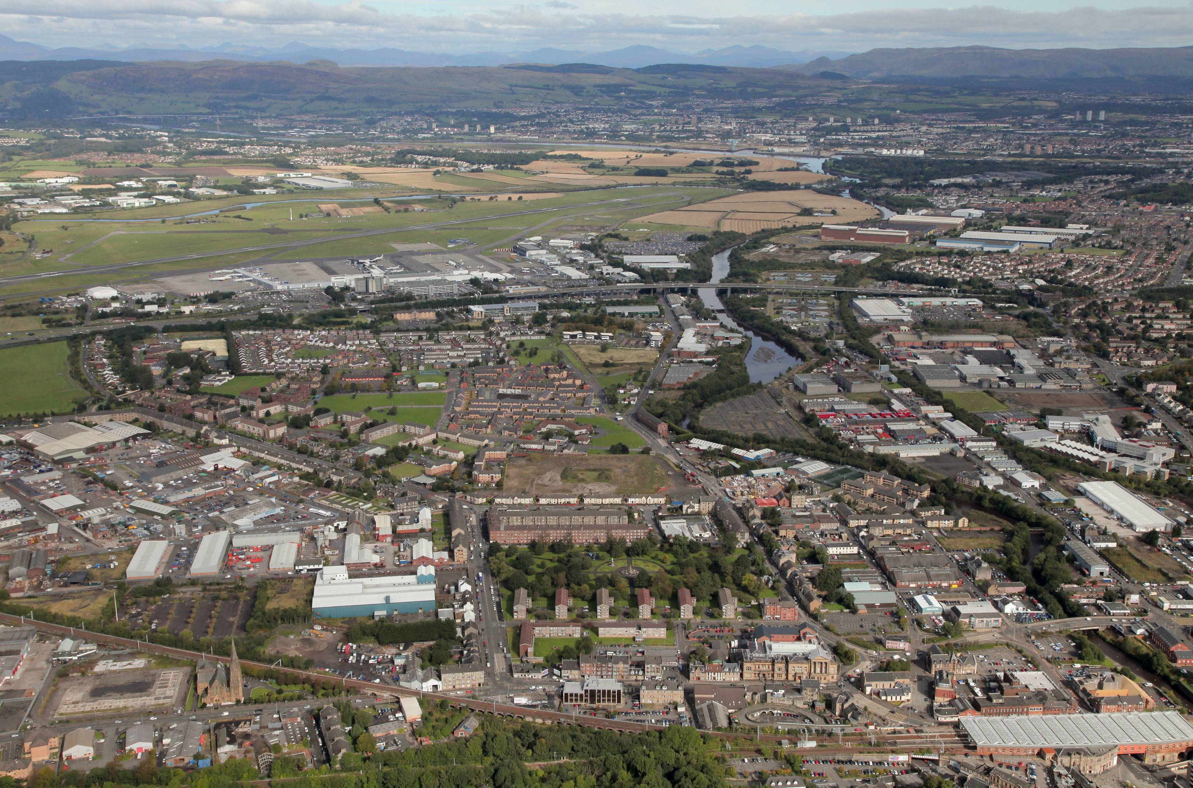

Renfrewshire Local Transport Strategy
Refresh – February 2017

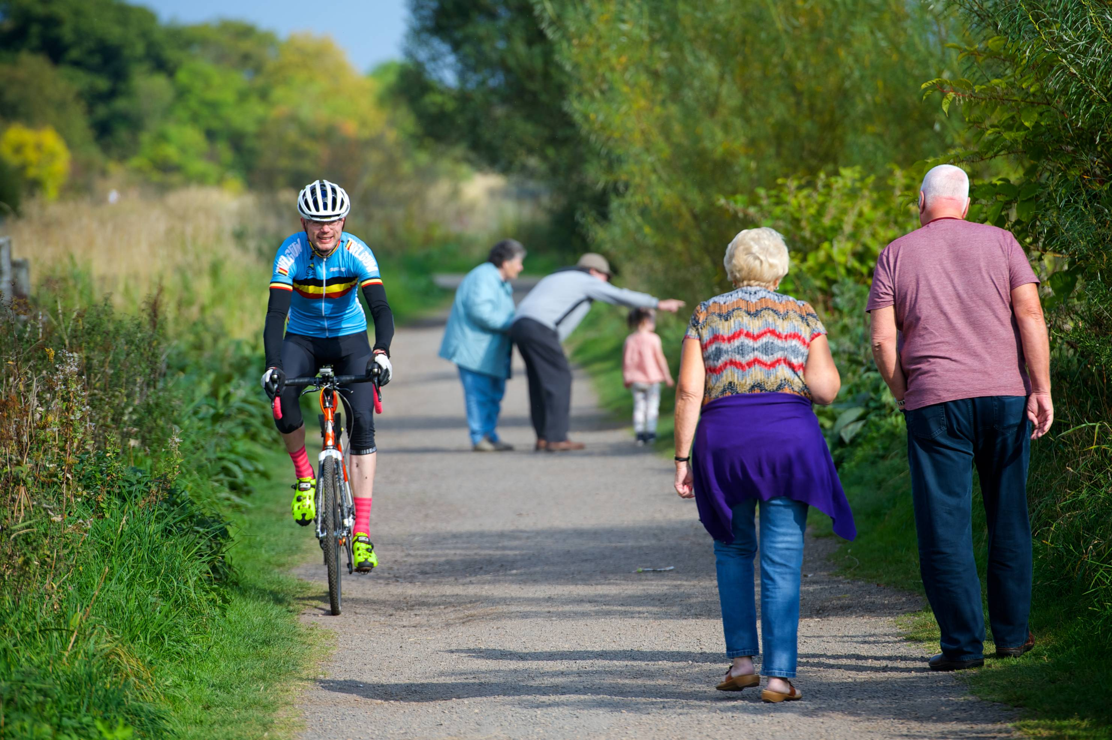
Connected Renfrewshire
Connectivity is key to the success of strengthening, enhancing and growing Renfrewshire, the City Region and Scotland. Having a fully integrated travel and transport system within Renfrewshire which is at the heart of our communities is central to delivering ambitious plans, strategies and projects.
Growth will be assisted and driven by supporting existing and new connectivity. Renfrewshire has a fundamental role to play at the centre of the Glasgow and the Clyde Valley City Region and there are opportunities to ensure that Renfrewshire is a place to live, work and invest.
Strengthening Renfrewshire’s Travel & Transport Infrastructure
The Renfrewshire Local Transport Strategy is central in enabling the Council and its partners to achieve its economic, social, regeneration and environmental objectives.
It will continue to support, guide and be developed through the context of strategic initiatives and projects that are now in place or progressing across the City Region and Renfrewshire.
The Renfrewshire Local Transport Strategy is a fluid document with an Action Plan that will continue to evolve and change to respond to funding opportunities.
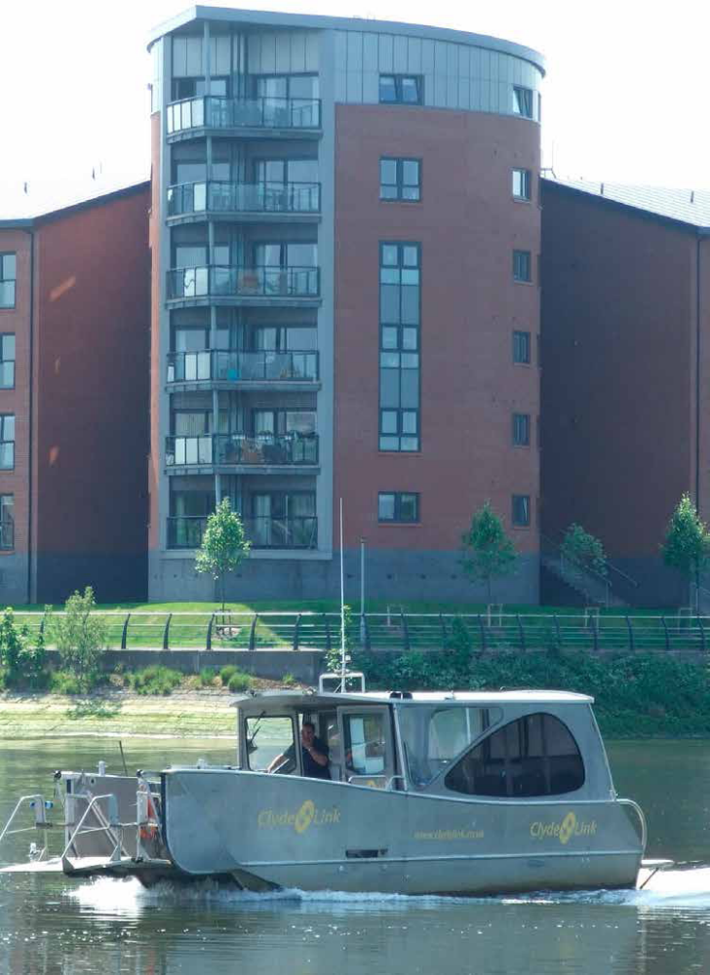

Renfrewshire Local Transport Strategy - 2007
The Renfrewshire Local Transport Strategy was approved in 2007, setting out a vision for transport for a 10 – 20 year timeframe.
‘The vision for Renfrewshire is that people can improve their health and travel to where they want to get to within a set timescale using all modes including walking, cycling, public transport or their car for essential trips; business can operate effectively and efficiently creating prosperity and job opportunities; visitors are attracted to enjoy the tourism and leisure facilities; and all of this is accommodated without compromising our future environment and at best value to the Council.’

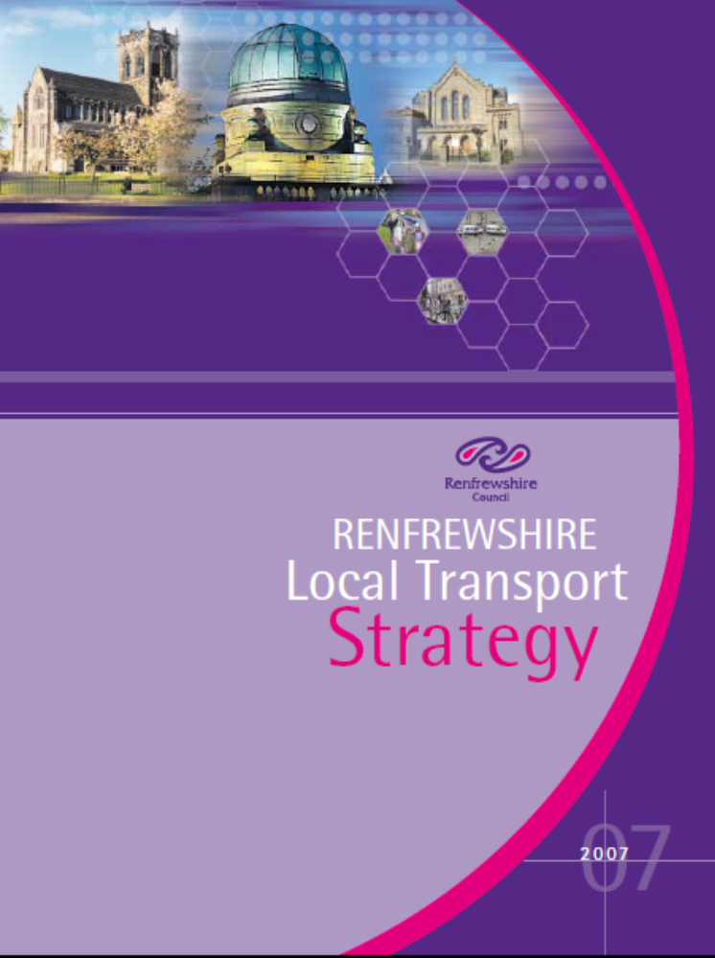

Objectives of the Renfrewshire Local Transport Strategy
The Renfrewshire Local Transport Strategy set out 5 key objectives to be delivered through the actions within the Strategy. These key objectives were as follows:
- Regenerate the local economy wherever possible;
- Extend opportunities for all by:
- Combating poverty and promoting equality including supporting behavioural change;
- Encouraging healthier lifestyles;
- Encouraging a choice of transport options;
- Improving access for all, including the mobility impaired.
- Ensure a healthy and sustainable environment;
- Improve community safety and security, both real and perceived and increase connectivity between settlements and services;
- Encourage integration of services and an integrated approach by public bodies whilst achieving best value.

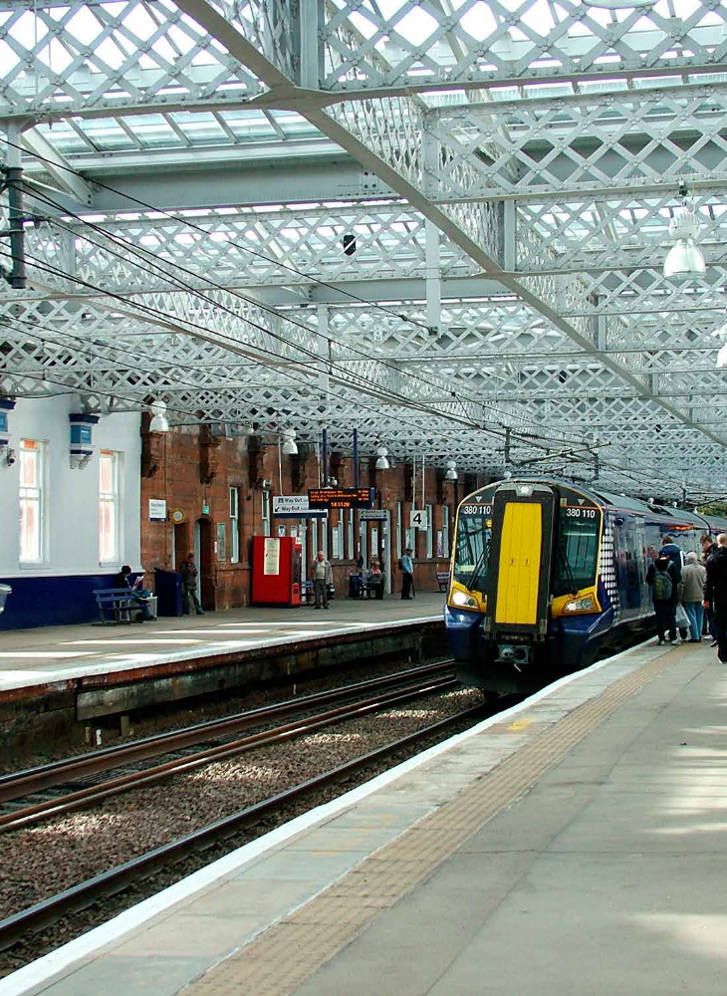
Role of Renfrewshire’s Local Transport Strategy
The Renfrewshire Local Transport Strategy captures the Council’s vision for travel and transportation, regionally and locally, to support wider economic, environmental and social objectives.
In reviewing the current Renfrewshire Local Transport Strategy, it is considered that much of the content, including the Vision and Key Objectives, are still relevant. Therefore there is no requirement for a full scale review or fundamental change in the overall approach.
Instead this ‘refresh’ of the Renfrewshire Local Transport Strategy reflects the changes to national, regional and local policy, plans and strategies as well as updating and capturing the relevance of all that has happened since Renfrewshire Local Transport Strategy was published in 2007.
Renfrewshire Local Transport Strategy Refresh
This refresh of the current Renfrewshire Local Transport Strategy provides an update on the Council’s achievements against the actions set out in the previous Strategy and sets out a broad direction of travel for Renfrewshire while the content of the new National and Regional Transport Strategies is awaited. A great deal of progress has been made in implementing the current Renfrewshire Local Transport Strategy. This refreshed Strategy builds on the success of these travel and transport interventions while maintaining the still relevant vision of the original.
When the new National and Regional Transport Strategies are published a new Renfrewshire Local Transport Strategy will be produced which will build, in detail, upon the vision, objectives and actions of the 2007 Strategy; updating its ambitions and approaches to today’s current and future needs and aspirations. The new transport strategy is not just about predicting what the future might hold and setting actions. The new strategy will assist in shaping and creating successful and resilient places.
Vision
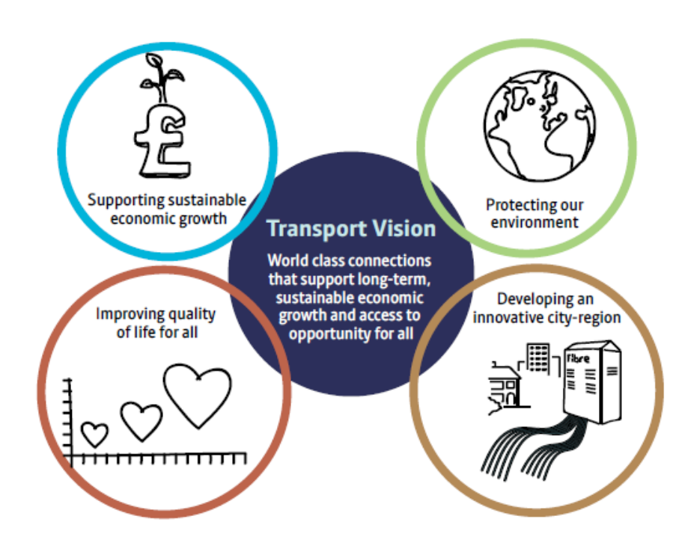
Setting the Scene
The new Renfrewshire Local Transport Strategy must take account of national and regional transport, planning and economic development policies, objectives and outcomes.
The new Strategy also needs to be fully integrated with the Council’s wider objectives and with other Council strategies including:
- Renfrewshire 2023 – Renfrewshire’s Community Plan;
- The Council Plan – A better Future, A better Council;
- Glasgow and Clyde Valley City Deal;
- Renfrewshire Strategic Economic Framework;
- The Renfrewshire Local Development Plan;
- Town Centre Strategies/ Action Plans;
- Paisley Town Centre Heritage Asset Strategy / Paisley 2021 Bid
- Renfrewshire Cycling Strategy; and,
- Renfrewshire Access Strategy and Core Path Plan;


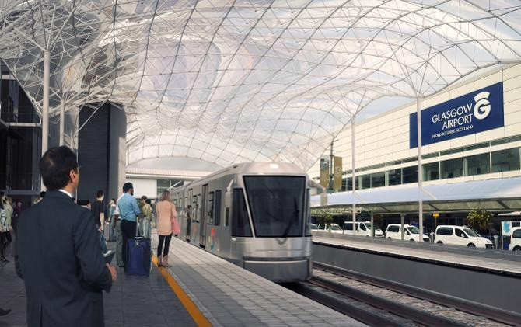
Plans, Policy & Strategy Influences
New
Renfrewshire Local Transport
Strategy
National Documents

National Transport Strategy

Scotland’s Economic Strategy

Scottish Planning Policy

National Planning Framework

Evidence Base

Census

Scottish Household Survey Local Area Analysis

Scottish Transport Statistics

Regional Documents

SPT - Regional Transport Strategy for the west of Scotland

Clydeplan -Strategic Development Plan

Glasgow City Region City Deal

Regional Economic Strategy

Infrastructure Requirements and Demands

Consultation & Engagement
Local Community, Local Businesses, Key Agencies, Developers and Landowners, Elected Members, Scottish Ministers &neighbouring Local Authorities

Local Documents

Renfrewshire Council Plan

Community Plan

Renfrewshire Strategic Economic Framework

Renfrewshire Local Development Plan

Town Centre Strategies / Action Plans

Paisley Town Centre Heritage Asset Strategy

Local Housing Strategy

The following plans, policy and strategies will positively influence the new Renfrewshire Local Transport Strategy. A summary of each will provide an outline of the key influences and considerations, indicating what the new Renfrewshire Local Transport Strategy will require to take into consideration.

National Transport Strategy (Jan 2016)
The Scottish Government’s refreshed its transport strategy with continued emphasis on:
- Improving journey times and connections;
- Reducing emissions;
- Improve quality, accessibility and affordability.
The National Transport Strategy has a greater focus on the climate change agenda, in particular meeting emission reduction targets and the climate change adaptation programme.
Scotland’s Economic Strategy is embedded within the framework along with reflecting the Strategic Transport Project Review and the infrastructure Investment Plan.
Integration of the land use plans with transportation objectives continues with a spatial reflection of the National Planning Framework with an emphasis of the ‘Town Centre First Approach’.
Digital connectivity and network resilience is a new feature of the National Transport Strategy as well as tackling inequality and promoting inclusive growth.
The Renfrewshire Local Transport Strategy already reflects the main aims and objectives of the National Transport Strategy. The new Strategy will be updated in line with the new and

emerging themes identified in the recently refreshed National Transport Strategy.
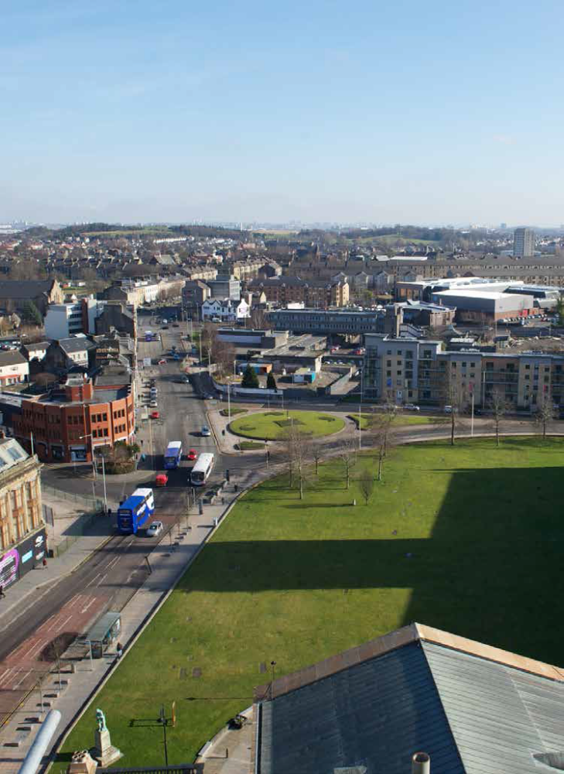
Scotland’s Economic Strategy
Scotland’s overarching economic framework aims to achieve a more productive, cohesive and fairer Scotland. Its priorities include boosting investment, stimulating innovation, supporting inclusive growth and a focus on increasing internationalisation.
The Economic Strategy emphasises the need to invest in physical and digital connectivity, creating good quality business and employment opportunities, a lower carbon economy and strengthening the success and resilience of local communities. These priorities along with new and emerging considerations will feature in the Renfrewshire new Local Transport Strategy.
Scotland’s National Planning Framework – NPF3
National Planning Framework 3 spatially sets out the Scottish Government’s Economic Strategy and future investment plans. NPF3 sets out that Renfrewshire, as part of the Glasgow and the Clyde Valley City Region, requires to build upon the economic strategy, working in partnership to successfully deliver the City Deal projects. Implementation of these projects will see a boost to employment and economic development in Renfrewshire as well as across the City Region.
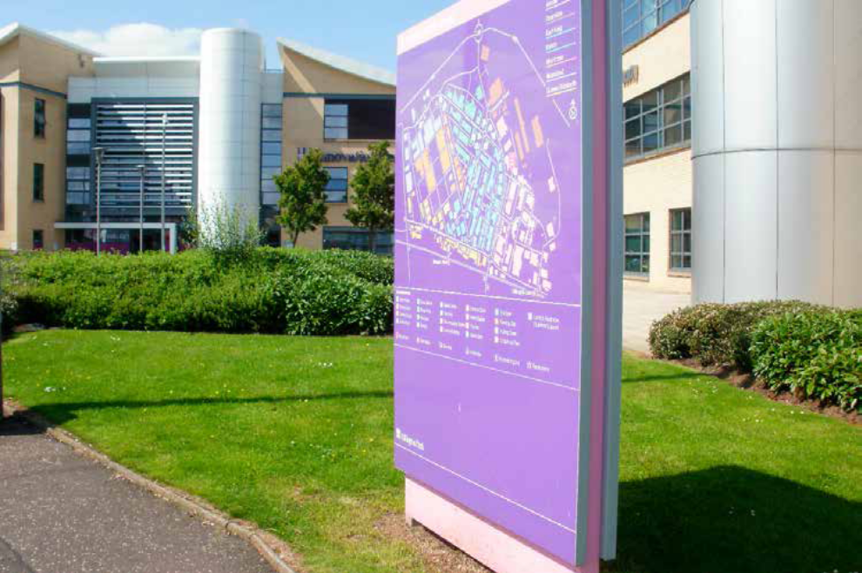
The new Renfrewshire Local Transport Strategy will require to set out a framework and align its actions so that it is integral to and can support the delivery of infrastructure and regeneration projects which will enhance Renfrewshire’s accessibility and connectivity.
Scottish Planning Policy
Sets out how development should take place across Scotland, aiming to achieve the ‘right development in the right place.’ The new Renfrewshire Local Transport Strategy will require to support economically, environmentally and socially sustainable places – ‘A more connected place’ – by supporting better travel and transport and digital connectivity.

Strathclyde Partnership for Transport – A Catalyst for Change – The Regional Transport Strategy for the West of Scotland
The Regional Transport Strategy was approved by the Scottish Ministers in 2008. Similar to the National Transport Strategy, there have been significant changes, new plans, policies and strategies along with other wider economic, social and environmental considerations that the Regional Transport Strategy requires to take into account.
Strathclyde Partnership for Transport are therefore reviewing the current Regional Transport Strategy and preparing an updated Strategy in line with the refreshed National Transport Strategy.
Given that the Renfrewshire Local Transport Strategy requires to reflect and be informed by both the National Transport Strategy and the Regional Transport Strategy, a new Renfrewshire Local Transport Strategy will not be prepared until the Regional Transport Strategy has been produced and consulted upon, then finalised. This refresh of the Renfrewshire Local Transport Strategy fills the policy gap in the meantime.
The Regional Transport Strategy Review will provide the opportunity to form an initial co-ordinated view from the west of Scotland perspective. The Review is anticipated to be completed by summer with Renfrewshire Council assisting and contributing to the preparation of the updated Regional Transport Strategy throughout the year.
Clydeplan – Glasgow and the Clyde Valley Strategic Development Plan
The second Glasgow and the Clyde Valley Strategic Development Plan has been produced. Clydeplan retains the focus and emphasis on the growth of the City Region.
Placemaking is a principle objective in Clydeplan, supporting a safe, pleasant and sustainable City Region where priority is given to people movement over vehicle movement.
Clydeplan also supports high quality and convenient public transport which is integrated with land use and development. It highlights support for development which is concentrated along transport corridors in close proximity to existing transport connections, optimising the use of existing infrastructure.
Both the Regional Transport Strategy and Clydeplan set the regional dimension for the Renfrewshire Local Transport Strategy. Many of the aims and objectives are already captured in the existing Renfrewshire Local Transport Strategy. New elements such as Placemaking Principles along with promotion of a Low Carbon City Region will require to be reflected in the new Renfrewshire Local Transport Strategy and actions considered to deliver the new principles that have been established.

Glasgow and Clyde Valley City Deal
City Deal has the potential to deliver significant economic growth through investment in Renfrewshire’s infrastructure, places and people.
£274 million of the overall £1.13 billion of the Glasgow and Clyde Valley City Deal investment is to be delivered in Renfrewshire.
Renfrewshire is set to benefit from the implementation of three of the biggest infrastructure investments in the Glasgow City Region which includes the following transport interventions:
- The Glasgow Airport Access project will provide a direct link between Glasgow Central Station and Glasgow Airport, via Paisley Gilmour Street station. This will deliver surface access improvements and will help to maximise the full potential of Glasgow Airport.
- The Glasgow Airport Investment Area project will help facilitate the creation of a world class business and commercial location focussed around the Airport. The project will deliver infrastructure and environmental improvements, including a new crossing of the White Cart Water and improved links for cyclists and pedestrians.
• The Clyde Waterfront and Renfrew Riverside project will see the construction of a new river crossing between Renfrew and Glasgow/West Dumbartonshire along with the development of the North Renfrew Development Road. This project will be the catalyst for the continued re-development of Renfrew Riverside.

This refresh of the Renfrewshire Local Transport Strategy provides an up to date framework to facilitate this investment along with realising the other potential connectivity and accessibility opportunities that this investment creates across Renfrewshire and the Glasgow City Region.
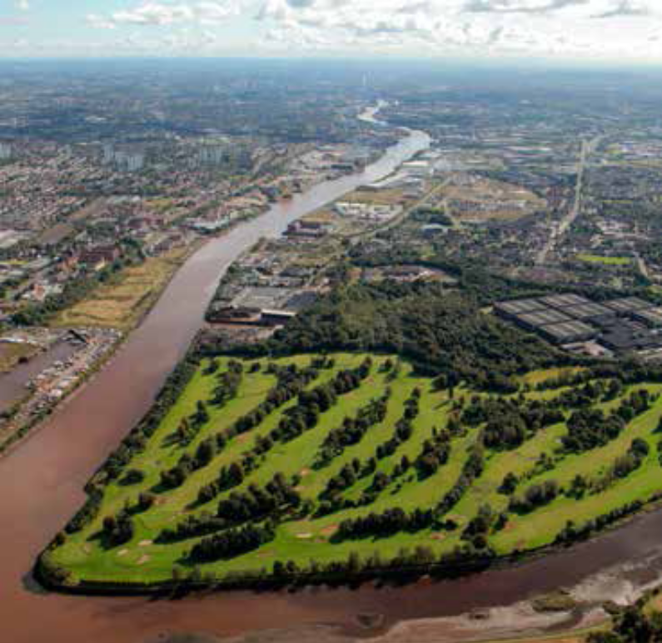

Glasgow City Region – Regional Economic Strategy
The Regional Economic Strategy builds on the City Deal projects and sets out the following vision;
‘A strong, inclusive, competitive and outward-looking economy, sustaining growth and prosperity with every person and business reaching their full potential.’
With the Glasgow City Region being the powerhouse of the Scottish Economy, contributing one third of GVA, population, jobs and businesses, the core aim of the strategy is to sustain and provide inclusive economic growth.
This aim reflects that of both the National Transport Strategy and Scotland’s Economic Strategy and the key elements as well as the vision will require to be embedded in the new Renfrewshire Local Transport Strategy.

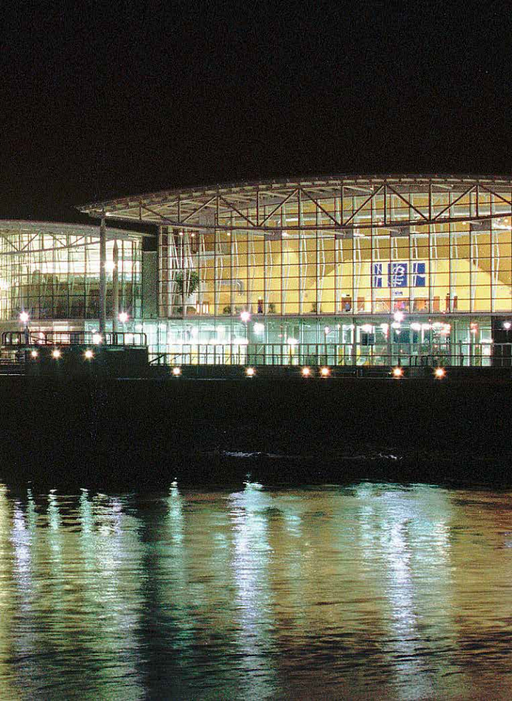
Renfrewshire’s Community Plan
The vision of the Community Plan of ‘Working together to make Renfrewshire a fairer, more inclusive place where all people, communities and businesses thrive’ will be central to the new Renfrewshire Local Transport Strategy.
All of the Community Plan themes will require to be captured in the updated actions of the Strategy. In particular the following will need to be considered:
- assisting in meeting the Scottish Government’s carbon reduction targets;
- Promoting and delivering sustainable growth through sustainable travel and transport options being available across Renfrewshire;
- Coordinating transport activities across Renfrewshire to enable a reduction in fuel use, carbon impacts and improve air quality.
This will align the new Local Transport Strategy with the Renfrewshire Community Plan.

Renfrewshire’s Council Plan – A Better Future, A Better Council
The vision of working more closely with communities, making the most of opportunities and delivering first class services will be a key consideration in the new Renfrewshire Local Transport Strategy.
Similar to the Community Plan, the new Renfrewshire Local Transport Strategy will play its part in assisting with tackling climate change, focusing on a reduction in carbon emissions. The Strategy will provide actions in line with the Council’s Carbon Management Plan. In particular, in relation to the Council’s own fleet vehicles and staff travel.
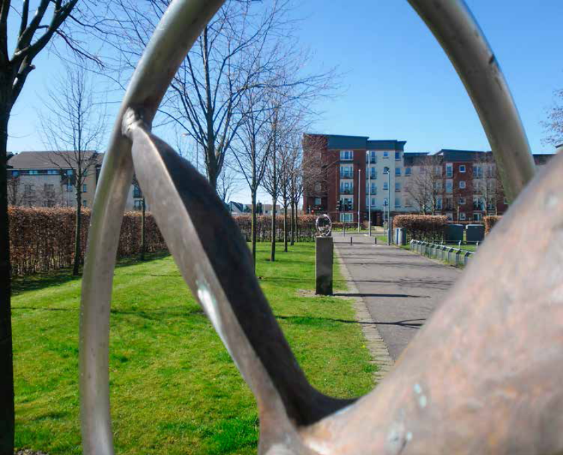

Renfrewshire’s Strategic Economic Framework
The Strategic Economic Framework is directly aligned to the Scottish Government’s Economic Strategy, aiming to increase competitiveness and tackle inequality.
The Framework intends to deliver 10 strategic priorities. One with particular relevance to the new Renfrewshire Local Transport Strategy is ‘Strengthening transport infrastructure’.
It is outlined that a full accessible and integrated network is a vitally important part of the Economic Framework and there requires to be a focus on behavioural shift to more sustainable forms of transport. Importantly, the ease by which people can get to Renfrewshire and move around is fundamental to achieving economic and social ambitions.
An action from the Framework is the preparation of a new Transport Strategy for Renfrewshire, which will focus on the following areas:
- Achieving a behavioural shift from the private car to other more sustainable modes of transport;
- Improved road network, reducing journey times;
- Walking and cycling provision;

- ‘Smart’ public transport and Quality Bus Corridors, Park and Ride and improved feeder services (including accessible and rural transport services)
- Developed and enhanced transport infrastructure, rail and station upgrades.
The new Renfrewshire Local Transport Strategy will require to focus on these areas, although many of these actions are already central to the existing Renfrewshire Local Transport Strategy. The new Strategy will provide an updated Action Plan which will focus on those points outlined in the Renfrewshire Strategic Economic Framework.
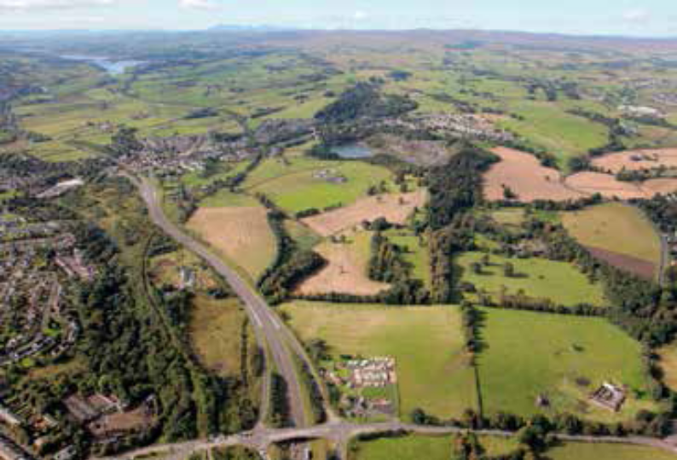
Renfrewshire Local Development Plan
The current Renfrewshire Local Development Plan was adopted in 2014. It sets out the Council’s priorities spatially to facilitate investment, directing development to existing built-up areas where existing active travel and transport links and networks exist.
The aim of the Renfrewshire Local Development Plan is to create sustainable mixed communities, high quality places, assisting in the delivery of sustainable economic growth across Renfrewshire.
The current Renfrewshire Local Development Plan is being reviewed. The main components of the Plan remain relevant and it is the main changes primarily related to housing land supply that need to be reflected in the next version of the Renfrewshire Local Development Plan.
The Renfrewshire Local Transport Strategy is central to where the Renfrewshire Local Development Plan identifies areas of growth and development in Renfrewshire. This is because connectivity is key to the success of strengthening, enhancing and growing Renfrewshire. The new Renfrewshire Local Transport Strategy should; ensure that people and places are well connected and; support and assist the implementation of the Renfrewshire Local Development Plan.

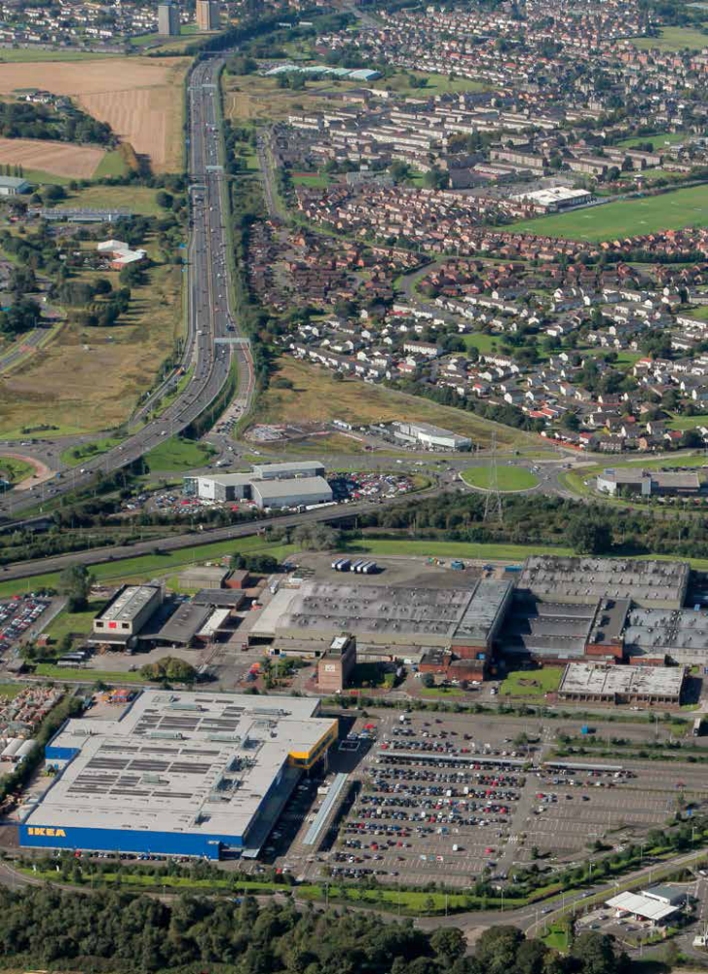
Centre Strategies / Action Plans
In line with Scottish Planning Policy and the ‘Town Centre First’ approach, Renfrewshire Council have prepared Centre Strategies, associated Action Plans and Centre Health Checks for Centres in Renfrewshire.

The strategies provide a framework for future growth and/or enhancement in Renfrewshire’s Centres. Central to delivering successful Centres is connectivity, ensuring Centres are more accessible by walking, cycling and public transport.

The new Local Transport Strategy will require to reflect the frameworks set out for these Centres, aiming to improve their accessibility, presenting actions which will enhance opportunities for investment, supporting increased numbers of visitors, businesses and residents.

As well as improving connectivity, the Renfrewshire Local Transport Strategy will require to deliver improved traffic management, where necessary and where network constraints allow.

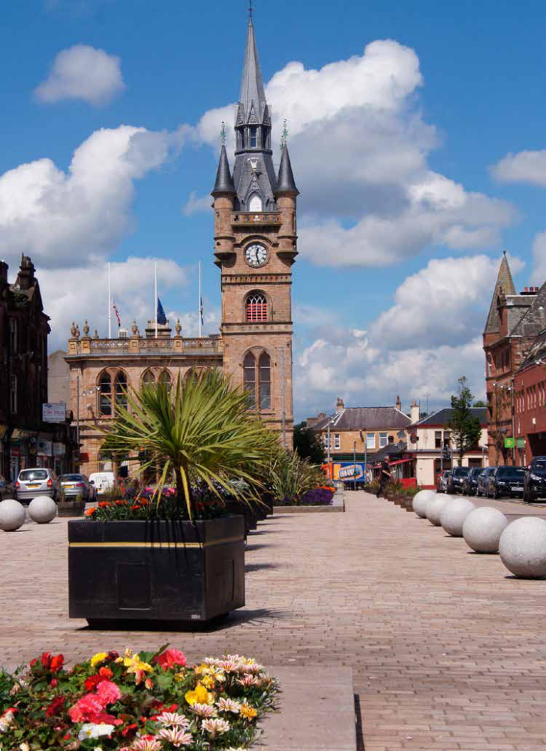
Paisley Town Centre Action Plan

The Paisley Town Centre 10 year Action Plan was prepared to provide an up to date context in relation to the Council’s investment in the Renfrewshire City Deal project and its bid for the UK City of Culture 2021. The Action Plan identifies key priorities for Paisley Town Centre, priority locations and short, medium and long term objectives for those areas.

The Paisley Town Centre Action Plan provides a framework to shape the investment decisions of both the council and other parties, including private sector landowners and investors.

The Action Plan takes its lead from the Renfrewshire Strategic Economic Framework. Again connectivity is a key element of this Action Plan and the new Renfrewshire Local Transport Strategy will need to reflect this, providing a framework to assist in the delivery of these objectives in priority areas of Paisley.

Paisley Town Centre Heritage Asset Strategy
The Paisley Town Centre Heritage Asset Strategy sets out an ambitious vision to deliver a range of projects and developments that could bring about a potential economic benefit of an additional £45 million to Renfrewshire’s economy along with the creation of new jobs.

Successful implementation of the Heritage Asset Strategy is important for all of Renfrewshire as this will support investment that will promote economic, cultural and social regeneration across Renfrewshire.

It is this vision that makes Paisley an ideal candidate for bidding for the UK City of Culture for 2021. A successful bid would raise the profile of Renfrewshire as a destination.

Updating the Renfrewshire Local Transport Strategy provides an opportunity to set out an integrated transport framework to assist in delivering the Heritage Asset Strategy to enable future development and growth as well as the enhancement of Paisley as a destination.

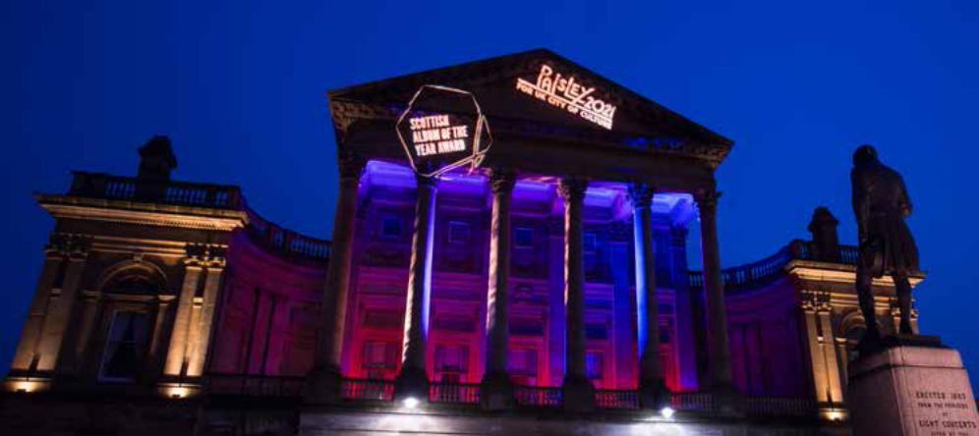

Renfrewshire Cycling Strategy

The Renfrewshire Cycling Strategy 2016 – 2025 provides an up to date framework, reflecting the increased focus on cycling across Scotland, along with aiming to achieve the national vision that has been set for cycling by aligning its actions to the Cycling Action Plan for Scotland 2013.

The Cycling Strategy sets the context around existing cycling routes and provides the direction for new or enhanced cycling infrastructure in order to achieve the Council’s target of 3% of all journeys to work being made by bicycle by 2020.

The components of the Cycling Strategy will require to be captured in the new Renfrewshire Local Transport Strategy, with actions aligned to delivering the aims and objectives of the Cycling Strategy.

Renfrewshire Access Strategy

Outdoors For You – Renfrewshire Outdoor Access Strategy 2016 – 2026, aims to improve health and well being, increase economic opportunities and improve connectivity between people and places. To achieve these aims requires good active travel networks and infrastructure.
The current Renfrewshire Local Transport Strategy includes enhancement as well as increasing active travel as part of its key objectives. This will continue as a key element of the new

Renfrewshire Local Transport Strategy. The focus will be on integrating both the actions and outputs of the Cycling Strategy and the Access Strategy, ensuring that the Local Transport Strategy supports them both.
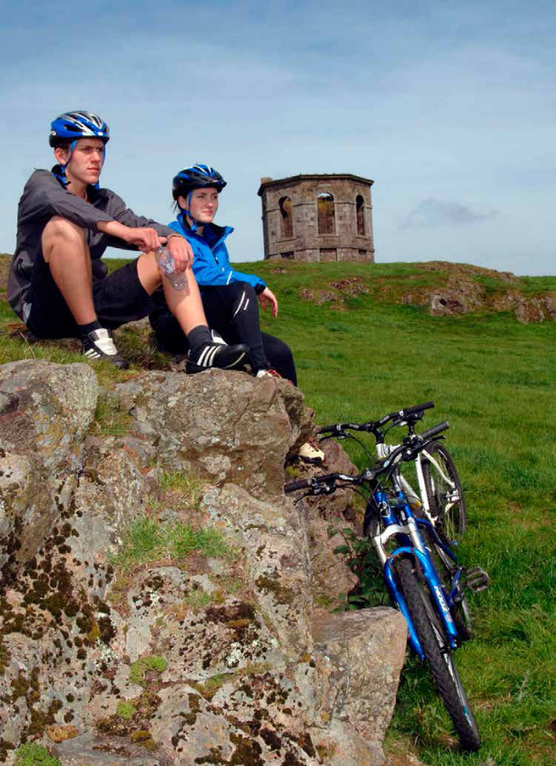
Legislation
Between 2007 and 2017 some items of transport legislation affecting local authorities have changed and plans to bring forward other new legislation have begun. The new Renfrewshire Local Transport Strategy will need to recognise these changes and seek to accommodate the consequences of such legislation in the way the Council delivers its services.
Transport and Works (Scotland) Act 2007 (TAWS)
Orders under the TAWS can authorise guided transport schemes such as railways, tramways, guided busways and their stations, and canal projects in Scotland. Applicants such as regional or local authorities can apply to Scottish Ministers for a TAWS order or Scottish Ministers can make orders at their own instigation. The TAWS order follows a set public consultation procedure and can grant a wide ranging number of powers including compulsory powers to buy land or close streets.
Disabled Persons’ Parking Places (Scotland) Act 2009
Local Authorities are no longer able to designate advisory on-road or off-road Disabled parking spaces. All Disabled parking places must now be included in a traffic regulation order and have signs erected to enable their enforcement.
Climate Change (Scotland) Act 2009
The Act sets out a statutory framework for greenhouse gas emissions reductions and targets of 42% by 2020 and 80% by2050. The planned reduction in NOx and PM emissions will impact on transport in particular.
Equality Act 2010
The act covers discrimination against people with ‘protected characteristics’ and imposes specific duties on local authorities through the Equality Act 2010 (Specific Duties) (Scotland) Regulations 2012.
Scotland Act 2012
The act devolves transport powers to Scotland in the fields of drink drive limits and the national speed limit.
Community Empowerment Act 2015
The act promotes public service reform, provides a legal basis for participation and establishes new rights and responsibilities for community bodies and local authorities. Local communities can now identify local transport initiatives which are then delivered in partnership.
Scotland Act 2016
The act devolves transport powers to Scotland in the areas of rail franchising, road signs, parking and speed limits. Public sector bodies are able to bid for the ScotRail franchise; Scottish Ministers can prescribe road signs and pedestrian crossings and; are given full control over all speed limits. The regulation of parking on roads is also devolved, resulting in the Transport Scotland consultation in March 2017 on Responsible Parking as part of a forthcoming Transport Bill. The bill is also planned to improve bus service regulation in Scotland and to give the Scottish Road Works Commissioner more enforcement powers.
Key Considerations for the Renfrewshire Local Transport Strategy
The following measures of key travel and transport in Renfrewshire will require to be considered in the new Renfrewshire Local Transport Strategy.
Main Mode of Travel
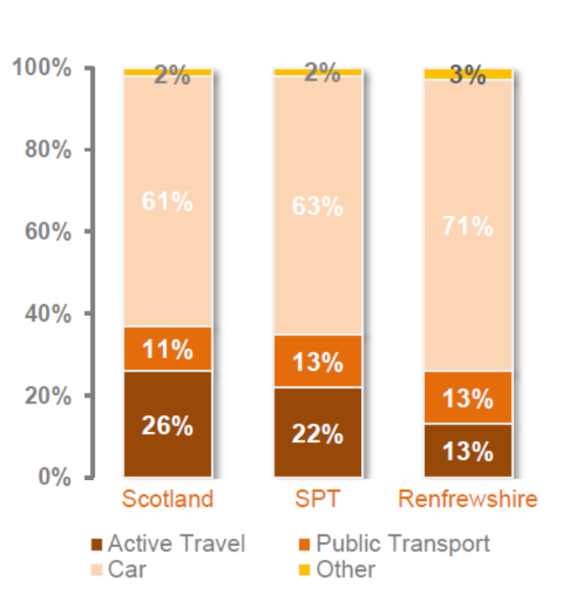

Convenience of Public Transport
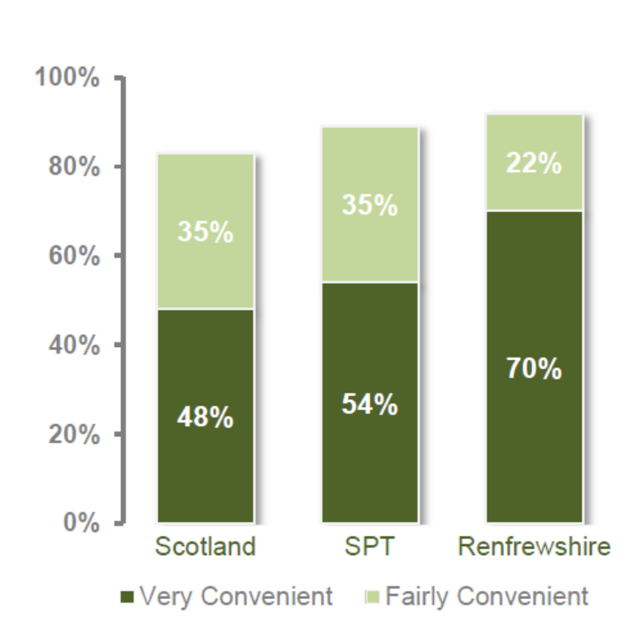

Satisfaction with Public Transport
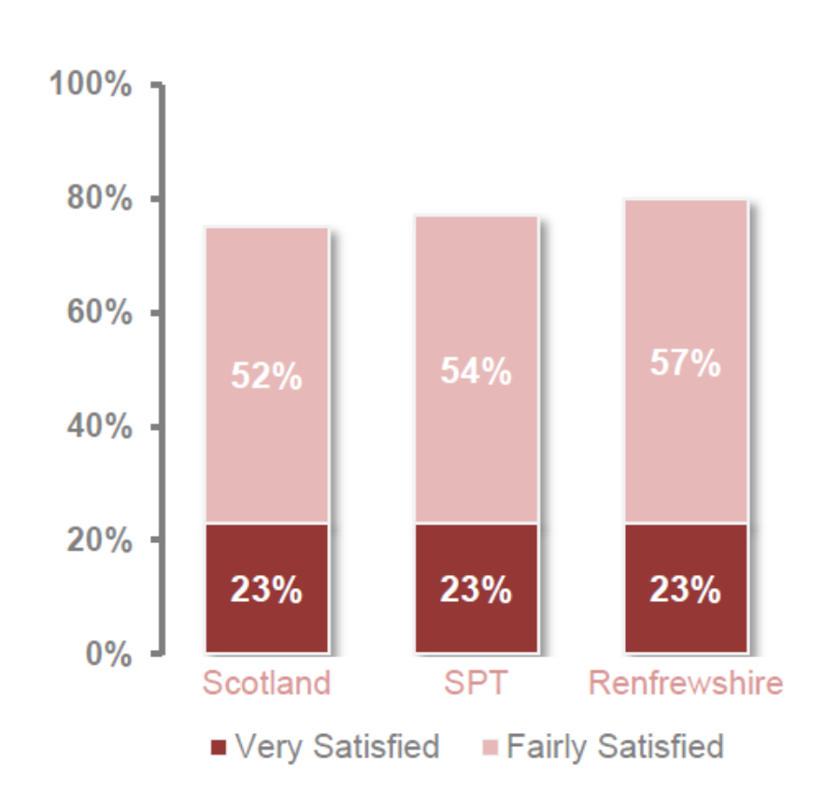

Congestion Delays Experienced by Drivers
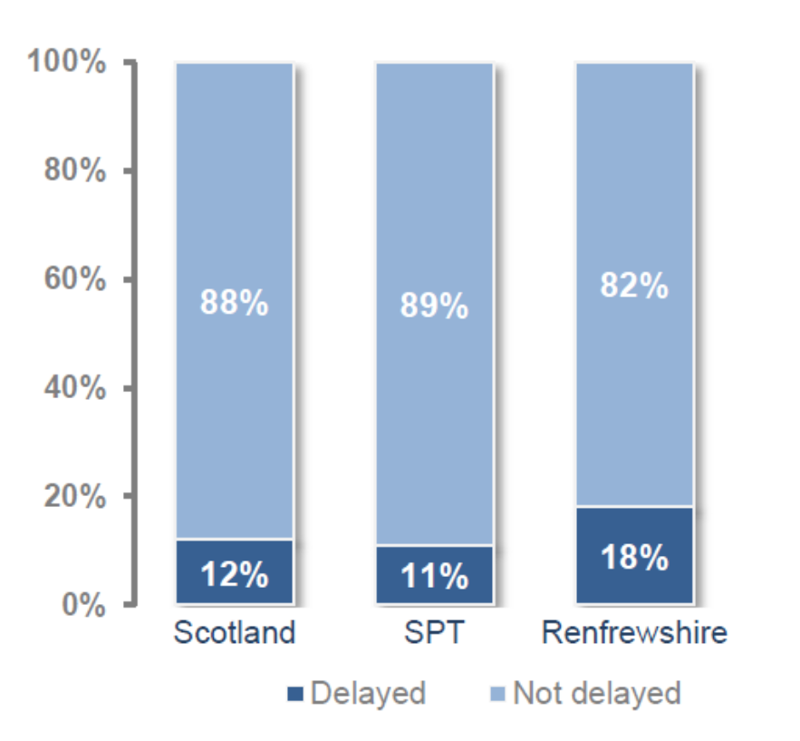

Use of Local Bus Services
(Adults aged 16+ living in Renfrewshire)
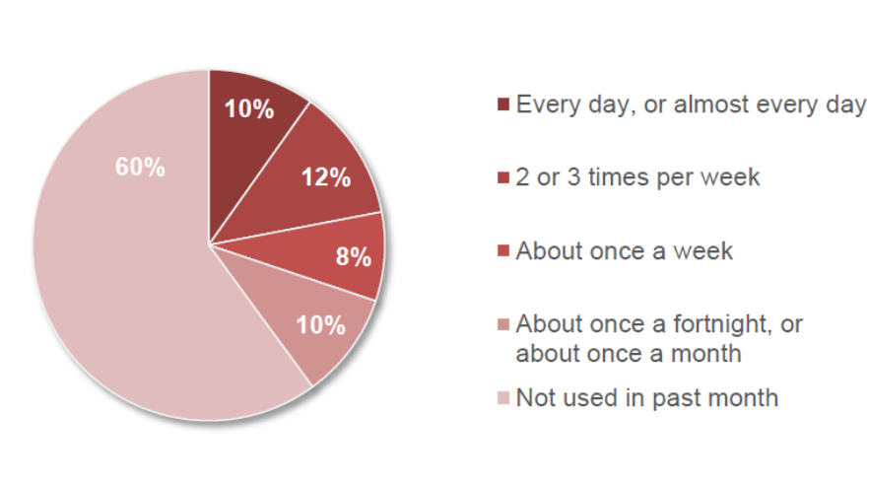

Patronage at Rail Stations in Renfrewshire
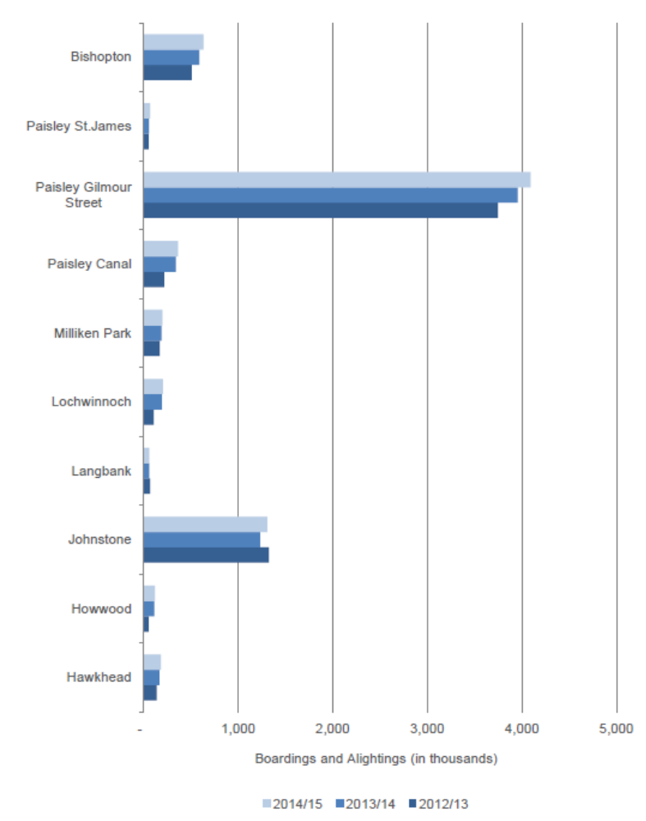
No. of Bicycles for Private Use
(By households)

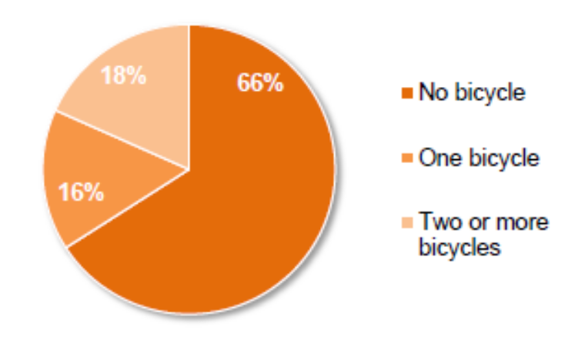

Frequency of Walking in Past Week as a Means of Transport (Adults aged 16+)

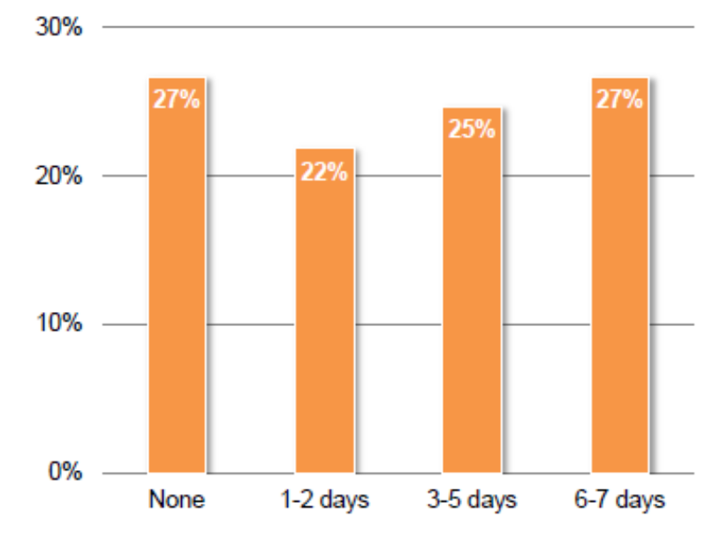

Delivering Opportunities through the Renfrewshire Local Transport Strategy
The new Renfrewshire Local Transport Strategy will link with different tiers of transport policy. It will continue to identify short, medium and long term priorities that contribute towards relevant local, regional and national transport targets and goals along with promoting and supporting sustainable economic growth through a strengthened and well connected travel and transport network.
The setting of travel and transport priorities will also support the wider holistic aims and aspirations of the many existing plans, policies and strategies that are being delivered by our partners.
In identifying priority schemes and projects in the Action Plan, it will be important to consider the deliverability as well as timing for implementation which will depend on the availability of resources.
Carried out in partnership with others, the new Renfrewshire Local Transport Strategy offers an opportunity to better integrate land-use and transport (focussing on future growth, employment opportunities and town centre actions); assist regeneration; and support new homes and other development where good access and connectivity can be provided.

For Renfrewshire, the new Local Transport Strategy will provide a framework to deliver an affordable, sustainable and effective travel and transport network which is seamless in serving all local community needs. It will do this by further enhancing strategic and cross boundary links, ensuring travel mode choice and connectivity for all, which will support the regeneration and growth of Renfrewshire’s economy whilst helping tackle pollution by reducing emissions.
LOOKING BACK
Renfrewshire Council’s Transport Achievements since 2007
Renfrewshire Council has made a number of transport related achievements in recent years. In recognition of its work towards encouraging its staff to travel actively, the Council was awarded the accolade of Cycle Friendly Employer in 2016 by Neilston Development Trust which manages the Cycle Friendly Employer scheme in Renfrewshire. The Council also has a 'Try Bikes' scheme which provides a pool of bikes for employees’ use for going out to meetings or other site visits.
The Council also Supported Paisley First (a business-led collaboration initiative to help create a better business environment, a more attractive town centre for residents and visitors and a safe place to work and live) to achieve ‘Purple Flag’ status in 2016 from the Association of Town and City Management. The Purple Flag is similar to the Blue Flag for beaches in that it denotes a town or city which has attained a target level of infrastructure which ensures a safe experience to those enjoying the evening and night time economy.
Changes to Renfrewshire since 2007
The 2007 Local Transport Strategy produced a table of travel statistics which described Renfrewshire’s population and its travel habits at the time. The following table provides a comparison of the same statistics between then and now, 2017.

 | 2017 | 2007 LTS
Kilometres of road | 844 | 784
Population | 174600  (2015 nomisweb.co.uk) | 170611
Households | 83245  (2015 National Records of Scotland) | 80590
Glasgow Airport passengers | 9.4 million  (2016 Glasgow Airport web site) | 8 million
Economically active population | 89100  (2015/16 nomisweb.co.uk) | 115000 (probable error)  (c.f. 84436, 2001 census)
Who Live and work in Renfrewshire | 57233 or 64%  (2011 census, nomis) | 66100 or 58%
Daily travel to Renfrewshire to work | 31,998  (2011 census, nomis) | 29,000
Of which are:  From Glasgow and the rest of Renfrewshire | 14,023  (2011 census, nomis Glasgow and East Renfrewshire) | 15,400
From Ayrshire | 5536 (nomis 2011) | 5000
From Lanarkshire | 3760 (nomis 2011) | 3400
Travel out of Renfrewshire to work | 32,676 (nomis 2011) | 32,000
Of which travel to Glasgow to work | 21,528 (nomis 2011) | 20,400
Development in Renfrewshire, mostly new housing, has added to its length of roads by around 6km per year. Both its population and economically active population have grown nominally but more people travel out of Renfrewshire to work, mostly to Glasgow, which in 2011 resulted in a net population decrease of 678 during the working day.

Changes to Renfrewshire’s Public Transport Network since 2007
 | 2017 | 2007
Bus companies | 6 | 33
Bus stops | 932 | 951
Bus shelters | 410 | 398
Rail Stations | 10 | 10
Rail Park and Ride car parks | 6 (spt website) | 7
Extra Rail Park & Ride car parking spaces | 83 at Johnstone  62 at Bishopton (another 150 planned)

The most marked changes to the public transport network in the ten years since 2007 have been the reduction in the number of bus companies active in Renfrewshire and the rise in popularity of park and ride at rail stations, although the Paisley St James Park & Ride car park has been lost. The drop in the number of bus stops is most probably due to the change in demand occasioned by the removal of old housing stock.
The deregulation of the bus industry in 1985 opened up the market to competition and a proliferation of bus companies vying for passengers in central Paisley causing congestion and pollution. In response the Council introduced one of Scotland’s first Statutory Bus Quality Partnerships to guarantee that only companies with modern clean buses and adequate customer service would be allowed to operate in Renfrewshire. The result of this and natural market forces has been a reduction in the number of bus companies operating in Renfrewshire from 33 to 6, a consequent reduction in congestion and an improvement in air quality.
The number of people travelling from Renfrewshire to Glasgow to work continues to rise. The National policy of encouraging travel by public transport before the private car and the limitation in the amount of affordable long stay parking provision in Glasgow has resulted in greater demand for rail Park & Ride. Renfrewshire Council recognises the environmental benefit of using the train and has sought to provide extra rail Park & Ride car parking spaces at popular stations where possible. A 83 space upper deck of car parking opened at Johnstone Station in 2015 and the car park at Bishopton Station was extended by 62 spaces in 2017, with another 150 planned to coincide with the completion of the residential development there.
Changes to Travel Habits in Renfrewshire Since 2007
From Scotland’s Census results for 2001 and 2011 and the Scottish Household Survey, the percentage of people in Renfrewshire with access to one or more cars has hardly changed in the intervening years. The only appreciable changes in people’s travel habits is a doubling of the number of people working from home and marked drop in the number of journeys made that are under 2km long.
Table of travel to work mode in Renfrewshire
Scotland’s Census
 | 2011 | 2001
People aged 16-74 in work (excl full time students) | 78244 | 75618
% car | 66.4 | 67.35
% train | 5.6 | 19.34
% bus | 11.1 | 19.34
% on foot | 6.4 | 9.56
% other | 2.1 | 9.56
% work mainly from home | 8.4 | 3.75

Scottish Household Survey
 | 2017 (2015 most recently available results) | 2007 (2003/4 results quoted in 2007 LTS)
Access to a bike | 34% (SPT Transport Outcomes Report: Renfrewshire 2016/17) | 34%
Access to 1 car | 39% | 41%
Access to 2 cars | 19% | 18%
Access to 3 cars or more | 5% | 2%
No access to a car | 37% | 39%
Percentage journeys under 2 km (1.2 miles) | 10% (2011 census) | 35%
Average adult journey length | 5-10km | 7.4km
Journey Times
Journey run surveys are carried out annually on eight key routes through Renfrewshire in order to determine if policies implemented between 2007 and 2017 have had any significant impact upon journey times on the routes.
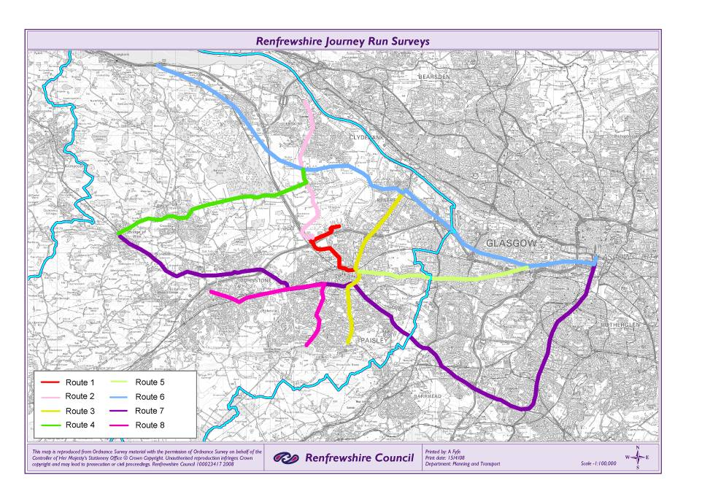
Across all eight routes, journey times have decreased by 0.14% i.e. a decrease of 40 seconds from an average of 22min 26 sec in 2008 to 21 min 46 sec in 2016.
Overall, three routes showed a slight increase in journey times in both directions and one route (Route 7) showed a decrease in journey time in both directions. The greatest change in journey time is the decrease of 10min 40sec on Route 7, one of the longest, from Bridge of Weir to Thornliebank. This seems largely due to a decrease in outbound journey time since 2012, probably attributable to traffic being attracted off the A726 to the M8/M74 Glasgow southern orbital which opened in 2011.
Traffic Counts
The Council undertakes traffic counts every two years at fixed points on three cordons surrounding Paisley, Renfrew and Erskine. The table below shows the changes in traffic flows at these points between 2006 and 2016.
Average 24 hour, 5 day average, two way traffic flow
Site | 2016 (most recently available results) | 2006 (5 day average converted from 7 day average quoted in 2007 LTS) | Difference
Paisley Cordon
Arkleston Rd Paisley | 10694 | 10434 | 260
Glasgow Rd Paisley | 12061 | 12561 | -500
Hurlet Rd Paisley | 29489 | 25699 | 3790
Caplethill Rd Paisley | 8563 | 9973 | -1410
Glennifer Rd Paisley | 3142 | 3612 | -470
Glenpatrick Rd Paisley | 2664 | 3309 | -645
Ferguslie Paisley | 30589 | 35237 | -4648
Greenock Rd Paisley | 22229 | 23107 | -878
Inchinnan Rd Paisley | 11769 | 12169 | -400
Renfrew Rd Paisley | 32009 | 32799 | -790
Renfrew Cordon
Paisley Rd Renfrew | 19244 | 18189 | 1055
Glasgow Rd Renfrew | 18580 | 20883 | -2303
Inchinnan Rd Renfrew | 12514 | 13543 | -1029
Erskine Cordon
Barnsford Rd M8 J29 | 17245 | 14483 | 2762
Greenock Rd Erskine | 13120 | 12718 | 402
Southbar Rd Erskine | 18506 | 17502 | 1004
Bridgeway Erskine | 11834 | 10579 | 1255
Other
Kilmacolm Rd Bridge of Weir | 8411 | 8513 | -102
Main Road Elderslie | 18599 | 19549 | -950
Total | 301262 | 304859 | -3597

The difference between 2006 and 2016 would suggest that weekday traffic flows have decreased by around 1.2% during that period. In fact, if traffic flow patterns are taken over a longer period, as shown in the graph below, it can be seen that overall traffic levels in Renfrewshire have, on average, remained static since 1999 (0.01% growth per year). Some roads see localised increases like the A761 in Ferguslie and the A8 (Glasgow Rd and Inchinnan Rd) but others like the A726 have seen a decrease in traffic, again probably attributable to traffic being attracted off the A726 to the M8/M74 Glasgow southern orbital.
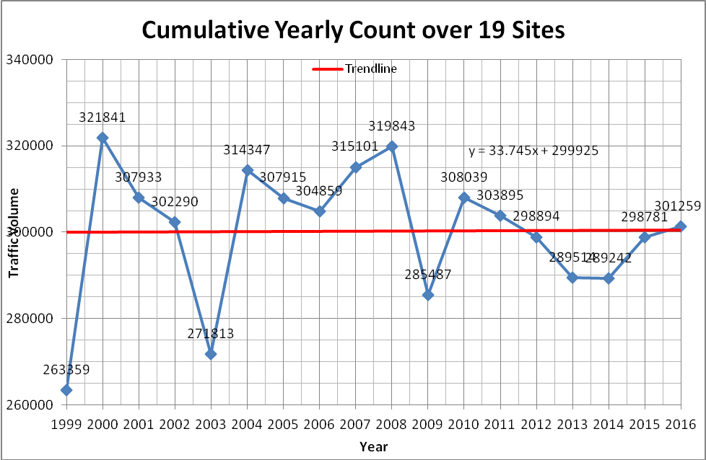
Road Accidents
The following table sets out casualties on Renfrewshire roads by road type since 2006.
RENFREWSHIRE CASUALTIES – ALL SEVERITIES
 | Trunk Roads | Rural Roads | Urban Roads | Total Council Roads | Total All Roads
2006 | 98 | 79 | 407 | 486 | 584
2007 | 87 | 77 | 384 | 461 | 548
2008 | 76 | 58 | 326 | 384 | 460
2009 | 68 | 55 | 269 | 324 | 392
2010 | 41 | 65 | 277 | 342 | 414
2011 | 82 | 88 | 313 | 401 | 483
2012 | 73 | 38 | 319 | 357 | 430
2013 | 53 | 55 | 216 | 271 | 324
2014 | 47 | 62 | 210 | 272 | 319
2015 | 60 | 50 | 212 | 262 | 322

Air Quality Management Areas
Central Road, an enclosed bus station and taxi rank, was declared as the only air quality management area (AQMA) in Renfrewshire in 2005. Buses have since ceased to operate from this location. Nonetheless, continuing high measurements of pollutants meant that the air quality management area was subsequently expanded to cover the majority of Paisley town centre in 2009. The effect of localised growth in traffic since 2007 has resulted in the designation of three AQMAs at Paisley town centre, Johnstone High Street and Renfrew town centre.
The pollutants of concern are nitrogen dioxide (NO₂) and particulate matter (PM₁₀ - particulate matter less than 10 microns in diameter). A variety of sources contribute to the levels of these pollutants within the Council area including background pollutant concentrations, transport, commercial and industrial sources. However, road transport emissions have been identified as a significant contributor especially in relation to nitrogen oxide emissions.
The Paisley town centre AQMA was declared in August 2009 for exceedances of the PM₁₀ annual mean objective and both the NO₂ annual and 1-hour mean objectives. These exceedance locations are mainly at busy roads and junctions on the town centre ring road. An Air Quality Action Plan (AQAP) for the Paisley town centre AQMA was published in 2014. The most significant measures included improvements to Central Road, implementation of a Statutory Quality Bus Partnership Scheme across Paisley town centre and council vehicle fleet improvements.
The Johnstone High Street AQMA was declared in August 2016 for exceedances of the NO₂ annual mean objective. The AQMA boundary extends along the entire High Street with locations of exceedances confined mainly at areas of canyon type topography.
The Renfrew town centre AQMA was declared in August 2016 for exceedances of both the NO₂ annual and 1-hour mean objectives. The AQMA boundary extends across the main junctions within the town centre (Inchinnan Road, Hairst Street, Glebe Street, Paisley Road, Canal St and High St).
A new Renfrewshire wide AQAP incorporating all three AQMAs is being developed during 2017.
LTS Actions undertaken since 2007
The second local transport strategy for Renfrewshire was produced in 2007. Most of the actions arising from the 2007 LTS have now been implemented and outcomes have been measured. The key areas of achievement since the last LTS are summarised below:
- The Glasgow and Clyde Valley City Deal project includes proposals for an alternative road bridge crossing of the River Clyde and a rail based connection to Glasgow Airport; to ease pressure on the M8 and existing rail paths to ensure that economic growth is supported without constraints imposed by transport.
- The Glasgow and Clyde Valley City Deal project also includes proposals for the Renfrew Northern Development Road to ease congestion in Renfrew.
- Fastlink extends from Glasgow city centre to Queen Elizabeth Hospital. The design of its western extension to Braehead is under consideration, in association with the proposed expansion of Braehead Retail Park.
- The Council has replaced all of its street lights with low energy, longer lasting, LED lamps to save on energy and maintenance bills while maintaining safe light levels for all road users.
- The weak bridge at Main Street, Lochwinnoch was replaced with one to current load capacity standards, which opened in February 2017.
- The Council’s Travel Plan was implemented in 2008.
- Johnstone Station has been upgraded with a two-storey park & ride car park, on-site bus stops and cycle storage.
- A Statutory Bus Quality Partnership was drawn up and implemented for 5 years from 2011, which succeeded in markedly raising the standard of bus provision in Renfrewshire.
- The Council has produced a Cycling Strategy and Outdoor Access Strategy which are available on the Council’s web site.
- The Paisley South Side Strategic Walking/ Cycling Route was implemented between 2010 and 2015
- The work associated with the Renfrew Town Centre Regeneration Strategy was completed in 2010.
- A new traffic signal junction with pedestrian and cycle crossings was opened at the junction of the A8 and Old Greenock Road, to improve access to Inchinnan, in January 2017.
Transportation Outcome Indicators
The 2007 LTS set up a number of transportation outcome indicators to monitor the effectiveness of the high level actions identified in the document. The following table shows the progress towards those outcomes achieved since 2007.
ROAD SAFETY PERFORMANCE | Target in 2007 LTS | 94-98 ave | 2010 | Reduction achieved by 2010
Road Casualties  Casualties are reduced in line with the targets set nationally by Government based on percentage reduction by 2010 on the 1994-98 average | 40% reduction in the number of killed and seriously injured accidents | 157 | 64 | 59%
 | 50% reduction in the number of child killed or seriously injured accidents | 35 | 7 | 80%
 | 10% reduction in slight casualties | 600 | 350 | 42%

Renfrewshire Council continues to better the targets for reductions in road casualties set by the Government.

ROAD SAFETY PERFORMANCE | Target in 2007 LTS | Growth from 2008 to 2016
Road Service Level Performance | Stabilise Journey run times (on all 8 routes used to measure journey times annually), so that year on year journey times correlate directly with traffic growth (i.e. if there is no traffic growth, journey times will remain the same) | -0.14% per year
Sustainable Transport | Local traffic growth is stabilised so that it does not exceed 0.5% per year (this is consistent with traffic growth from 1999 – 2006) | 0.01% per year

Journey times and traffic growth have, for all intents and purposes, both been static between 2008 and 2016.
HEALTHY TRAVEL OPTIONS | Target in 2007 LTS | Increase achieved by 2015
Walking | Increase the incidences of walking to work from 11% to 13% by 2015 | 9.3%  (2012 Statistics.gov.scot)
 | Increase the percentage of journeys under 2km undertaken on foot from 64% to 70% by 2015 | 60%  (Scotland’s Census 2011)

Despite Renfrewshire Council’s efforts between 2007 and 2015, walking is becoming less popular as a way of getting to work or covering short distances. The Council’s Outdoor Access Strategy and its future focus on the improvement and expansion of Renfrewshire’s walking and cycling network is hoped to be able to halt this trend.
LOOKING FORWARD
Key Objectives
The 2007 Local Transport Strategy had five key objectives to:
- Regenerate the local economy wherever possible.
- Extend opportunities for all by:
  - combating poverty and promoting equality including supporting behavioural change
  - encouraging healthier lifestyles
  - encouraging a choice of transport options
  - improving access for all, including the mobility impaired
- Ensure a healthy and sustainable environment
- Improve community safety and security, both real and perceived, and increase connectivity between settlements and services
- Encourage integration of services and an integrated approach by public bodies whilst achieving best value
These objectives remain valid and largely align with the refreshed National Transport Strategy’s High Level Objectives to:
- promote economic growth;
- promote social inclusion;
- protect our environment and improve health;
- improve safety of journeys and;
- improve integration.
However, changes in the transport landscape since 2007 will affect the priority with which each of the objectives is treated in future. The National Transport Strategy refresh describes trends in transport which may affect the approach taken by Renfrewshire with regard to its Key Objectives.
Regenerate the local economy wherever possible
The recession undoubtedly impacted on some key transport trends, such as traffic growth, but the need for a safe, efficient, effective and sustainable transport system, for both passengers and freight, remains one of the key enablers of sustainable economic growth.
The ‘Town Centre First Principle’ asks local authorities to put town centres at the heart of decision making, to create flourishing focal points of community life, providing a base for people to live, work, socialise and do business. Renfrewshire will need to align its policies and target its available resources to priority town centre sites to provide good accessibility, either by public transport or by foot or bike, to encourage enhanced vibrancy, equality and diversity within its town centres.
The devolution of Air Passenger Duty and the Scottish Government’s plans to reduce the tax by half from April 2018, and then abolish it, will bring about a step-change in promoting Scotland’s international air connectivity and may result in more than 1 million additional passengers using Scotland’s airports. Renfrewshire’s City Deal projects are designed to accommodate such an increase at Glasgow Airport by promoting mass transit, public transport connections but the Council must also prepare to mitigate increased levels of private traffic on the local road network.
Combat poverty and promote equality including supporting behavioural change
Most of Renfrewshire’s transport plans, policies and strategies are subject to recent changes in legislation to do with how the Council promotes equality. The Community Empowerment (2015) Act gives community planning a statutory purpose, based on public bodies working together and with the local community to improve local outcomes and tackle inequalities of outcome in the local authority area.
The UK’s Equality Act 2010 identifies nine ‘protected characteristics’ and introduces a duty on local authorities to take action to eliminate unlawful discrimination, advance equality of opportunity and foster good relations between people who share a protected characteristic and those who do not.
‘Scottish specific equality duties’ require local authorities to equality impact assess policies and practices and publish the results.
Encourage healthier lifestyles
Renfrewshire is already promoting healthier travel options through its Cycling and Active Travel Strategies, aligned with the Cycling Action Plan for Scotland. The Council also recognises the National Planning Framework’s (NPF3) call for at least one exemplar walking and cycling friendly settlement to be taken forward in each local authority area.
Encourage a choice of transport options
Renfrewshire has a wide choice of public transport options. Its bus services have improved in terms of quality due to its recently completed Statutory Quality Partnership. However, bus patronage continues to decline in favour of rail travel. Renfrewshire is lucky enough to be serviced by the Glasgow conurbation’s large suburban rail network. The Council wishes to improve bus patronage and is working to buck the trend by improving user convenience by providing real time information at bus stops. Renfrewshire looks forward to the culmination of SPT’s integrated transport project (including smart & integrated ticketing) and hopes that the forthcoming Transport Bill will produce the impetus to make the bus once again a priority travel choice.
Renfrewshire welcomes the growth in the market for low carbon and electric vehicles and continues to supply public charging points. It is hoped that Transport Scotland will enable councils to charge for such facilities in future, to make them self-sustaining and to free them from their dependence on continuing local authority financial support.
Improving access for all, including the mobility impaired
Local authorities have particular responsibilities in relation to meeting the needs of road users with disabilities. Renfrewshire will continue to meet its obligations in this regard.
Ensure a healthy and sustainable environment
Economic conditions have arguably held current levels of congestion (and associated emissions) largely static. Should a strong economic rebound impose new demands on the transport system and the environment, such as through increased car use, Renfrewshire will have to adjust to a more resource-efficient, lower emission, sustainable economic model.
Scotland now has the most ambitious emissions reduction targets in the world (greenhouse gas emissions reductions targets of 42% by 2020 and 80% by2050), as set out in the Climate Change (Scotland) Act 2009. Meeting these targets will require concerted effort by local authorities and the transport sector. The need to reduce NOx and PM₁₀ emissions in particular will require adaptation of the strategic transport network to cope with effects of climate change in the future.
Scottish government is considering phasing out half of all petrol and diesel fuelled vehicles from urban environments by 2030 and during 2015-16, it will be considering a revision of the Noise Insulation Scotland Regulations with a view to create a new Scottish Statutory Instrument on this issue of householder protection from new road noise.
Improve community safety and security, both real and perceived, and increase connectivity between settlements and services
The long term trend of the reduction in road casualties is welcomed by Renfrewshire and efforts will be made to continue this success. Greater efforts must also be made in improving connectivity, and improving the passenger experience in line with Transport Scotland’s expectations. Renfrewshire will increasingly consider proposals promoting sustainable communities and engaging with businesses around sustainable transport to ensure efficient use of the road network.
Working from home and flexible working patterns, both of which are possible due to the increasing use of technology outside the traditional workplace, are reducing commuting in the regular peaks. However, they create demand for travel at other times to other places, as travel and work patterns change. For example, increases in on-line shopping means a higher number of individual deliveries, with high expectations around next day or same day delivery. The transport system has to be able to meet this challenge. Renfrewshire must react to these changes and pre-empt the public’s expectation of better, quicker information about transport in order to meet people’s ever-higher expectations of ‘normal service’ being maintained at all times.

Encourage integration of services and an integrated approach by public bodies whilst achieving best value
The vast majority of local government funding is provided by means of a block grant and it is the responsibility of councils to manage their own budgets, including transport. Since 2006, overall public spending has been reduced by the UK Government, with a corresponding effect on Scottish Government budgets. Scottish capital budgets have been cut by about a quarter between 2010-11 and 2015-16 in real terms.
Renfrewshire will be asked to make the most of scare public resources by adopting a three tiered approach to transport investment:
- To maintain and safely operate existing assets;
- To make better use of existing capacity; and
- To target infrastructure improvements.
A way to deliver efficiencies and make greater use of under-utilised assets is to work in partnerships; sometimes with other departments of the same council, other councils or possibly private organisations. Renfrewshire may have to consider a greater degree of partnership working in future, which may also go beyond the conventional boundaries of the transport sector, in order to secure the long term future of the local authority transport network.

Clearer Roles and Responsibilities for Partnership Working
The forthcoming National Transport Strategy and other future transport policies and guidance will include a specific focus on roles and responsibilities concerning who will be responsible for doing what in order to deliver one or more key strategic outcomes.
Local authorities play a critical role in the transport system. Renfrewshire is responsible for local economic development, education and health and social care integration, all of which depend on effective transport arrangements. Through spatial planning and its wider responsibilities for place making and local service delivery, Renfrewshire can significantly influence transport needs. Renfrewshire owns, manages and sets priorities for the use of the local road network used by private cars, buses, coaches and taxis, light and heavy goods vehicles and cyclists and walkers.
Changes to the responsibilities of both Regional and Local Roads Authorities may appear in the forthcoming Transport Bill and the National Transport Strategy. Renfrewshire will have to be agile enough to assimilate these changes into its business as usual and its new Local Transport Strategy to ensure the seamless continuation of services to the public and the local economy.
Strategic Aims and Actions
Many of the strategic aims of the 2007 LTS are still relevant (See Appendix) but some require restating in light of more recent developments. As this document is a ‘refresh’ the more detailed aims and actions for individual locations will be left to be revised by the ‘new’ Renfrewshire Transport Strategy in due course. The following aims and actions describe a general direction of travel for Renfrewshire’s strategic transport aspirations in the short term while the new Regional and National Transport Strategies are awaited.
ACTIVE TRAVEL
From the results of SPT’s Transport Outcomes Report: Renfrewshire 2016/17 and Scotland’s Census, Renfrewshire lags behind the region and Scotland in the number of people cycling or walking regularly. The Council has published its Cycle Strategy and Outdoor Access Strategy in order to rectify this position.
Aim:
The Council will seek to close the gaps in its footway/cycleway network and to extend the network into locations of future demand as directed by its Cycling and Outdoor Access Strategies. New routes will be designed with the assumption that walkers and cyclists will be segregated from motorised traffic and opportunities will be taken to improve existing routes by doing the same, where possible.
Actions:
- Pursue design solution to close the ‘Elderslie Gap’ in the national cycle route NCR7 and implement it
- Support Glasgow and Clyde Valley City Deal by designing and building Inter urban cycle routes between;
  - Bishopton and Glasgow Airport
  - Bishopton to Inchinnan
  - Paisley and Renfrew
- Design and build inter urban cycle routes between;
  - Linwood and Bishopton and Erskine Bridge
  - Renfrew and Braehead and Glasgow City Council boundary
DEMAND MANAGEMENT
Public Transport
From the results of SPT’s Transport Outcomes Report: Renfrewshire 2016/17, even though public transport in Renfrewshire scores highly in terms of convenience and satisfaction, bus use continues to follow the national downward trend. The Council awaits the Government’s forthcoming Transport Bill and the means by which it intends to improve Scotland’s bus services.
Aim:
The Council will continue to promote public transport within the constraints of the present legislative structure and provide shelters and easy-access kerbs, amongst other infrastructure, to make public transport a more attractive mode of transport.
Actions:
- In partnership with SPT, provide and promote Real Time Passenger Information displays at Paisley town centre’s bus stops.
- In partnership with SPT, provide and promote Real Time Passenger Information displays on the Glasgow Road corridor to link with Glasgow City Council’s displays on the rest of the route.
- In partnership with SPT, continue its annual programme to upgrade bus stop infrastructure on major bus routes.
- In partnership with SPT and Braehead Retail Park, work to incorporate public and active transport hubs into its expansion plans and bus only lanes to Queen Elizabeth Hospital.
Private Car
Traffic growth remains static in Renfrewshire. However, small pockets of development can cause localised difficulties where the influence of the private car needs to be controlled to maintain a safe and enjoyable environment for all road users.
Aim:
The Council will continue to advocate measures to control the growth in the use of the private car to achieve a shift to healthier more sustainable forms of transport which have less impact on the environment.
Actions:
- Targeted expansion of the Paisley town centre controlled parking zones is being considered to help residents in the face of greater pressure from commuter car parking.
- The Council plans to update its Travel Plan in association with its emerging Air Quality Management Area Strategy in due course.
ROAD NETWORK PERFORMANCE
From the results of SPT’s Transport Outcomes Report: Renfrewshire 2016/17, Renfrewshire lags behind the region and Scotland in the amount of journey delay experienced by drivers due to congestion.
Aim:
The Council will continue to improve its traffic management infrastructure to reduce traffic delay where possible without detrimentally affecting active travellers and those using public transport.
Action:
- The Council plans to produce a specific Transport Strategy for Paisley town centre. The strategy will assess the accessibility of trip attractors in the town centre and the legibility of the road network to visitors in order to make improvements to support Paisley’s bid for UK City of Culture 2021.
- The Council will work alongside Transport Scotland and North Ayrshire Council to investigate the financial case for dualing the A737 from Kilbarchan to Dalry.
- The Council will review the Elderslie Main Road Route Action Plan measures in terms of road safety, journey time benefit and sustainability in association with its aspirations for closing the gap in national cycle route NCR7.
STRATEGIC ROAD AND RAIL CONNECTIONS
The future of Renfrewshire’s strategic road and rail connections to Glasgow and the rest of the UK is now closely aligned with the Glasgow and Clyde Valley City Deal. Among the eight local authorities involved, Renfrewshire is embarking on three projects which all affect the number of journeys which will be made to Renfrewshire in future and how they will be made, whether by road, rail or air. The City Deal will:
- Enable investment in the transport network, key development and regeneration sites and improved public transport through a contribution from a £1.13 billion Infrastructure Fund.
- Generate an estimated 15,000 construction jobs during the build period and 29,000 permanent additional jobs once construction is complete.
Aims:
The Council aims to support the continuing growth of Glasgow Airport and the wider economy by offering an improved travel experience and better connections to all areas of the Glasgow City Region by improving links with the wider transport network. The project aims to realise the potential for economic growth in Renfrewshire, particularly at key commercial sites such as Westway and Inchinnan Business Parks and Paisley and Renfrew town centres.
This investment in infrastructure will help to make Renfrewshire a more attractive, vibrant and sustainable place to live and work by better connecting communities and businesses; resulting in more employment opportunities for residents of Renfrewshire. Roads and other key infrastructure will provide enhanced access to land which is currently underused or derelict in the local area, unlocking the potential for regeneration and new development to follow.
Work is ongoing to determine the most appropriate positions of the bridge and roads to ensure that local communities gain maximum benefit, whilst ensuring appropriate designs are developed to fit well with the local environment and incorporate walking and cycling opportunities. Work is expected to start on site in 2018 with construction complete in 2020.
Actions:
- The Glasgow Airport Access Project (AAP) is the City Deal's flagship project and will provide a direct guided transport link between Glasgow Central Station and Glasgow Airport, stopping at Paisley Gilmour Street station.
- The Glasgow Airport Investment Area (GAIA) will deliver the realignment of Abbotsinch Road, a new bridge across the White Cart and new cycle routes; aimed at improving connections between the Westway, Inchinnan and Airport Business Parks.
- The Clyde Waterfront and Renfrew Riverside project (CWRR) will provide a new 'opening' bridge across the River Clyde from Renfrew to Yoker and the construction of the Renfrew North Development Road.
- The Bascule Bridge over the White Cart Water, between Renfrew and Glasgow Airport, is to be repaired and painted in2017 to meet the challenge of the predicted increase in traffic flows attracted to the Glasgow Airport Investment Area.
DEVELOPMENT
The Council is largely dependent on developers for bringing forward new transport infrastructure to accommodate the predicted demand for travel that a particular development generates. This is managed by the planning process through the Local Development Plan; identifying appropriate locations for development and the Development Management process; making sure that impacts on the existing transport network are mitigated and that any new infrastructure is built to the Council’s standards.
In some instances development is driven by the Council. This development often takes the form of streetscape or public realm improvements which affect the environment of the road and may involve road narrowing or closures to create pedestrian friendly zones.

Aim:
The Council will ensure that development does not adversely affect the transport hierarchy of users; pedestrians, cyclists, public transport, deliveries, private car; and will strive to obtain improvements in environment, safety and capacity for all transport users where possible.
Actions:
- Support the Paisley Townscape Heritage Initiative of improvements to shop frontages, footways, street lighting and public realm in the area of Causeyside St, Gordon St, High St and University.
- Support the UK City of Culture 2021 bid
- Support Paisley town centre’s Purple Flag accreditation by maintaining a safe street environment for evening activity.
- Support the continued development of the BAE Royal Ordnance site at Bishopton.
- Undertake early discussions on sustainable transport solutions with developers of regionally significant developments at;
  - Hillington Industrial Estate
  - Braehead Retail Park extension
  - Paisley north – Diageo/ Chivas sites
  - Paisley south – Hurlet / Hawkhead Road / BASF site / Dykebar Hospital site / University of West of Scotland former campus.
NETWORK MAINTENANCE
The Council has been prioritising its maintenance effort using a database describing the condition of its assets, and has brought its street lighting and bridge stock up to an acceptable standard. However, the necessary funding to recover the condition of the road network has not been available to ensure that it is maintained to a condition that will not deteriorate to an unsatisfactory level in future. The Council has made available £6.7 million in 2017/18 to address this backlog of maintenance work created in recent years.
Aim:
The Council will maintain roads, bridges, street lighting and furniture to a standard that ensures public safety using the most cost effective combination of structural repairs and cyclic maintenance.
Actions:
- The Council will institute a programme in 2017/18 of targeted carriageway and footway reconstruction, resurfacing, kerb and drainage repair, based on priorities derived from the asset management database.
- The Council will maintain its roads and structures asset management database through a process involving visual inspections, machine surveys, accident records, travel demand and customer feedback.
- The Council will continue to prioritise the maintenance of its roads and structures, beyond 2018, in accordance with its asset management database.
ROAD AND COMMUNITY SAFETY
The Council, through its program of road safety actions in the past, has been able to meet the Government’s targets for accident reduction by 2010 and is well on the way to meeting its targets for 2020. However, the majority of known accident sites have now been addressed and the ability to identify locations, where clusters of accidents with the same cause suggest a common solution, is becoming more difficult. So difficult in fact that the Council has changed its approach and now targets its effort with bespoke measures only when specific locations become identified as being of concern.

Aim:
The Council will continue to target accident reduction through awareness-raising for road users, introduce engineering measures to reduce risk and support Police enforcement.
Actions:
- Address perceived risk of road danger through engineering and community actions where this impacts on the quality of life.
- Partner with the Police on priorities for enforcement and maintain close liaison on road safety matters.
- Work with schools and Renfrewshire Leisure to re-introduce bikeability training for primary school pupils.
BIODIVERSITY
A forthcoming Biodiversity Strategy will cover biodiversity issues in future.

Progress towards Government’s 2020 Accident Reduction Targets
Since the publication of the 2007 LTS new national targets for accident reduction have been published by Scottish Government. Renfrewshire Council is now working towards these Government targets to reduce deaths and serious injuries on our roads (KSI) by the year 2020, based on the average injuries for 2004-08. These targets are:
- A 40% reduction in the number of people killed;
- A 55% reduction in the number of people seriously injured;
- A 50% reduction in the number of children killed;
- A 65% reduction in the number of children seriously injured and;
- A 10% reduction in slight casualties, expressed as the number of people slightly injured.
A combination of education, changes to physical infrastructure and partnership working will contribute to a strategy which will assist in the targets being met.
The table below shows Renfrewshire Council’s current progress (2015) towards meeting these targets.

ROAD SAFETY PERFORMANCE | Target for new LTS | 04-08 ave | 09-15 ave | Reduction achieved by 2015
Road Casualties  Casualties are reduced in line with the targets set nationally by Government based on percentage reduction by 2020 on the 2004-08 average | 40% reduction in the number of people killed | 8 | 5 | 38% (on target)
 | 55% reduction in the number of people seriously injured | 70 | 49 | 30% (on target)
 | 50% reduction in the number of children killed | 1 | 0.1 | 90% (on target)
 | 65% reduction in the number of children seriously injured | 9 | 5 | 44% (on target)
 | 10% reduction in slight casualties | 403 | 272 | 33% (on target)

Appendix: Status of Actions included in LTS 2007
Location | Topic | Aim | Action | Action Status
Renfrewshire | Strategic Road and Rail | The Council seeks to resolve traffic congestion on the M8 and A737 and rail capacity at peak periods such that economic growth is supported without constraints imposed by transport | Partner Transport Scotland, Strathclyde Partnership for Transport (SPT) and Glasgow Airport on a strategy for action | The Glasgow and Clyde Valley City Deal project includes proposals for an alternative road bridge crossing of the River Clyde and a rail based connection to Glasgow Airport to ease pressure on the M8 and existing rail paths. Regular liaison occurs between all parties on strategic project elements such as M8 junction 29A for the Bishopton residential development expansion and Glasgow Airport Access via rail and the active travel route network.
Renfrewshire | Strategic Road and Rail |  | Coordinate strategies on the M8 corridor with Glasgow Airport’s Access Strategy
Renfrewshire | Strategic Road and Rail |  | Liaise with Transport Scotland, SPT and North Ayrshire on the A737 corridor and agree traffic projections and actions | Ongoing engagement with Transport Scotland
Renfrewshire | Strategic Road and Rail |  | Prioritise travel planning amongst local employers where they generate significant numbers of car trips on the M8 and A737 | Glasgow Airport has implemented its Travel Plan. Other employers are approached as necessary
Renfrewshire | Strategic Road and Rail |  | Liaise with Glasgow City Council and SPT over parking policies which influence peak hour traffic growth | Not taken forward
Renfrewshire | Strategic Road and Rail |  | Seek funding from SPT for Renfrew Northern Development Road | Being taken forward by Glasgow and Clyde Valley City Deal Project Team
Renfrewshire | Strategic Road and Rail |  | Form a working group with Glasgow City Council and West Dumbartonshire to promote Fastlink | Fastlink now extends from Glasgow to Queen Elizabeth Hospital. The design of its western extension to Braehead is under consideration, in association with the proposed expansion of Braehead.
Renfrewshire | Network Maintenance | The Council will maintain roads, bridges, street lighting and furniture to a standard that ensures public safety and the most cost effective combination of structural repairs and cyclic maintenance | Complete the database of the condition and location of all infrastructure and finalise the process of best value asset management to:
Renfrewshire | Network Maintenance |  | - Identify the expenditure needed to recover the condition of the network | Achieved by the Council’s Asset Management Strategy
Renfrewshire | Network Maintenance |  | - Identify base level maintenance budget necessary to maintain infrastructure to a satisfactory condition | Achieved by the Council’s Asset Management Strategy
Renfrewshire | Network Maintenance |  | - Bring forward a strategy for street lighting | Achieved by the Council’s replacement of all street lights with low energy, longer lasting LED lamps in 2016/17
Renfrewshire | Network Maintenance |  | - Carry out bridge condition surveys to nationally agreed criteria | A programme of general and principal inspections continues year on year
Renfrewshire | Network Maintenance |  | - Provide complete picture of load carrying capacity of Council and private bridge stock
Renfrewshire | Network Maintenance |  | - Prepare investment programme to bring weak bridges up to an acceptable standard | Bridges continue to be strengthened or replaced as funds become available. The most recent being in Lochwinnoch in 2016.
Renfrewshire |  |  | Prioritise carriageway resurfacing through visual inspections, machine surveys, accident records and customer feedback | A prioritised programme of targeted resurfacing continues year on year as funding allows.
Renfrewshire |  |  | Prioritise footway resurfacing in locations which address safety, high pedestrian flows, and frequent passage by school children or people with mobility difficulties
Renfrewshire |  |  | Include dropped kerbs in all footway reconstruction work to assist people with mobility impairment
Renfrewshire | Demand Management | The Council will continue to develop strategies for travel planning and parking which reduce the growth of trips by private car and achieve a shift to walking, cycling, public transport and car sharing, thus having a positive impact on our environment | Continue to fund a full time Travel Planning Officer | Budget pressures have necessitated the discontinuation of these actions
Renfrewshire | Demand Management |  | Further develop travel planning in schools such that all schools are involved and pupils travel behaviour is affected in a positive way
Renfrewshire | Demand Management |  | Work in partnership with the Local Enterprise Company and major employers to promote sustainable travel plans
Renfrewshire | Demand Management |  | Develop a Council Travel Plan | The Council’s Travel Plan was implemented in 2008.
Renfrewshire | Demand Management |  | Through the Local Plan, prioritise development to locations sustainable in transport terms | The Local Development Plan (the successor to the Local Plan) and Town Centre Strategies continue to address this issue
Renfrewshire | Demand Management |  | Work in partnership with SPT to improve parking and public transport accessibility at railway stations | Johnstone Station has been upgraded with a two-storey park & ride car park, on-site bus stops and cycle storage.
Renfrewshire | Demand Management |  | Set high standards with respect to provision and maintenance of bus stops and shelters within Council control | An annual programme of bus route upgrading continues to provide our major bus route corridors with high quality shelters and raised kerbs at bus stops, most recently on Renfrew Road and Paisley Road in 2015/16 and 2016/17.
Renfrewshire | Demand Management |  | Encourage SPT to ensure that all bus companies provide timetables at bus stops | Timetables at bus stops are regularly updated and made available online
Renfrewshire | Demand Management |  | Continue to develop parking policies which favour shoppers in town centres and displace commuters to long stay car parks | Parking tariffs continue to be used as a policy tool.
Renfrewshire | Demand Management |  | Investigate the case in Renfrewshire for a Statutory Bus Quality Partnership with SPT to improve bus service quality | A SBQP was drawn up and implemented for 5 years from 2011. The SBQP succeeded in raising the standards of bus provision in Renfrewshire to such an extent that it is not necessary to continue it any longer.
 |  |  | Continue to liaise with SPT on bus service subsidy which provides socially necessary services linking people to jobs, shops, health and leisure facilities | SPT continues to provide socially necessary bus services where applicable
 |  |  | Work in partnership with other councils to encourage development of business travel plans | Not taken forward
 |  |  | Work with SPT and Glasgow City Council to investigate expanding real time passenger information for bus services | Discussions with SPT have resulted in plans for Real Time Passenger Information displays in central Paisley and on Glasgow Road.
 | Road and Community Safety | The Council will continue to target accident reduction through education and awareness-raising for drivers and pedestrians, introduce engineering measures to reduce risk and support Police enforcement with particular emphasis on achieving compliance with speed limits. | Extend community road safety initiatives in support of Scottish Executive road safety campaign “Foolsspeed”. | 'Foolsspeed' was a five-year campaign by the Scottish Road Safety Campaign designed to reduce the use of inappropriate and excessive speed on Scotland's roads. It ceased in 2003.
 | Road and Community Safety |  | Develop a strategy for driver behaviour change which engages all the community in improving quality of life for all residents | Not taken forward
 | Road and Community Safety |  | Carry out accident evaluation annually and report to Council | Undertaken every year until 2015. Low accident rates and lack of distinct cluster sites now suggest reporting every 3 years would be adequate.
 | Road and Community Safety |  | Develop strategies for investment in road safety engineering measures which emanate from accident evaluation and risk assessment to establish priorities. | Annual programmes for spending government funding for Cycling, Walking and Safer Streets are derived from such strategies and in consultation with Community Councils
 | Road and Community Safety |  | Address perceived risk of road danger through engineering and community actions where this impacts significantly on the quality of life.
 | Road and Community Safety |  | Continue with and develop road safety education in all schools using the curriculum materials produced by the Scottish Executive “Road safety campaign”. | Budget pressures have necessitated the discontinuation of this action.
 | Road and Community Safety |  | Partner with Police on priorities for enforcement and maintain close liaison on the Council’s road safety strategy | Regular Police liaison on road safety matters is maintained
 | Road and Community Safety |  | Address road safety on rural roads with higher than average accident rates through route action plans | No rural roads have exhibited sufficiently high accident rates since 2007 to warrant the creation of more route action plans.
 | Walking and Cycling Strategy | The council will continue to promote and encourage increased cycling and walking for commuter, leisure and business trips in order to improve the health of our citizens and improve the environment through reduced car usage. | Continue to develop a strategy which facilitates walking and cycling as an alternative for all short to medium length trips | The council’s Cycling Strategy and Access Strategy are available on the council’s web site
 | Walking and Cycling Strategy |  | Partner with Sustrans in developing leisure opportunities for walking and cycling and support the council’s access strategy | The council works in partnership with Sustrans on all its match-funded cycling projects. Recent focus has been on promoting commuter cycling through the design of routes to expand the inter-urban network.
 | Walking and Cycling Strategy |  | Implement the Paisley South Side Strategic Walking/ Cycling Route which links East Renfrewshire to the national cycle route and provides off-road linkages between schools, homes, shops and work on the south side of Paisley | The Paisley South Side Strategic Walking/ Cycling Route was implemented between 2010 and 2015.  Recent work in 2016/17 has extended the route to Linwood and the On-X Sports Centre and has promoted the whole route through a personalised travel planning exercise among residents along its route.
 | Walking and Cycling Strategy |  | In partnership with East Renfrewshire Council, deliver a cycle route between Barrhead and Paisley
 |  |  | Identify locations isolated from jobs and services due to barriers to walking and cycling and prioritise actions to tackle this | The council works through the development management process to prioritise walking and cycling as primary modes to access jobs and services
 |  |  | Support the council’s economic development strategy by providing safe walking and cycling access to employment, particularly in areas of low car ownership
 |  |  | Improve pedestrian crossings on busy roads through the introduction of zebras or signal controls where this coincides with pedestrian desire lines and removes barriers | The council provides pedestrian crossings where warranted by sufficient demand and degree of difficulty experienced in crossing.  All new pedestrian crossings are designed to be as safe as possible for all user types. Older crossings are reviewed for adequacy on demand.
 |  |  | Ensure pedestrian crossings are suitable for disabled persons and endeavour to reduce crossing distances where possible
 |  |  | Prioritise investment in the improvement of walking routes where this supports the council’s “Safer Routes to Schools” programme | The “Safer Routes to Schools” programme of walking route improvements was completed in 2010. Improvements to walking routes to schools are now undertaken on request.
 |  |  | Continue to roll out secure cycle parking in town/ village centres, railway stations etc. and provide cycle parking facilities in schools | The council provides cycle parking as necessary at locations of proven demand
 |  |  | Continue to refine design principles for urban roads in Renfrewshire to safely accommodate cyclists where off-road facilities do not exist | The council uses national guidance documents issued since 2007 from Sustrans and Transport Scotland for such design principles.
 |  |  | Partner in supply of bicycle storage at public transport nodes | The council continues to liaise with SPT, Scotrail and Network Rail on the provision of cycle infrastructure
 |  |  | Encourage bicycle transport facilities on public transport
 | Road Network Performance | The council will strive to achieve the most efficient operation of the road network to minimise delays for road users, particularly for public transport, subject to constraints imposed by road safety, physical limits on the network and the need for repairs. | Maintain a database of all signal controlled junctions and check and optimise the efficiency of each junction on a 2 year cycle | Signal junctions are regularly monitored and optimised as much as their control software allows
 | Road Network Performance |  | Evaluate the potential to upgrade traffic signal controlled junctions around Paisley such that they are incorporated within a real time reactive computer control system which maximises signal efficiency | A core network of traffic signals in Paisley is controlled by a real time vehicle actuation system. Research in 2017 associated with the council’s Air Quality Management Area Strategy will investigate the need for expansion and/or upgrading of the system
 | Road Network Performance |  | Review the need for signals at priority junctions | Reviews of the need for new traffic signals are undertaken on demand
 | Road Network Performance |  | Co-ordinate council road works to minimise disruption taking account of any works being undertaken by the Scottish Executive on trunk roads A737 and M8. | The council uses the national symology database to co-ordinate all works on the road network.
 | Road Network Performance |  | Record and co-ordinate public utility works on the road network, recognising that access cannot unreasonably be denied to public utilities and that emergencies will be treated as exceptions
 | Road Network Performance |  | Carry out periodic reviews of directional road signs | In 2016 a review of all direction signs in and around Paisley was undertaken and a rationalisation programme to simplify sign face information for drivers was instituted as a result.
 | Biodiversity | The council will manage green elements and natural habitats of the transport network in a manner which encourages biodiversity and supports the Local Biodiversity Action Plan | Identify locations where wildflower diversity is an asset on verges and programme verge cutting to sustain this | Where there are road safety/ visibility issues, verges will require to be cut to maintain road safety however, verges will be left where this is unaffected.  Verge cutting is also targeted at periods in the year that will have minimal effect on wild flowers e.g. earlier and later in the season
 | Biodiversity |  | Endeavour to only cut hedgerows outwith the bird nesting season | All hedgerow works take cognisance of nesting season and no works are conducted during this period.  All programmed works for hedges take place outwith this period.
 | Biodiversity |  | As a general rule, rural embankments will not be cut unless there are specific safety concerns | Rural verges are cut at 2/3 times during the growing season but only up to 1m from the road edge.
 |  |  | Consider nesting birds and bats when required to trim or remove older trees and time works accordingly | All tree works take cognisance of nesting season and no works are conducted during this period.  All programmed works for trees take place outwith this period.
 |  |  | Encourage native trees in urban areas where they can be accommodated | Will be covered by the Council’s forthcoming Biodiversity Strategy
 |  |  | Seek to replace trees that have been removed | Trees in residential areas that are removed where there has been damage sustained to the footway will now not be replaced although other areas such as town centres will still be given consideration to maintain the local amenity.
 |  |  | Check older bridges and structures for resident bat colonies and nesting birds prior to commencing works and replace any roost and or nesting resources nearby | Will be covered by the Council’s forthcoming Biodiversity Strategy
 |  |  | Recognise the value of off-road walking and cycling links as corridors of biodiversity and animal movement and follow management practices to encourage this | As many of these cycle paths and links run through amenity park land, there are few opportunities for biodiversity in these formal settings. However, where the cycle paths or links go through more natural surroundings, Renfrewshire Council will seek to maximise the opportunities for suitable for habitats along pathways and strategic lings to encourage biodiversity.
 |  |  | Identify locations where animals conflict with traffic and where possible provide safe crossing facilities (e.g. tunnels) or warnings to drivers | Will be covered by the Council’s forthcoming Biodiversity Strategy
 |  |  | Use a mixture of grass seed and wild flowers when forming or reinstating grass verges | Will be covered by the Council’s forthcoming Biodiversity Strategy

Location | Aim | Action | Action Status
Paisley | The council will develop transport actions for Paisley which support and compliment the wider economic regeneration strategy, improve accessibility, particularly for cycling, walking and public transport, minimise congestion around the ring road and enhance the street environment | Review the current traffic management system in the core of the town centre to determine if the current network of bus and taxi only streets remains appropriate | A review was undertaken in 2011 and the bus and taxi only streets were reopened to general traffic as a result
Paisley |  | Reduce congestion on the ring road through the introduction of central computer controlled dynamic traffic signal management to improve bus accessibility to the town centre and generally reduce queuing traffic | A core network of traffic signals in Paisley is controlled by a real time vehicle actuation system. Research in 2017 associated with the council’s Air Quality Management Area Strategy will investigate the need for expansion and/or upgrading of the system
Paisley |  | Review parking location, signage and supply in the context of future development aspirations in the town centre and prepare a long term parking supply strategy | A survey was undertaken in 2009 and there remains a need for a parking supply strategy in association with the forthcoming Transport Strategy for Paisley
Paisley |  | Prioritise travel planning amongst employers who impact on Paisley town centre traffic levels to reduce the rate of peak hour traffic growth | Budget pressures have necessitated the discontinuation of this action.
Paisley |  | Undertake studies into walking and cycling accessibility to the town centre giving particular consideration to the barriers created by the ring road | To be addressed by the forthcoming Transport Strategy for Paisley
Paisley |  | Complete studies into a Statutory Bus Quality Partnership covering central Paisley specifically to address air quality problems in Central Road | A SBQP was drawn up and implemented for 5 years from 2011. The SBQP achieved its aims within its allotted period.
Paisley |  | Review an historical proposal to create a bus interchange in Old Sneddon Street, immediately behind the railway station through making this street bus and taxi only and revising the layout of the existing ring road to accommodate this | A review was undertaken but found the proposal to be unworkable
Paisley |  | Review an historical scheme which includes proposals to upgrade Underwood Road which forms part of the Northern Ring Road and the replacement of a rail-over-road bridge which has severe height restrictions | A review was undertaken but found the proposal to be unworkable
Paisley |  | Encourage SPT and Transport Scotland in partnership with Network Rail to identify and upgrade Gilmour Street railway station | The new Scotrail franchisee, Abellio, undertook cosmetic improvements to the station in 2015/16 – and improved access to Old Sneddon Street
Renfrew | Redress the balance in access demands for the town in order to reverse economic decline whilst providing linkages between town centre and Renfrew riverside, as well as creating a more attractive and safe environment for Renfrew residents and visitors. | Implement the Renfrew Town Centre Regeneration Strategy including: | The work associated with the Renfrew Town Centre Regeneration Strategy was completed in 2010
Renfrew |  | - Installing traffic signals with pedestrian facilities at the cross (Hairst St/ Glebe St/ Inchinnan Rd/ Paisley Rd)
Renfrew |  | - Introducing ‘gateway’ traffic management measures to raise the awareness of drivers that they are entering an area where vehicle speeds should be reduced.
Renfrew |  | - Implementing ‘streetscape’ projects in Hairst St and High St to create space for people, deter through traffic and visually enhance the town centre
Renfrew |  | - Managing parking to assist access for people shopping or visiting the town centre
Renfrew |  | Liaise with transport providers and SPT to provide bus routes along Kings Inch Rd | Bus services No. 26 and 77 now run on Kings Inch Road.
Renfrew |  | Discuss route penetration and timetabling with SPT | The provision of bus routes and service frequencies are commercial matters under the control of the bus companies. SPT continue to plug the gaps in this provision by sponsoring socially necessary services where applicable.
Renfrew |  | Bid for funding from SPT initially for a feasibility study and subsequently for construction of the Northern Development Road to relieve town centre congestion. | Being taken forward by Glasgow and Clyde Valley City Deal Project Team
Renfrew |  | Investigate, in partnership with SPT, the feasibility of a LRT/ Fastlink bus service along the River Clyde linking residential areas to health facilities, leisure facilities and employment centres. | Fastlink now extends from Glasgow to Queen Elizabeth Hospital. The design of its western extension to Braehead is under consideration, in association with the proposed expansion of Braehead.
Johnstone | Seek to support the shopping and commercial role of the town through transportation actions which ensure accessibility, sufficient parking and a safe and pleasant environment. | Partner with SPT to address parking problems at the rail station park & ride car park | Johnstone Station has been upgraded with a two-storey park & ride car park, on-site bus stops and cycle storage.
Johnstone |  | Explore options to reduce the pressure on Johnstone rail station such as considering improved park & ride at locations such as Milliken Park | Investigations concluded that the only viable option was to upgrade park & ride at Johnstone station. However, parking pressures remain at Johnstone station, necessitating a re-assessment of Milliken park
Johnstone |  | Undertake parking studies to quantify the appropriate level of supply and develop a strategy to achieve this | Extra parking provided at Johnstone Town Hall in 2015. Programme of direction signing to all car parks will be implemented 2017/18
Johnstone |  | Investigate bus route penetration and timetabling with SPT and develop proposals to be discussed with bus companies | The provision of bus routes and service frequencies are commercial matters under the control of the bus companies. SPT continue to plug the gaps in this provision by sponsoring socially necessary services where applicable.
Johnstone |  | Improve the performance of traffic signals in the town centre for both vehicles and pedestrians by introducing a computer controlled system which responds dynamically to traffic levels | Research in 2017 associated with the council’s Air Quality Management Area Strategy will investigate the upgrading of the traffic signal system
Erskine | Support the town centre redevelopment, strengthen public transport links, address speeding on urban roads and ensure accessibility by walking and cycling modes to improve connectivity to jobs both within and outwith Erskine | Study speeding problems and propose measures to reduce speed and assist pedestrians on urban distributor roads | The Council undertook a Speed limit Review of the A726 and B815 in 2014
Erskine |  | Ensure adequate pedestrian links to bus stops | Pedestrian accessibility of bus stops is routinely addressed at the time of implementation
Erskine |  | Investigate provision of bus park & ride | Not taken forward
Erskine |  | Investigate routes and seek SPT to improve bus penetration and timetabling | The provision of bus routes and service frequencies are commercial matters under the control of the bus companies. SPT continue to plug the gaps in this provision by sponsoring socially necessary services where applicable.
Erskine |  | Improve links to the existing cycle/ walking network | Not taken forward
Linwood | Increase connectivity to assist with access to employment, services and leisure pursuits by means other than the private car and enhance road safety in the town centre | Improve pedestrian access to the Phoenix retail park by providing traffic signals with pedestrian facilities at Linclive Roundabout on the A737 | Traffic signals at the end of the eastbound off-slip from A737 were installed in 2014.
Linwood |  | Provide safe pedestrian and cycle routes to new secondary school | Safer Route to School measures installed in 2010
Linwood |  | Improve linkages with the national cycle network for walking as well as cycling | Recent work in 2016/17 has created a connection from the national route NCN75 to Linwood and the On-X Sports Centre
Linwood |  | Investigate options for improved bus services in partnership with SPT | The provision of bus routes and service frequencies are commercial matters under the control of the bus companies. SPT continue to plug the gaps in this provision by sponsoring socially necessary services where applicable.
Linwood |  | Liaise with developers on town centre traffic management and develop strategy to reduce traffic speeds | The large scale redevelopment of the town centre in 2015 introduced traffic signal control on the A761 and traffic calming measures
Houston and Crosslee | Agree a strategy to manage traffic in Houston centre, reduce vehicle speeds and the severance effect of the B790. Improve linkage to adjacent communities by walking, cycling and public transport | Prepare a plan for traffic management in Houston village centre | Proposals were put forward but restricted because of the village’s conservation status
Houston and Crosslee |  | Investigate and report on options to reduce the severance effect of the B790 | Investigations resulted in short term improvements to underpasses
Houston and Crosslee |  | Undertake feasibility studies on walking/ cycling links to adjacent communities | 2016 Renfrewshire Cycling Strategy addresses this issue
Houston and Crosslee |  | Explore options, in partnership with SPT for improved bus services | The provision of bus routes and service frequencies are commercial matters under the control of the bus companies. SPT continue to plug the gaps in this provision by sponsoring socially necessary services where applicable.
Bishopton | Ensure the redevelopment of the ROF site is associated with appropriate upgrades to infrastructure which contribute positively to the existing community and improve links to main employment centres | Expand the car park at the railway station | Planning agreements with the developer have resulted in Bishopton rail station’s car park being enlarged from 213 spaces to 275 spaces
Bishopton |  | Permit the provision of a direct connection to the M8 in connection with the development of the ROF site | Planning agreements with the developer and Transport Scotland have guaranteed the building of a new junction 29A connection to the M8 eastbound, when triggered by the building of a threshold number of new houses.
Bishopton |  | Develop proposals to reduce traffic speeds on the A8 through the village | Not taken forward
Bishopton |  | Explore options to improve bus services in partnership with SPT | Planning agreements with the developer and SPT will bring forward a Public Transport Strategy for the ROF development
Bridge of Weir | Enhance the village centre through reducing traffic speeds and creating entrance features to improve the village environment and improve connectivity by public transport, walking and cycling to Johnstone and Paisley | Undertake a study and implement a Town Centre Action Plan to address the traffic and transportation issues in the village. This including consideration of plans for introducing entrance treatments, extending the 30mph zone, implementing 20mph zones in appropriate locations, improving links to the cycling/ walking network and defining suitable parking areas. | Study undertaken and entrance treatments implemented in 2015 and links to the cycling/ walking network improved through the Council’s Wayfinding Strategy signing works in 2016.
Bridge of Weir |  | Improve pedestrian links to Johnstone (investigate footways and remote footpaths) | Not taken forward
Bridge of Weir |  | Provide links to the cycling network | Links to the cycling/ walking network improved through the Council’s Wayfinding Strategy signing works in 2016.
Bridge of Weir |  | Investigate opportunities in partnership with SPT to improve public transport linkages, especially during the evening | The provision of bus routes and service frequencies are commercial matters under the control of the bus companies. SPT continue to plug the gaps in this provision by sponsoring socially necessary services where applicable.
Elderslie | Reduce the severance and safety concerns associated with Main Road and improve accessibility to community facilities and shops | In partnership with Sustrans, identify a long term solution to the on road element of the cycle route | Results of an in depth consultation held with local residents to seek an acceptable solution remain unresolved.
Elderslie |  | Develop a Route Action Plan for Main Road to reduce speeds | A system of carriageway width reduction by using road markings and islands was introduced in 2008
Elderslie |  | Prepare a long term parking strategy for the village to serve community facilities and local shops | Interim traffic regulation orders have been promoted to respond to localised parking issues as they arise
Kilbarchan | Improve connectivity by public transport and manage parking in a manner sympathetic to the historical and conservation nature of the village | Prepare a proposal for parking control where appropriate, working with the Community Council
Kilbarchan |  | Explore options in partnership with SPT for improved bus services
Lochwinnoch | The Council will seek to accommodate the expansion of housing and increasing car ownership such that access and safety in the village is not compromised and that the village continues to be attractive for tourism and leisure purposes | Investigate enlargement of rail station park & ride car park in partnership with SPT
Lochwinnoch |  | Prepare a traffic management plan for the town centre to address parking and road safety
Lochwinnoch |  | Upgrade the weight restricted bridge to restore unrestricted access | The replacement Main Street bridge was opened in February 2017.
Inchinnan | Enhance walking and cycling in and around the village, public transport connectivity in the evening and address road safety at the main access on the A8 | Ensure walking and cycle routes, especially to Inchinnan Industrial Estate, are improved | Being taken forward by Glasgow and Clyde Valley City Deal Project Team
Inchinnan |  | Investigate options for improved evening bus services in partnership with SPT | The provision of bus routes and service frequencies are commercial matters under the control of the bus companies. SPT continue to plug the gaps in this provision by sponsoring socially necessary services where applicable.
Inchinnan |  | Develop proposals to improve the access to the village on the A8 to address safety concerns | A new traffic signal junction with pedestrian and cycle crossings was opened at the junction of the A8 and Old Greenock Road in January 2017
Howwood | Reduce traffic speeds through the village to improve road safety and the environment, enhance bus services in the evening and provide a direct link to the national cycle route | Prepare a route management strategy for the main route through Howwood to reduce vehicle speeds | Not taken forward
Howwood |  | Provide a direct link to the national cycle route | National cycle route NCN7 now has an access point called the Howwood Link from Station Road, Howwood
Howwood |  | Investigate improved evening bus services with SPT | The provision of bus routes and service frequencies are commercial matters under the control of the bus companies. SPT continue to plug the gaps in this provision by sponsoring socially necessary services where applicable.
Langbank | Seek to improve public transport, walking and cycling connectivity for Langbank to increase access to services and jobs | Examine A8 layout and request that Transport Scotland consider access needs of the village to address safety concerns | Road safety measures to slow traffic implemented on trunk road approaches to junction
Langbank |  | Investigate opportunities to create parking areas that can support the railway station | Not taken forward
Langbank |  | Liaise with transport providers and SPT to investigate bus routes to and through the village | The provision of bus routes and service frequencies are commercial matters under the control of the bus companies. SPT continue to plug the gaps in this provision by sponsoring socially necessary services where applicable.
Langbank |  | Link the village with the existing walking/ cycle network | The council’s publication Cycling in Renfrewshire shows Route 7 using Finlayston Road to link from Langbank rail station to National Cycle route NCN75 at Kilmacolm.
Langbank |  | Introduce a pilot Leisure Lanes project to increase safe access into the countryside for walkers, horse riders and cyclists on single track rural roads | Not taken forward
Brookfield | Reduce traffic speed on the A761 and improve connectivity in order that villagers can more easily access facilities such as health, food and leisure pursuits without having to rely on the private car | Provide walking and cycling connections to Linwood and Johnstone | Not taken forward
Brookfield |  | Investigate enhanced public transport provision in partnership with SPT | The provision of bus routes and service frequencies are commercial matters under the control of the bus companies. SPT continue to plug the gaps in this provision by sponsoring socially necessary services where applicable.
Brookfield |  | Implement a lower speed limit (30mph) on the A761 where it runs through the village | A 30mph speed limit was introduced in 2014

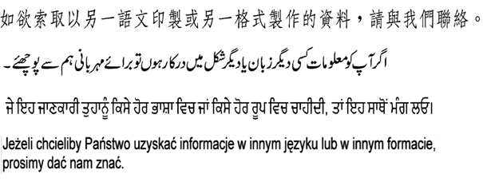

This publication can be made available in
braille, large print or audio.

If you would like information in another language please ask us.

 0300 300 0300

Extract from SPT Transport Outcomes Report: Renfrewshire 2016/17
Extract from SPT Transport Outcomes Report: Renfrewshire 2016/17
Extract from SPT Transport Outcomes Report: Renfrewshire 2016/17
Extract from SPT Transport Outcomes Report: Renfrewshire 2016/17
Extract from SPT Transport Outcomes Report: Renfrewshire 2016/17
Extract from SPT Transport Outcomes Report: Renfrewshire 2016/17
Extract from SPT Transport Outcomes Report: Renfrewshire 2016/17
Extract from SPT Transport Outcomes Report: Renfrewshire 2016/17
Children are regarded as those under 16 years of age

