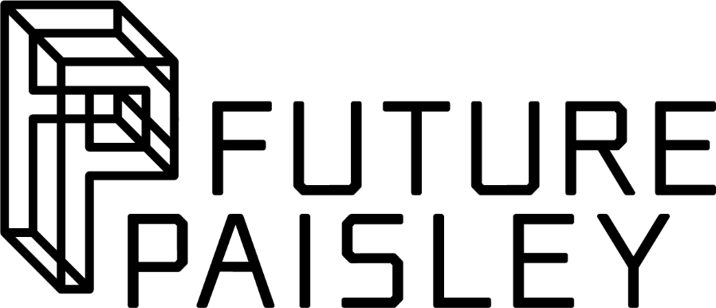
Cultural Organisations Development Fund
(CODF)
Round 4

Equalities Monitoring Form

This form should be completed by applicants to Round 4 of the Cultural Organisations Development Fund. Please include your completed form as an attachment to your application.

The information you provide will help us to monitor the types of applications we receive, in relation to protected characteristics in the 2010 Equality Act.

The information you provide is confidential and not personally attributable. It will be stored anonymously and separately to your application. This information will be used for monitoring purposes only. It does not relate to our assessment of your application and will have no bearing on the outcome of your application.

For further information please visit https://www.renfrewshire.gov.uk/CODF or email codf-enquiries@renfrewshire.gov.uk

Please complete the questions below with details about your organisation.

Age

Please indicate the number of board members, staff and volunteers in the following age groups, or state if not known or prefer not to say:

 | Board members | Staff | Volunteers
18-24 years
25-49 years
50-64 years
65+ years
Not known
Prefer not to say

Disability

Please indicate how many of your board members, staff and volunteers consider themselves to be disabled and the number who consider themselves non-disabled, or state if not known or prefer not to say:

 | Board members | Staff | Volunteers
Disabled
Non-disabled
Not know
Prefer not to say

Ethnicity

Please indicate how many of your board members, staff and volunteers are from the following ethnic groups, or state if unknown or prefer not to say:

 | Board members | Staff | Volunteers
African, African Scottish or African British
Arab, Arab Scottish or Arab British
Asian, Scottish Asian or British Asian
Bangladeshi, Bangladeshi Scottish or Bangladeshi British Chinese
Black, Black Scottish or Black British
Caribbean, Caribbean Scottish or Caribbean British
Chinese/Chinese Scottish/Chinese British
Gypsy/Traveller
Indian, Indian Scottish or Indian British
Irish
Pakistani Scottish or Pakistani British
White Eastern European (for example, Polish)
White Scottish or White British
Mixed or Multiple Ethnic Groups (please specify)
Other (please specify)
Not known
Prefer not to say

Gender

Please indicate the gender of your board members, staff and volunteers, or state if prefer not to say:

 | Board members | Staff | Volunteers
Female
Male
Other
Prefer not to say

Sexual orientation

Please indicate how many of your board members, staff and volunteers are from the following groups, or state if unknown or prefer not to say:

 | Board members | Staff | Volunteers
Bisexual
Gay/Lesbian
Heterosexual/Straight
Other
Not known
Prefer not to say

Thank you for completing this form. Please submit your completed form as an attachment to your application.

